Africa A+ field trip: February 2022

27 ECD centres in the Eastern Cape St Francis and Humansdorp area are now participating in the Kouga Windfarm Trust ECD project. The Africa A+ team completed the first 2022 field trip which focused on four activities: implementation support visits to ECD centres, facilitating workshops, training local facilitators and developing the Izinto materials centre in Humansdorp. Each activity is outlined below:

- On-site implementation support visits: Cohort 1 and 2 ECD centres
18 ECD centres benefitted from an on-site support visit by an A+ facilitator between 31st January and the 4th February. The highlight of the week was the first visit to a school for differently abled children. Although the children are older, they are developmentally at the preschool level. A+ facilitated an experiential learning activity with the children which worked very well.

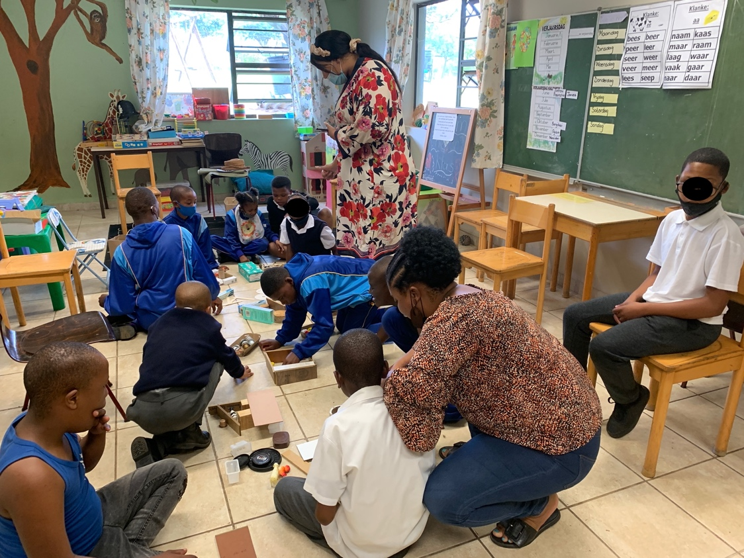

During the site visits A+ noted that changing old-style pedagogical mindsets remains the biggest challenge for ECD centre staff. A+ encourages the teachers to engage with the children in ways that gets the children thinking for themselves, reasoning, imagining, problem-solving and talking about their ideas. A+ also encourages ECD centres to limit colouring and worksheets because they do not nurture the children’s creativity and imagination. The activity below has been done with the ECD centre staff as a way of explaining the benefits of using open-ended materials and letting the children create their own ideas:

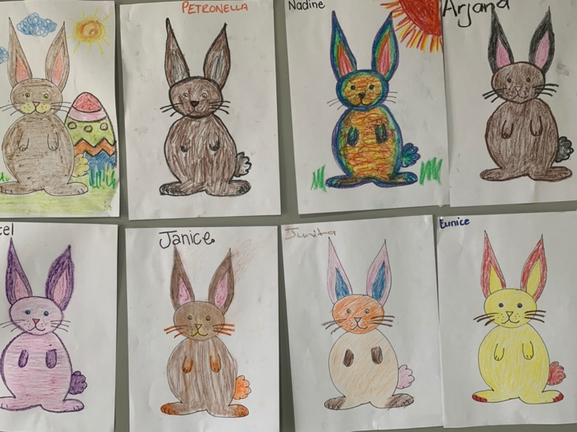 | 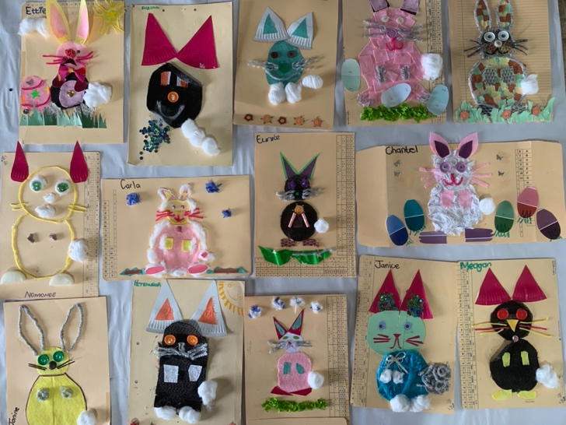
What do four year old children learn from colouring in worksheets:  - fine motor control (colouring in)  - attention and concentration  - persevering and finishing a task  - colours | What do four year old children learn by choosing their own materials, using their own idea and making a collage:  - fine motor control (cutting and drawing)  - attention and concentration  - persevering and finishing a task  - colours  - shapes e.g. what shape must I make the body/tail/ nose?  - number e.g. how many ears/eyes/paws/tail must my bunny have?  - space and position e.g. where do I stick the ears? On top, in front, or on the side?  - creativity: imagining and using their own ideas  - problem-solving e.g. what materials I do I use and how so that my picture looks like a bunny?

- Workshops:
Cohort 1: 34 attendees from the 15 Cohort 1 ECD centres attended the A+ workshops facilitated by two A+ facilitators in the afternoons of the 3rd and 4th February. The apprentice Kouga facilitators also attended as part of their training. Having two workshops supports the A+ whole school approach in that it offers everyone an opportunity to attend (someone is always left behind to look after the children).
Cohort 2: 40 ECD staff from the 12 Cohort 2 ECD centres attended the two A+ workshops facilitated in the afternoon of the 1st and 2nd February. The local A+ facilitators co-facilitated the workshop in part.

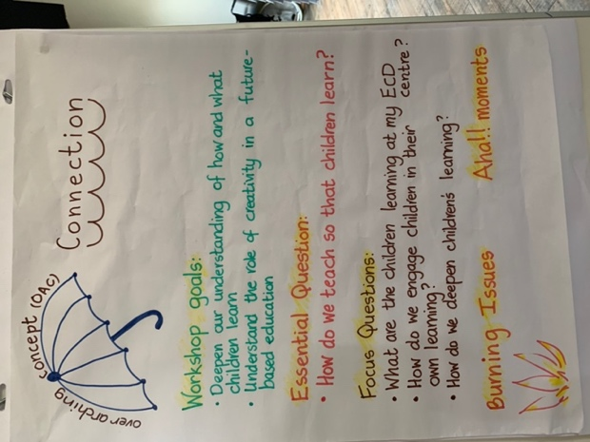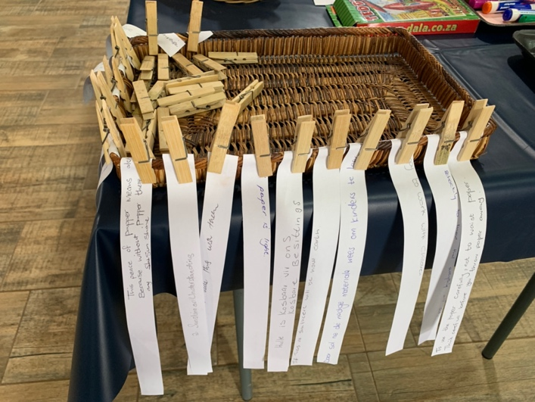
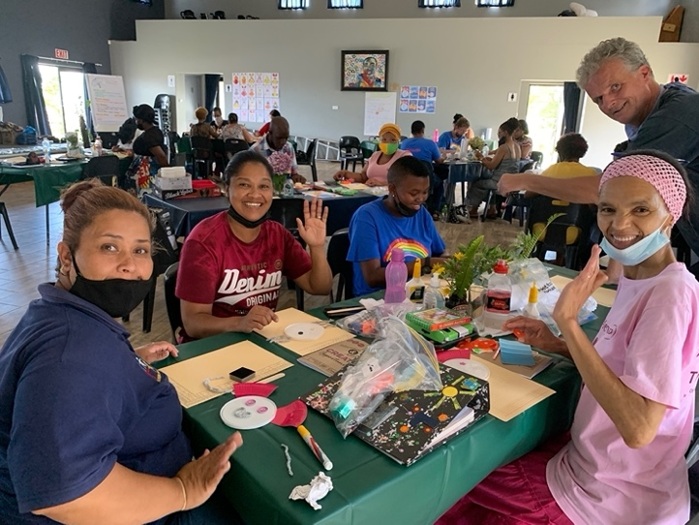
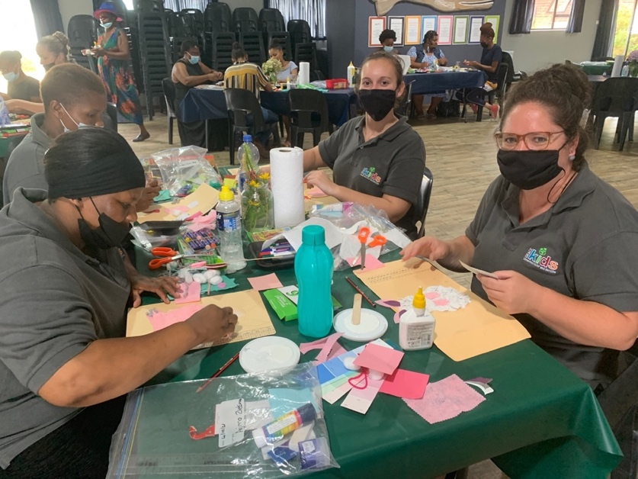

- Facilitators’ training session: Seven of the nine Kouga facilitators attended the learning session on the 31st January at the Victory4All hall. The training session focused on organisation and planning, setting up the workshop venue, and preparing to co-facilitate the Cohort 2 workshops.
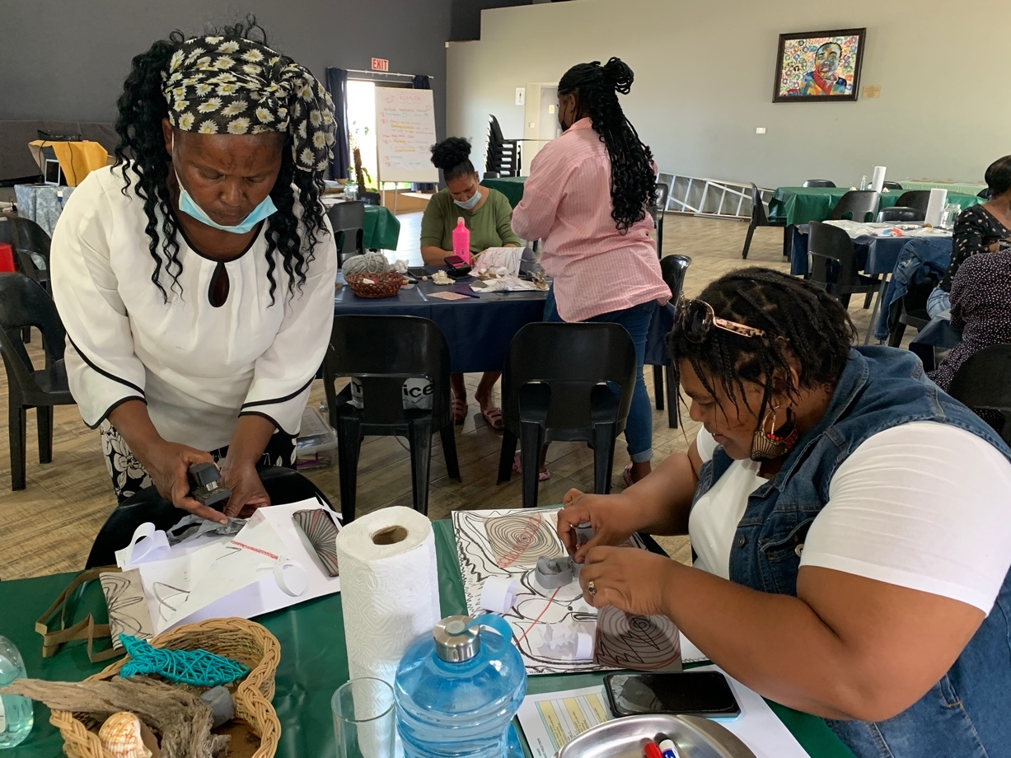

- iZinto materials centre
A+ facilitator, Carole Scott, sourced materials from businesses and manufacturers in the Kouga area, and worked on developing the layout of the 200m storage space in Humansdorp.
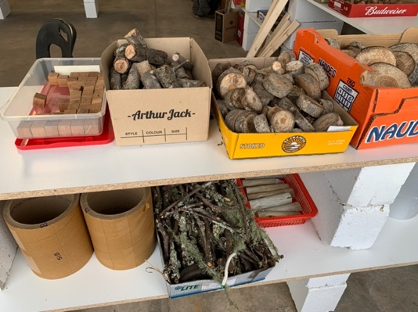

When the A+ facilitators model learning activities with the children during site visits they use and distribute materials from the Izinto materials centre. Using the materials enables the children to exercise their creativity, imaginative and problem solving skills.
