Africa A+ field trip: March 2022
The Africa A+ team completed the second 2022 A+ field trip in March. The field trip activities included on-site visits to 14 Cohort 1 and 2 ECD centres, a leadership workshop, two ECD workshops for the Cohort 2 schools, and the opening of the iZinto materials centre in Humansdorp. The field trip activities are outlined below:

- On-site visits to Cohort 1 and 2 ECD centres (7-11th March)
- An ECD centre in Kwanomzamo, Humansdorp (below) is located in a church hall. A+ modelled an activity with the children using ‘loose parts’ e.g. bottle tops, that demonstrated how teachers can, despite constraints, facilitate quality learning experiences for the children in their care.
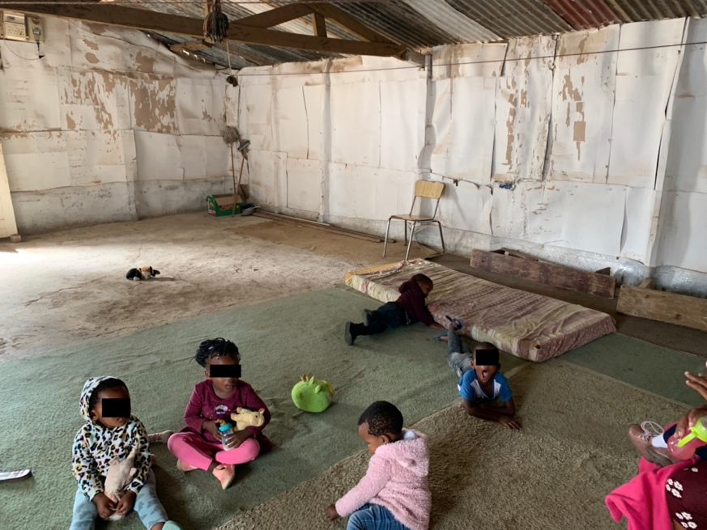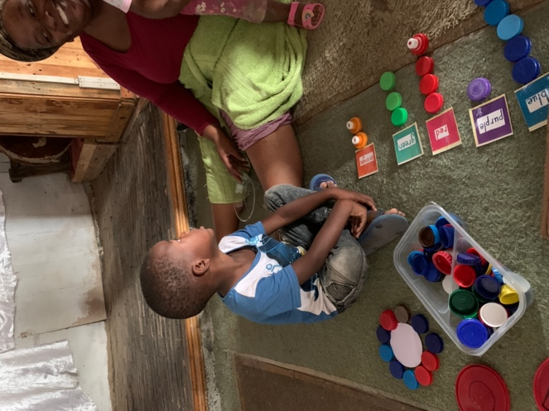

- One of the challenges observed during the site visits is the formality of classroom set ups and teaching methods. A+ encourages ECD centres to do play-based activities, to set out floor activities, to value and foster the children’s creativity, to provide open-ended materials, and to create opportunities for children to make choices.

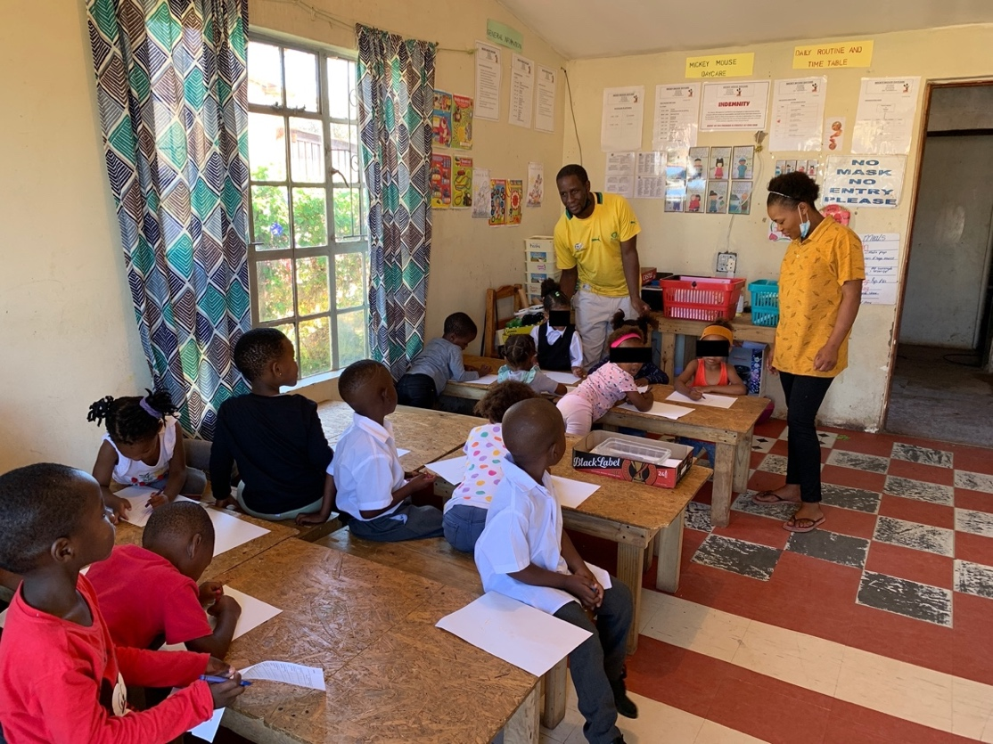

- Below is a recently upgraded Cohort 1 ECD centre in Kwanomzamo, Humansdorp. Having a nice place and learning materials makes a big difference to the teachers and the children in their care.
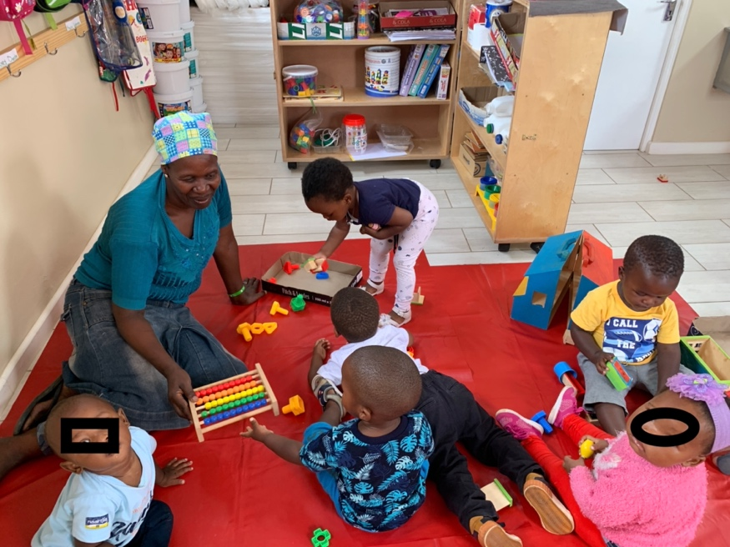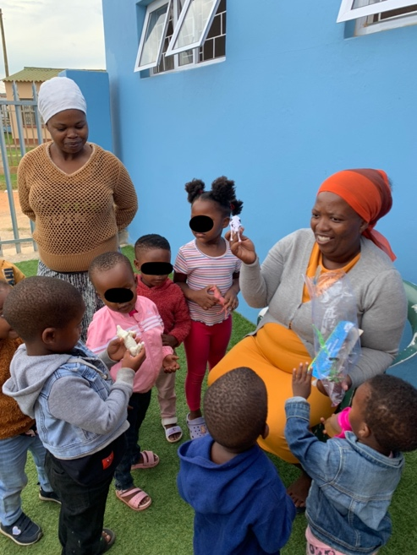

- Facilitators’ learning session (8th March)
The Kouga facilitator’s training session was facilitated in two parts:
      - From 1.30 - 2.45pm the learning session was held at the Victory4All hall where the A+ and Kouga facilitators focused on setting up and preparing to co-facilitate the Cohort 2 workshops.
      - From 2.45 – 4.30pm the Kouga facilitators were at the iZinto materials centre where Carole Scott introduced the concept of ‘loose parts’ and the facilitators worked creatively with the iZinto materials.

- Leadership workshop (9th March)
27 ECD principals and school leaders attended the workshop which focused on;
      - creativity (imagination, an entrepreneurial mindset, problem-solving, critical thinking, innovation),
      - the 0 – 4 years National Curriculum Framework (NCF),
      - and how to support ECD staff in nurturing the children’s creativity.
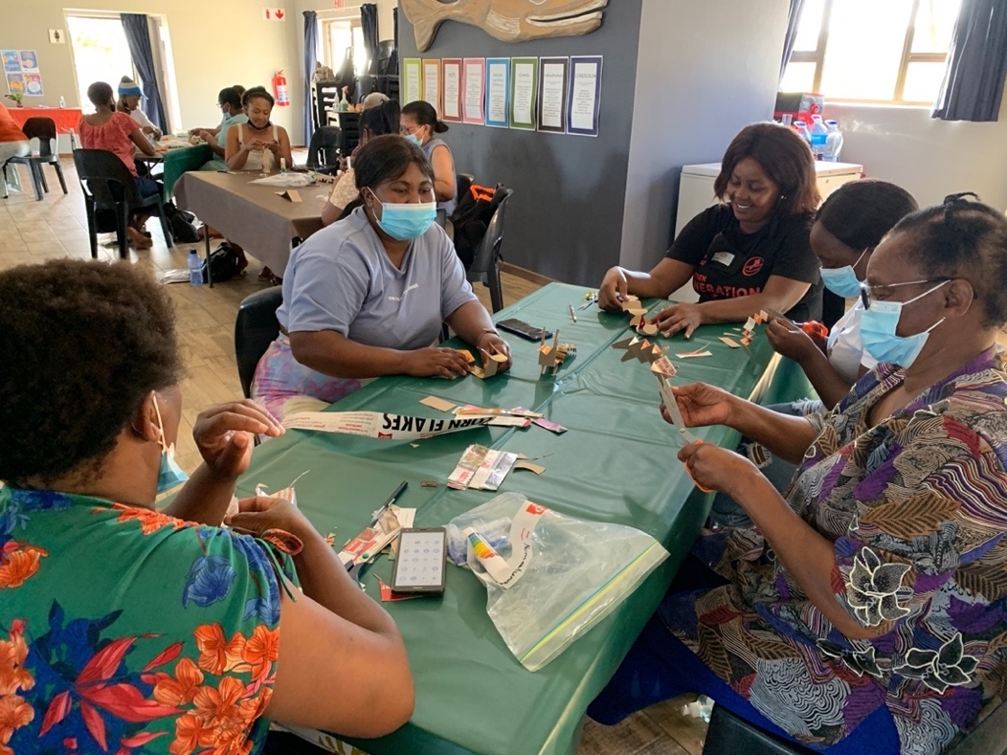

- Cohort 2 workshops (10th and 12th March)
46 staff from the 12 Cohort 2 ECD centres attended the two A+ workshops. The second workshop was moved to the 12th, a Saturday morning, after two ECD centres indicated that they cannot attend weekday events on account of the afternoon programs they run at their centres. The workshops focused on bringing art, creativity and early learning to life in an ECD centre. The participants also experienced the outdoors as an early learning resource.

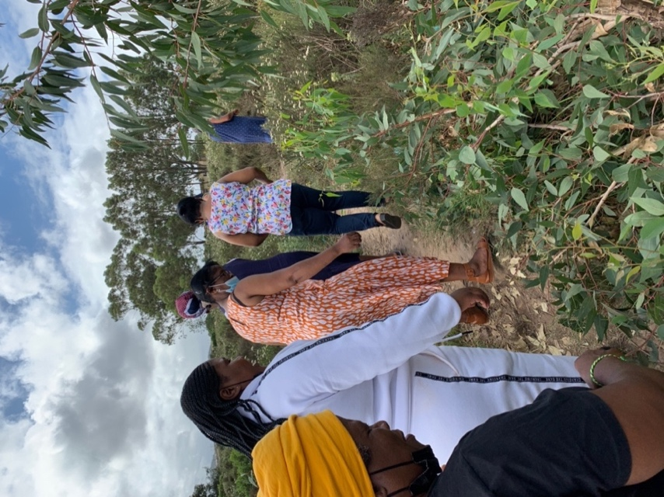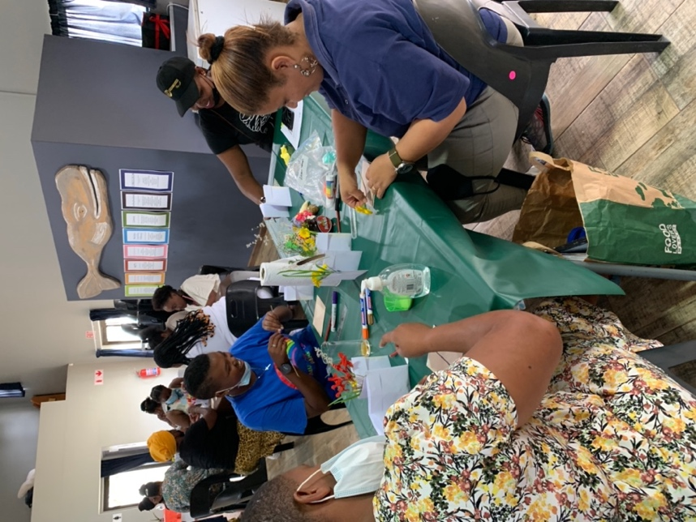
The Saturday morning workshop for Cohort 2 ECD centres was held at the iZinto materials centre:

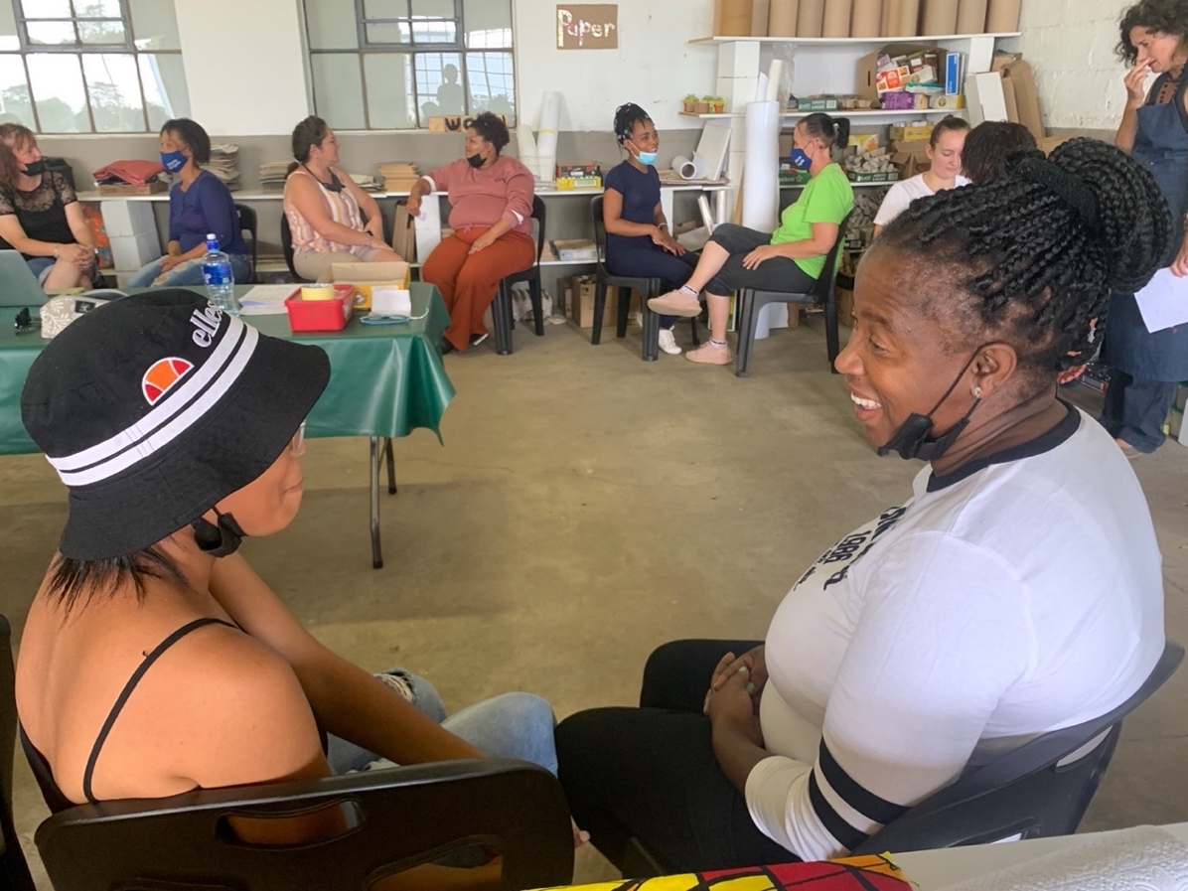

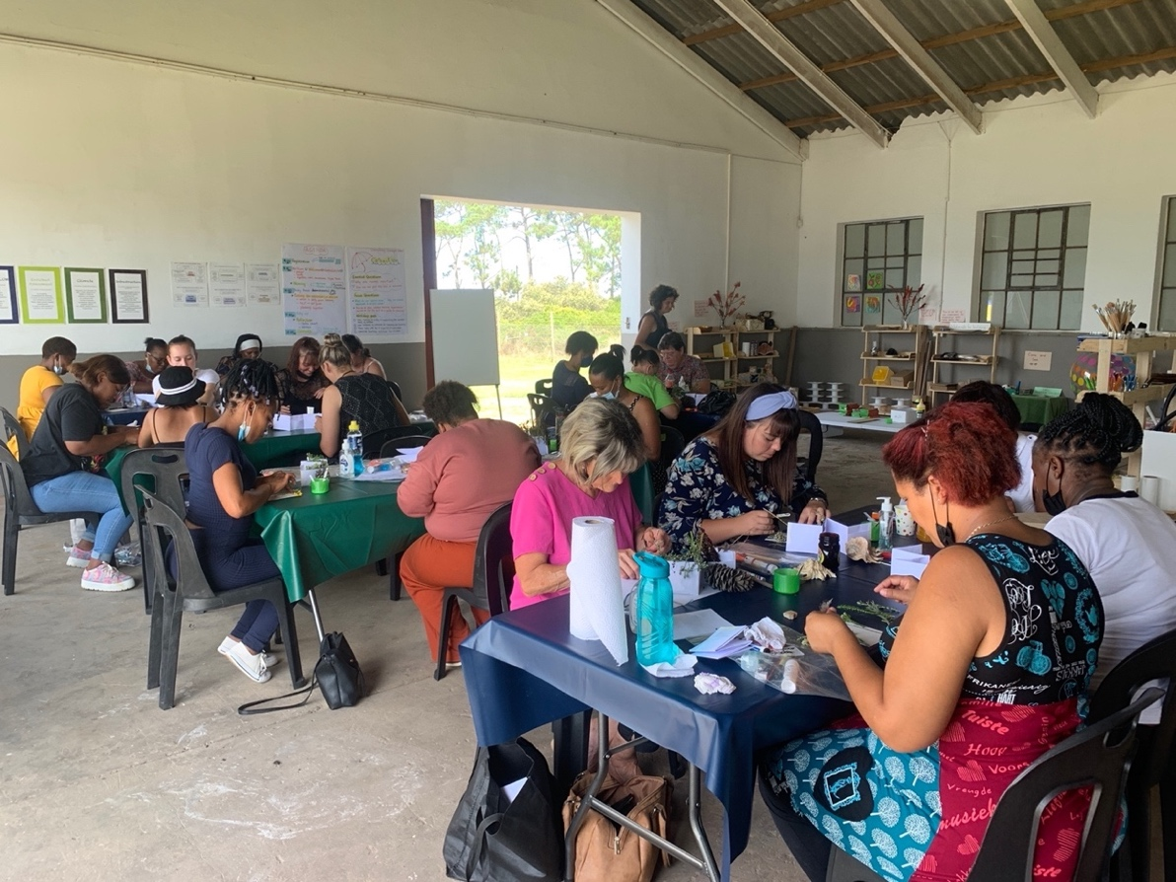

- Opening: iZinto materials centre
A+ formally opened the Humansdorp iZinto materials centre on the 11th March. The 2 – 4pm opening celebrations were attended by the Bophelo Impilo Development Centre (BIDC) and the Kouga ECD project principals and teachers who selected and took away materials to use in their centres.

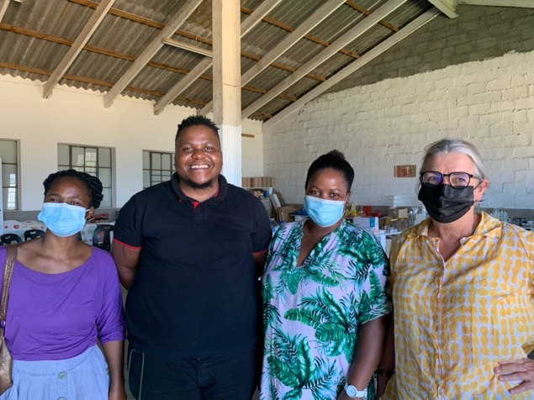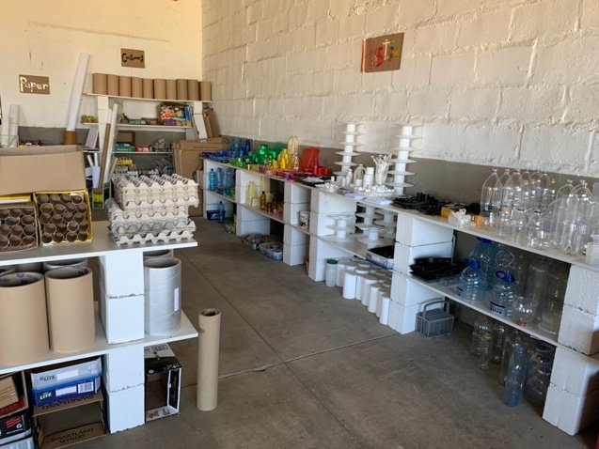
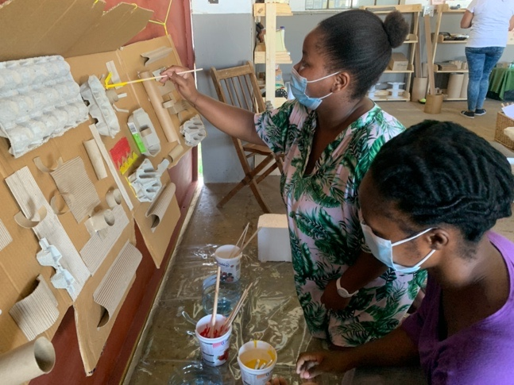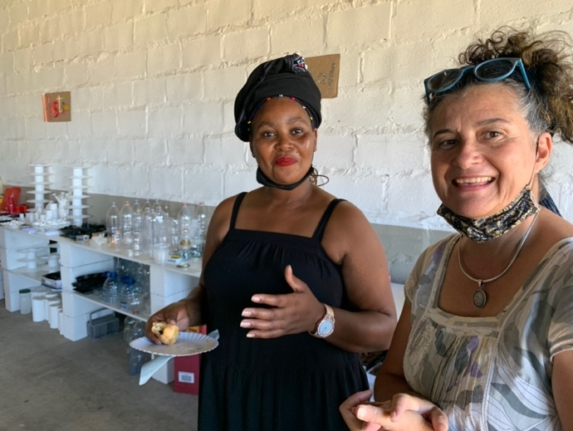
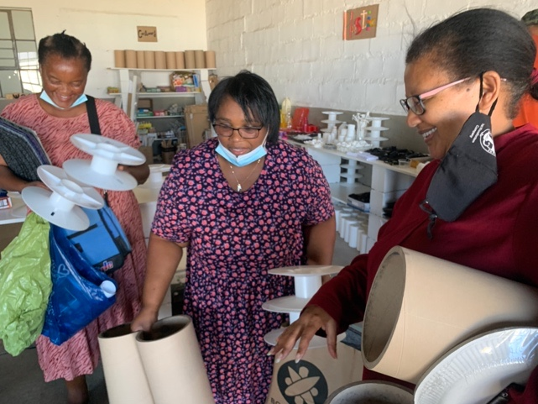

Highlights and challenges:
- There is a feeling that life and work are returning to normal. ECD centres are reporting that enrolments have increased overall particularly in the larger established ECD centres. It was a challenge keeping COVID protocols in place during field trip events!
- ECD centres are starting to work collaboratively by sharing resources and working together on school admissions.
- There has been an increase in break-ins and theft at ECD centres
- Some ECD principals have to work another job as the income generated by their ECD centres is insufficient for their family’s needs. This means that the principal cannot be at her centre to mentor young or inexperienced teachers, and that taking time off to attend workshops is not always possible.




