Field trip: May 2022
The Africa A+ team undertook their third 2022 field trip to Kouga from 8 – 15th May. The field trip activities included on-site support visits to 17 ECD centres (mornings), and four workshops (afternoons) for the 26 schools participating in the Kouga Windfarm ECD project. The field trip activities are outlined below:

- On-site visits to Cohort 1 and 2 ECD centres (9 - 14th May)
The two A+ facilitators visited 17 ECD centres and worked with the teachers and children teaching in joyful and meaningful ways using recyclable and found materials from the iZinto materials centre. The purpose of each visit is to understand the context in which each school community finds themselves, and to show the staff diverse ways of facilitating quality play-based learning experiences with children.

The Grade R class at Eagles Accolades Academy in Humansdorp learning to count, measure, pattern and sort using coloured bottle tops. | The older children at Chioma Safehaven ECD centre learning to count using pebbles.
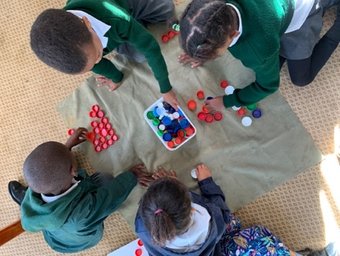 | 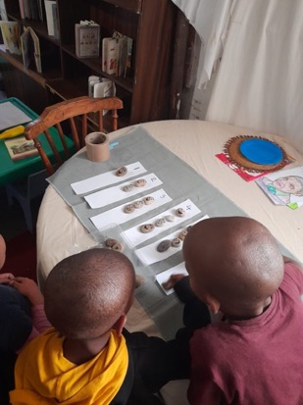

The children at Rainbow Angels had lots of fun listening, sequencing and problem-solving while the teachers and A+ dramatized a story together. | Toddlers at Chioma Safehaven exploring different materials with their teacher.
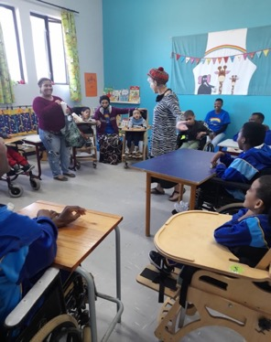 | 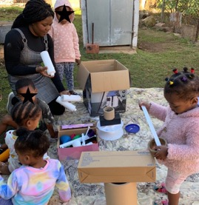

A+ worked with the Grade R children at Grace Kids on mathematical patterning.
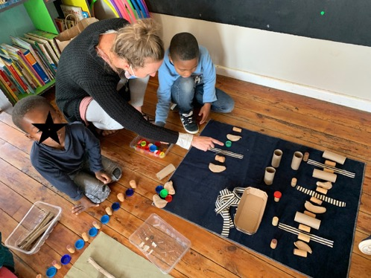

Faith in Action have moved into their new premises. The principal, Annaline Didloft, wears many hats: owner, employer, teacher, parent support, and a provider of warm hugs and comforting words.
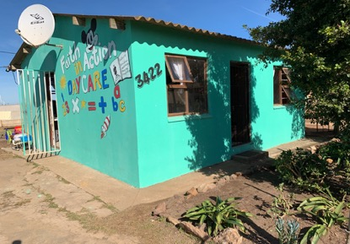

Arise and Shine has expanded their ECD centre. A+ facilitated sorting and counting with the children.
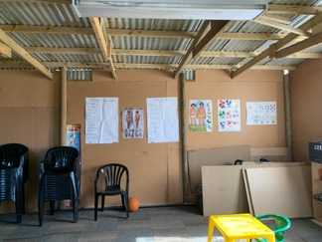 | 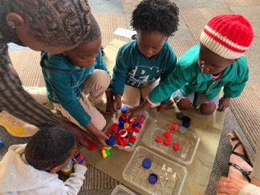

- Workshops (10, 11, 12 and 14th May)
The four workshops began by introducing the principals and staff from 26 ECD centres to the recently published Thrive⁵ report based on the 2021 assessment of 5,139 children at ECD centres throughout South Africa. The key findings https://innovationedge.org.za/wp-content/uploads/2022/04/242-Action-brief-Findingsv02.pdf , show that:
- 65% of children are not thriving at ECD centres in South Africa. This means that they are not ready or prepared for formal schooling.
- One in four children at these ECD centres show signs of long-term malnourishment
- Children from poor households are disadvantaged before they start formal schooling. The report however notes that there are exceptions:
….. poor outcomes for poor children are by no means inevitable. There are many poor children who have significantly better outcomes than their peers, despite their disadvantaged circumstances (p.3).

A+ used the Thrive⁵ key findings to motivate each participant to implement what they learn at the A+ workshops so that their centre becomes part of the 35% of ECD centres where children thrive.

Participation at all four workshops was enthusiastic and hands on. The workshops were directed at teachers and principals changing old pedagogical habits and creating new mindsets about teaching and learning. The workshops began with the teachers enjoying their own creativity as part of learning how to nurture the children’s imagination, initiative, problem-solving, critical thinking, communication and collaboration (21st Century skills).

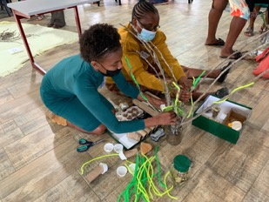

After working together creatively, the workshop participants began planning how to nurture the children’s development using the aims of the 0 – 4 years National Curriculum Framework (NCF) as a guide.
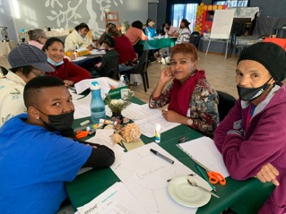 | 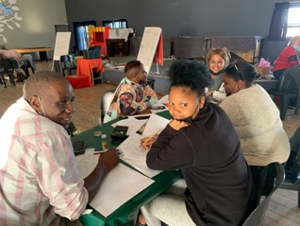

Comments:
The participants wrote the following in response to the workshop reflection questions:
1: What can you do so that the children can thrive at your ECD centre?
- Give children opportunities to discover
- Nuurskierige aktiwiteite te laat doen [Let them do activities that arouse their curiosity]
- Hul baie aan to moedig om dinge op hul eie te doen [Encourage them to do things on their own]
- Ask open-ended questions. Let them do some thinking and don’t tell them what to do.
- More creativity – less colouring in!
2: What is going to be different at your ECD centre?
- Working together as teachers on our planning.
- We are going to start planning better so that things can go better.
- Celebrate the children’s work
- Beplanning meer deeglik te doen [Do my planning more thoroughly]
- Making activities more fun and practical – learn while playing.

Highlights and challenges:
- The iZinto materials centre in Humansdorp is working well. It is a rich local source of materials for site visits and workshops and when the teachers attend a workshop at iZinto, they can select their own materials to take back to the children at their centre.
- The teachers and principals appreciate that the Kouga Windfarm ECD project is building a supportive ECD community.
- Changing mindsets and implementation of workshop learning remain the biggest challenges.

