Loose parts and the iZinto materials centre

‘Loose parts’ play a significant role in Africa A+’s work because they offer children hands-on opportunities to exercise their creativity and to learn in diverse ways. ‘Loose parts’ are discarded, found and everyday materials sourced from manufacturers, businesses and the local community.

Carole Scott inspired the first Africa A+ iZinto (Xhosa word for things) materials centre in Humansdorp in 2021. A second iZinto is opening in June 2022 in Muizenberg, Cape Town. Our mission is to provide access to discarded materials, and to enable problem solving, critical thinking, collaboration and creativity in teachers and children by using open ended materials in joyful and dynamic ways.

A+ and the Grade R children use loose parts to learn about pattern - a mathematical concept where repetition is based on a rule.
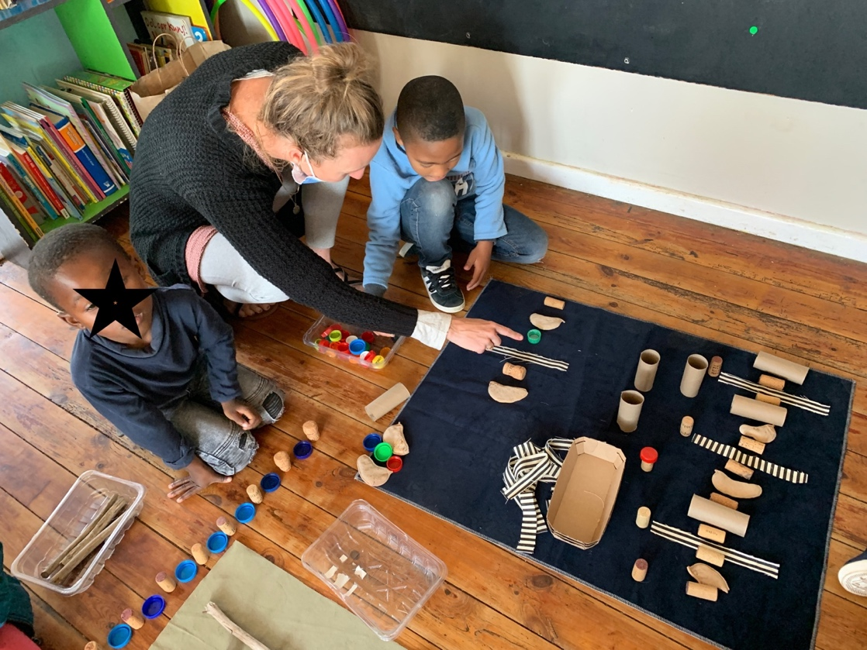

The materials are arranged aesthetically at iZinto in order to inspire creativity and to show that the materials are respected and valued as creative and pedagogical tools.
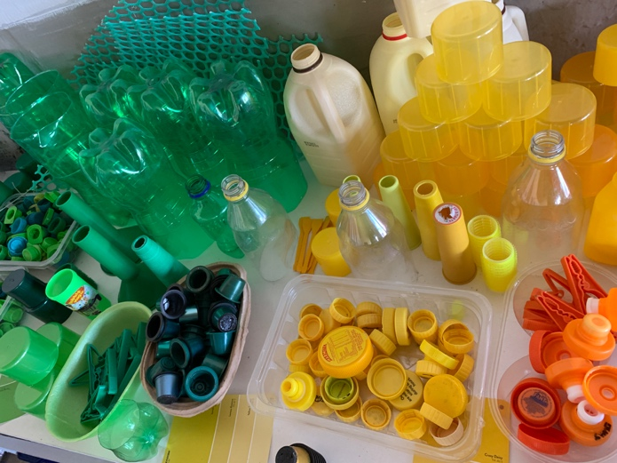 | 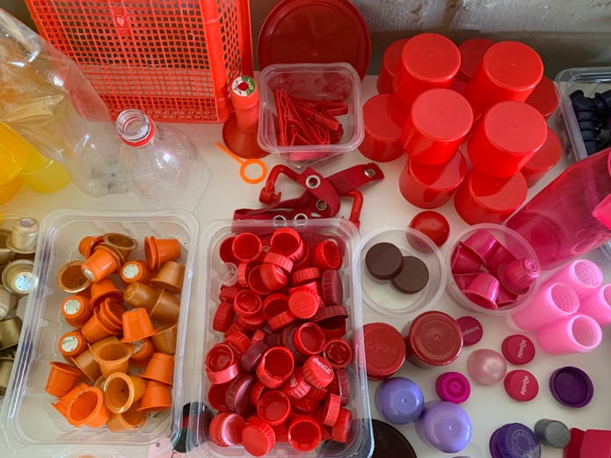
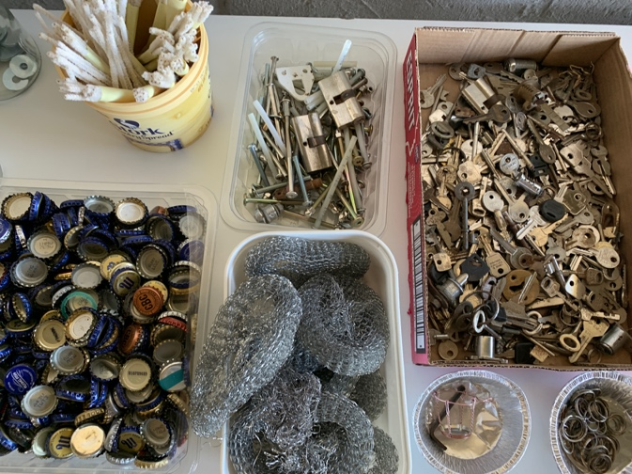 | 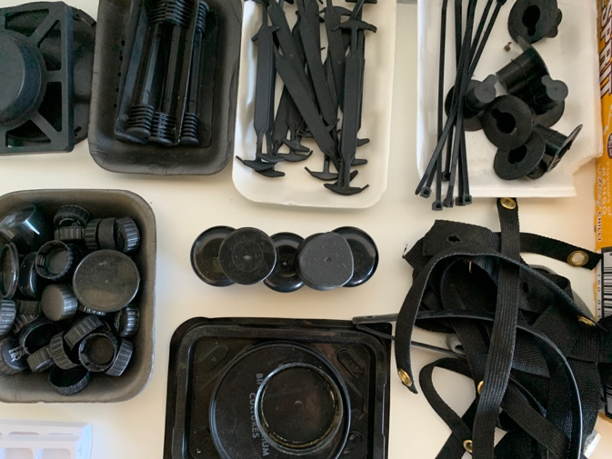
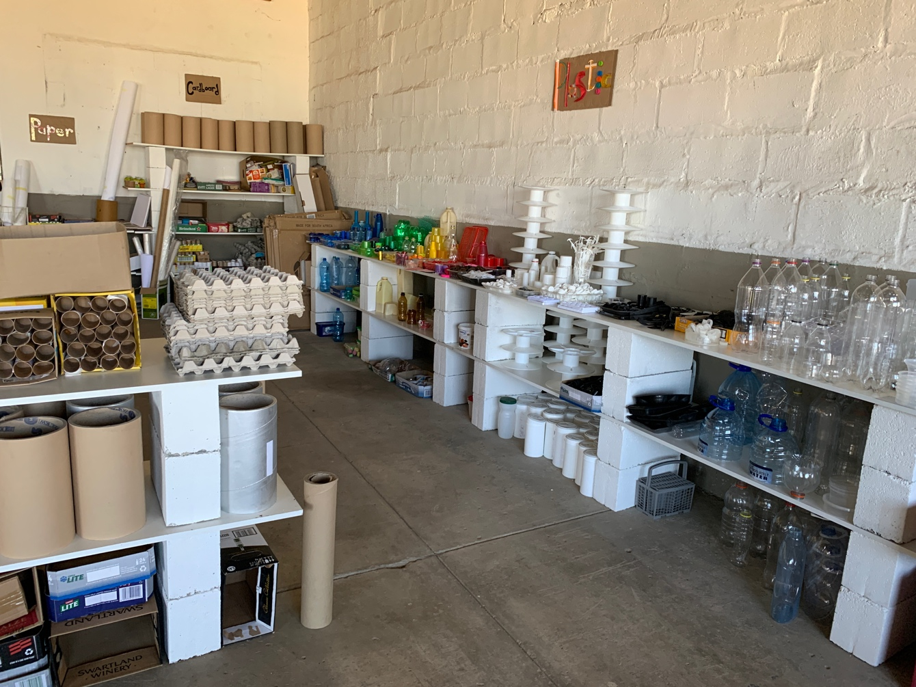

Africa A+ facilitated a workshop in the Humansdorp iZinto centre. After the workshop the teachers selected and took materials back with them to their ECD centres to use with the children.
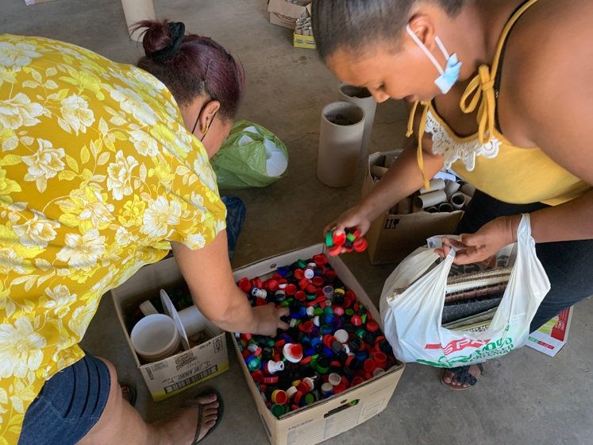 | 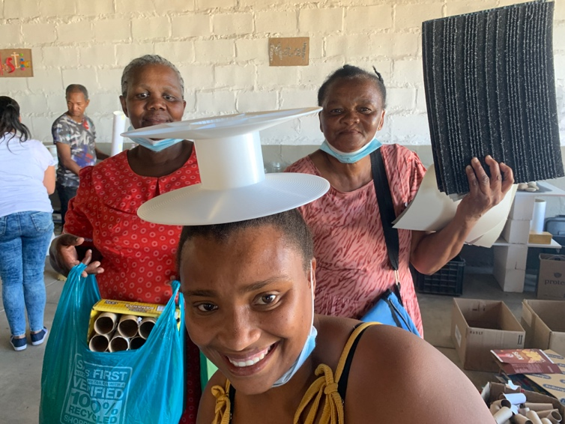

When children play with loose parts, they are using their imagination, innovating, persevering, sharing, problem-solving, and working with early mathematical concepts such as space, shape, balance, measurement, sorting, and counting.
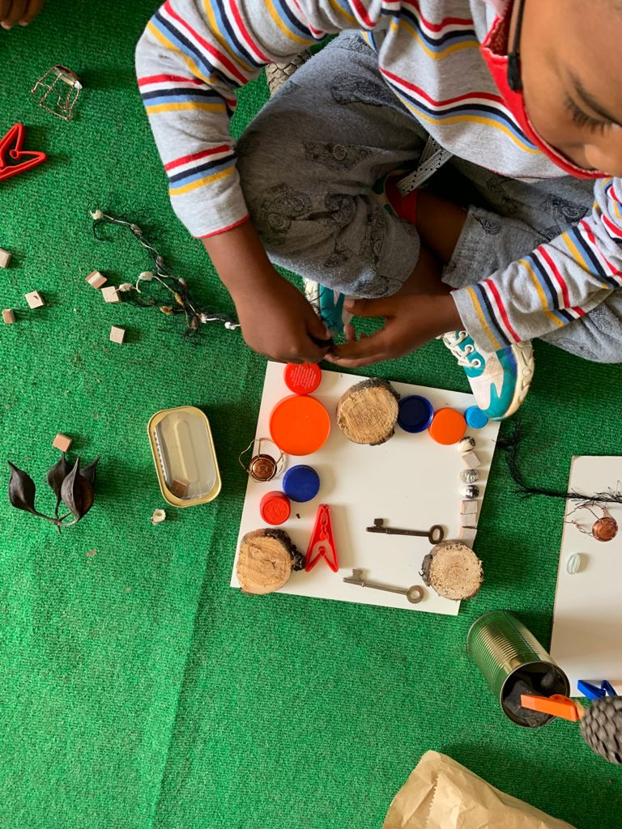 | 