Africa A+ undertook their sixth 2022 field trip to Kouga from 7th – 17th September. The focus of the field trip was to introduce the 13 Cohort 3 ECD centres, who were entering the Kouga Windfarm Trust ECD project for the first time, to the A+ approach. Africa A+ is now working with 38 ECD centres in the Kouga area. The Field trip 6 activities are outlined below:

A baseline survey for each Cohort 3 ECD centre (8 – 9th September 2022)
A+ first completed a Teaching and Learning Survey at each Cohort 3 ECD centre. These surveys serve as a baseline against which pedagogical progress is measured over the next three years.

Photos 1 & 2: A school in Sea Vista, St Francis, joined Cohort 3.
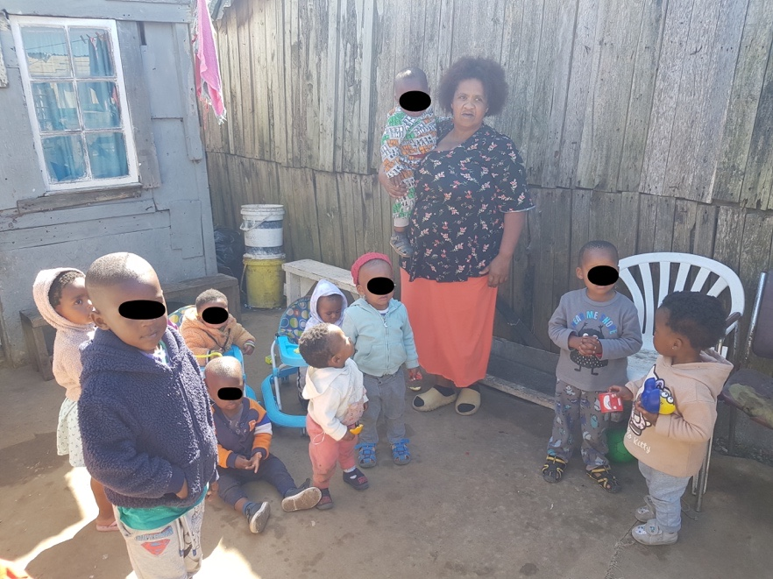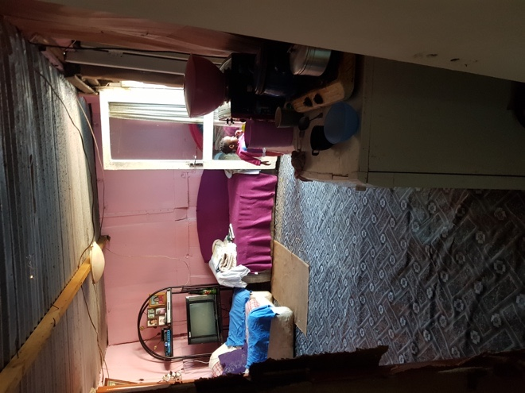

Photos 3 & 4: A School in Humansdorp joined Cohort 3. The principal is also one of the local facilitators in training.
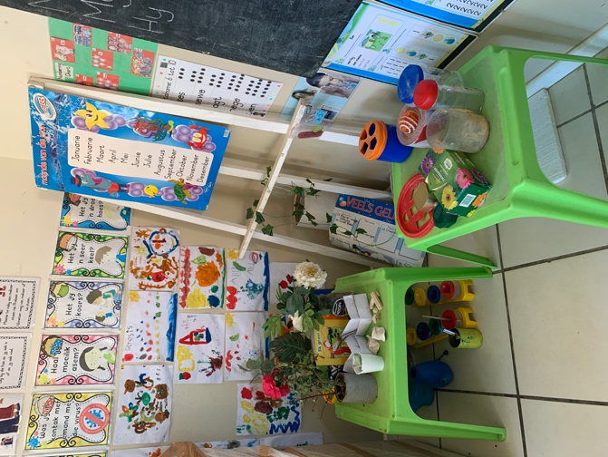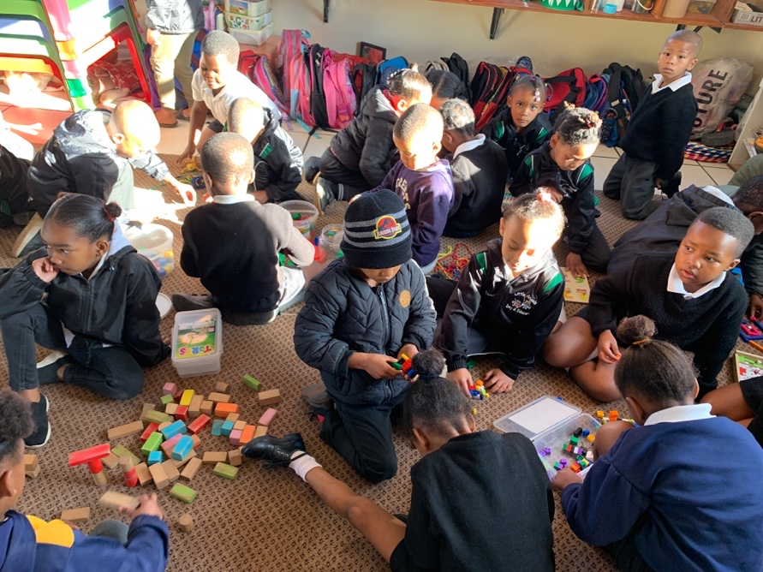

Principals’ meeting (9th September 2022)
This meeting is an attempt by A+ to work with the ECD principals in managing the loss of pedagogical skills caused by high staff turnover. A+ has observed over the two years a steady stream of teachers leaving the poorer ECD centres to find better paying work elsewhere. Their replacements are young untrained practitioners which puts the school back to entry level in terms of providing a quality early learning programme. The attendees responded positively to the idea of A+ training principals on how to facilitate staff development to ensure a quality learning programme.

Kouga Facilitators’ Training Session (10th September 2022)
A+ is training a team of nine local faciliators to support the Kouga ECD centres after the project has ended.

Cohort 3 Summer Institute (12 – 16th September 2022)
The five day Summer Institute for the 13 Cohort 3 ECD centres went smoothly. Each day involved the participants in experiential learning, the creative arts, personal development, teamwork, planning, the 0-4 years National Curriculum Framework, and reflection.

Photos 5 - 7: Day 1 of the Summer Institute
The Cohort 3 principals and teachers participating in the five day Summer Institute. Day 1 began with introductions: to each other and to the A+ approach to teaching and learning.
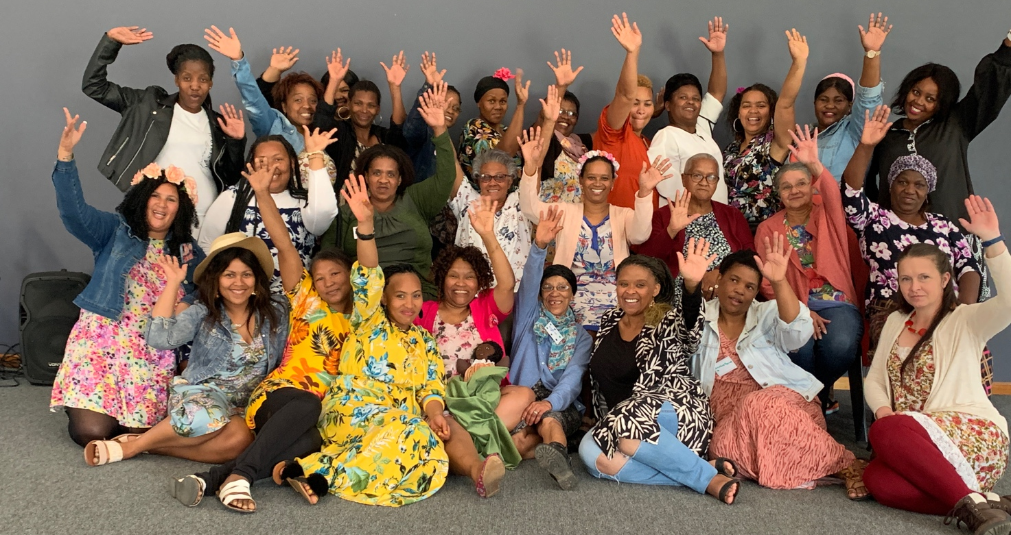

The Kouga assistant facilitators (Petronella Ruiters, Ntombomzi Ndamse, Nomonde Siqwengana and Marlyn Dyantyi) helped facilitate the Summer Institute.
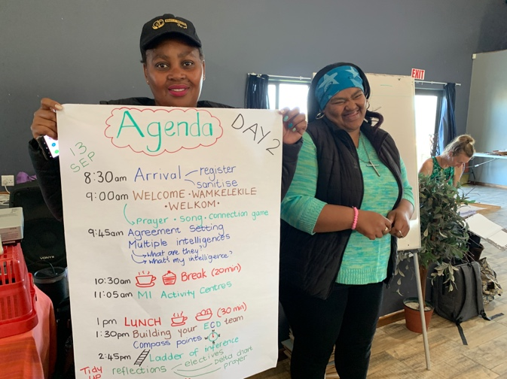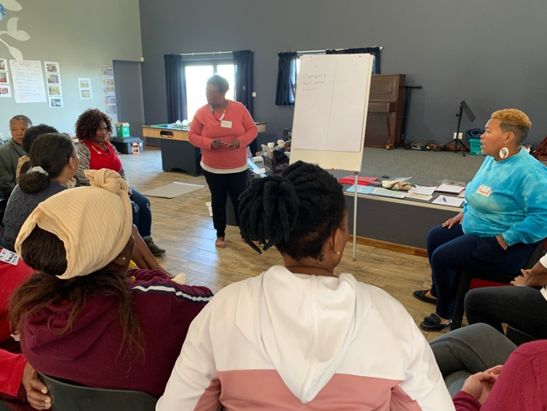

Photos 8 - 9: Day 2 of the Summer Institute
Understanding Howard Gardner’s theory of multiple intelligence and applying it to how young children learn.
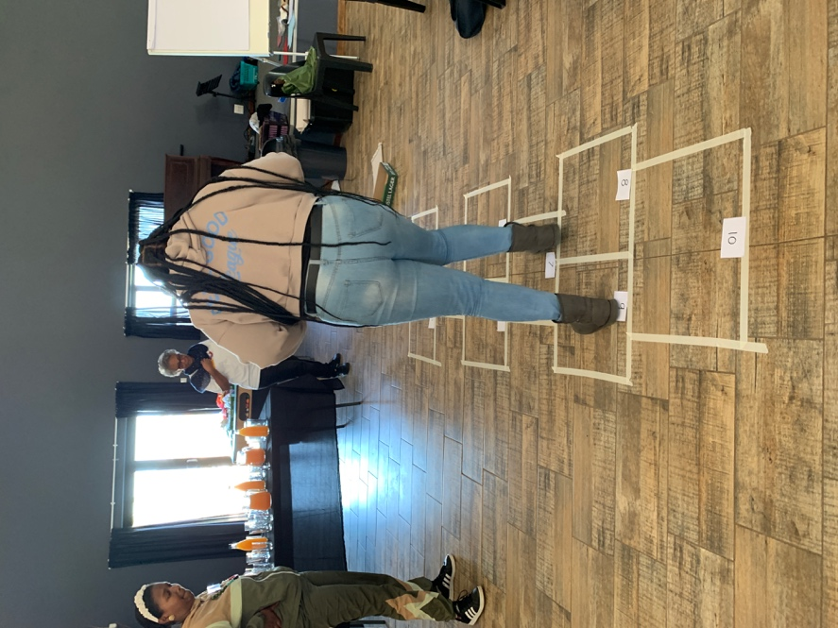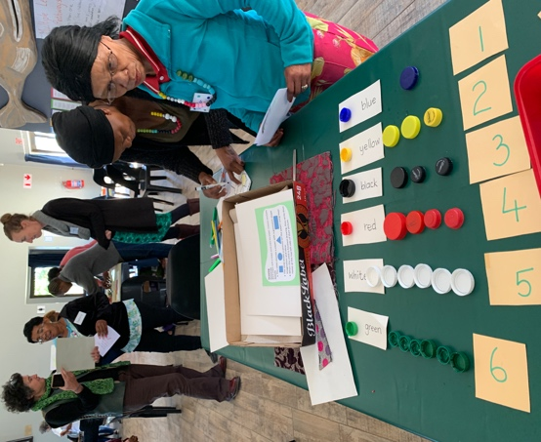

Photos 10 - 12: Day 3 of the Summer Institute
Teamwork: sharing ideas and helping each other to plan quality early learning experiences for children.
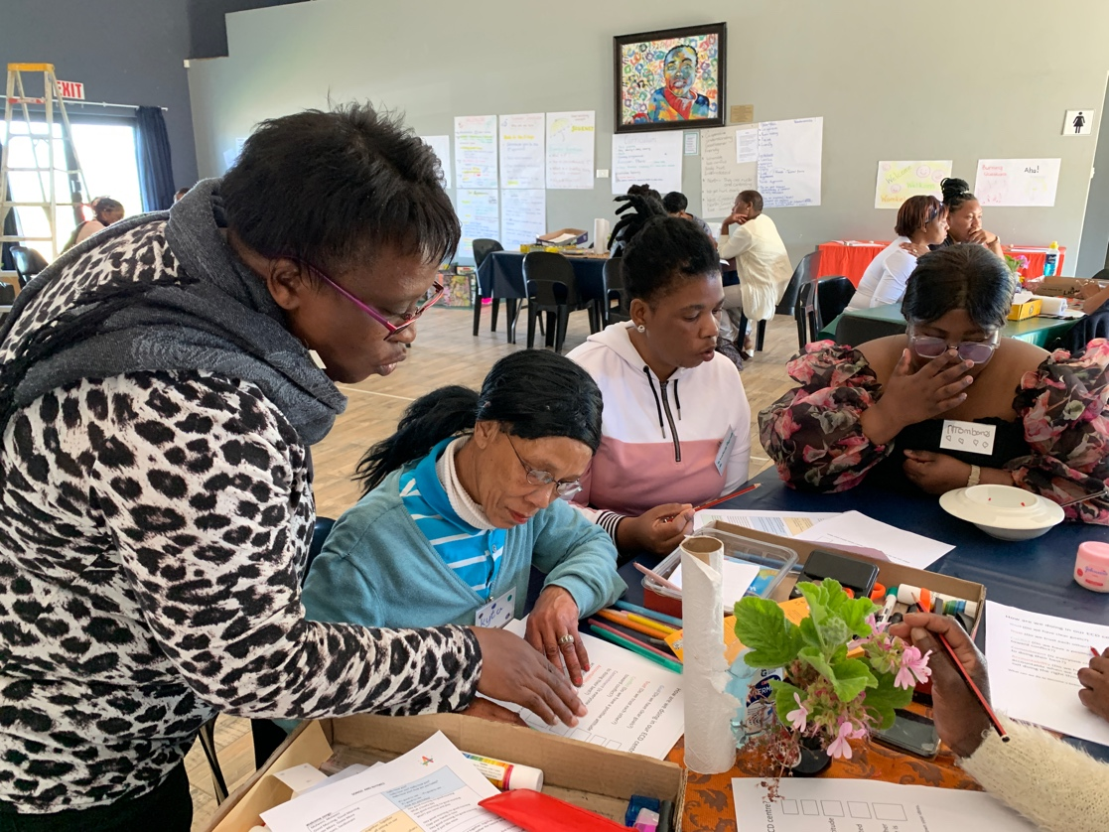

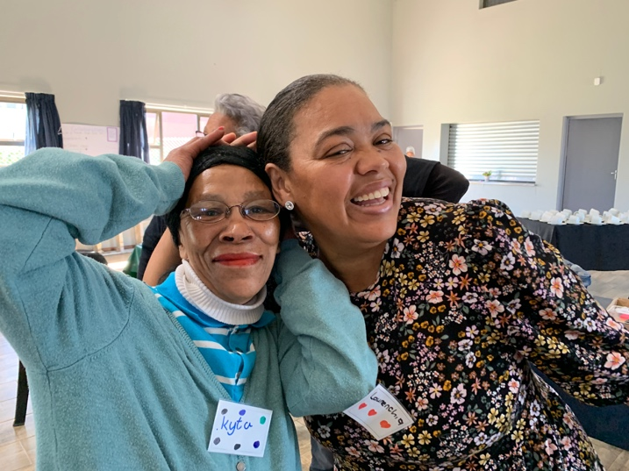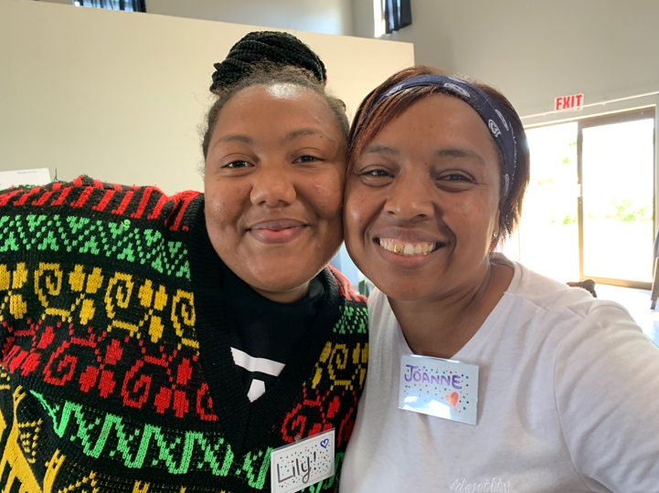

Photos 13 - 14: Day 4 of the Summer Institute
An introduction to the 0 – 4 years National Curriculum Framework.
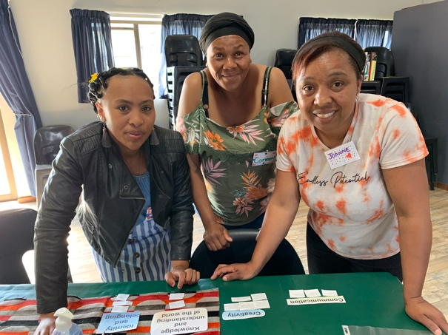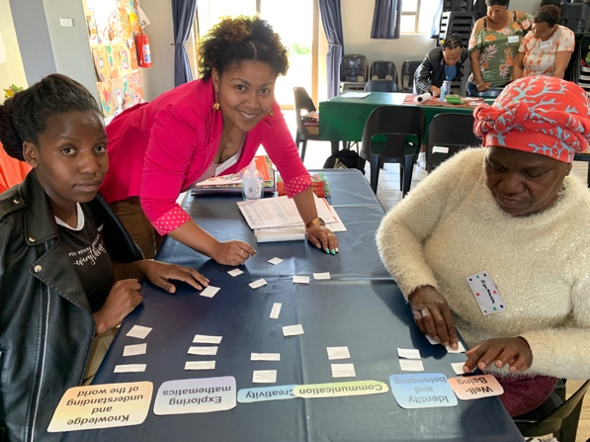

Photos 15 - 16: Day 5 of the Summer Institute
Planning play-based learning activities for 2023 using the 0-4 years National Curriculum Framework as a guide.
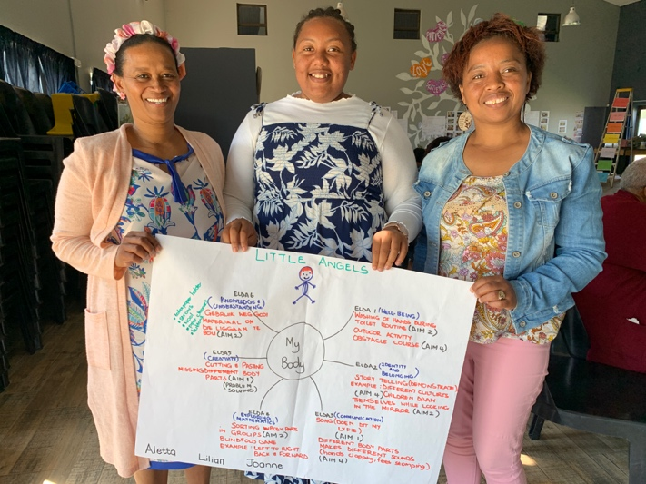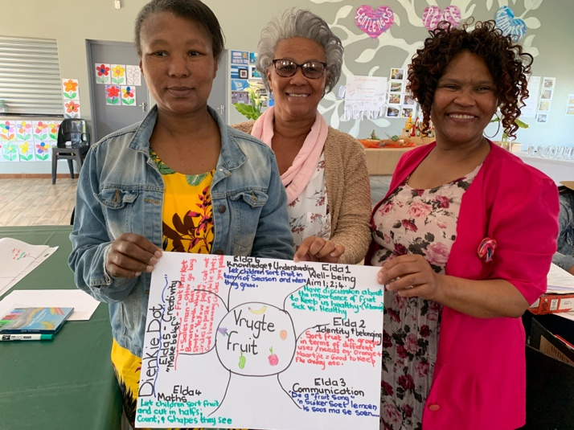

The highlights of the Summer Institute were:
- The participants’ enthusiasm, active engagement, enjoyment, and growing confidence.
- Building an ECD community, the tasty food, and the facilitators’ co-facilitation. Comments from the participants:
- ‘Daar is niks verveeling aan die gang in hierdie plek!” [There is nothing boring going on in this place!] (Nicoline).
- ‘I have been teaching for 25 years. DSD [Department of Social Development] did many, many trainings but then I met A+. Wow! This is it!” (Elysteen)

Celebrating successes
- Seven Kouga principals and teachers graduated with a Level 4 ECD certificate. This is the result of a collaboration between ITEC and Africa A+ Schools.
- Although changing mindsets takes time, some ECD centres are already shifting their thinking about early education:

Photo 17:  Kruisfontein in 2020: children sitting at tables with a worksheet. | 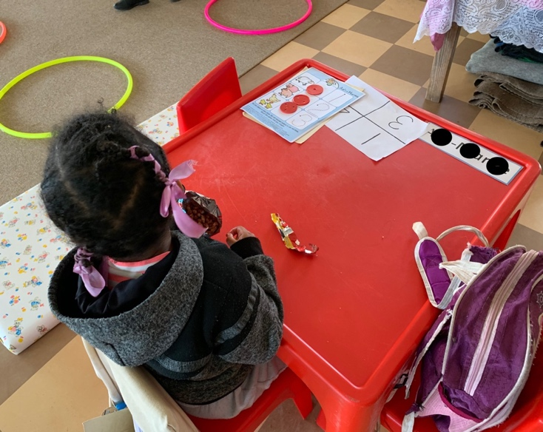

Photo 18:

Kruisfontein in 2022: children playing outside with natural materials on Spring Day (1st September 2022).

There are lots of opportunities for the children to collaborate, imagine, explore, create, and implement their own ideas.

This is the best kind of early learning: joyful, hands-on, free choice, sensory learning using concrete materials while making a glorious mess with your friends

