Africa A+ facilitated a two day Spring Conference for the Cohort 1 preschools participating in the Kouga Windfarm Trust ECD project in the Eastern Cape, South Africa. The conference was facilitated by two A+ facilitators and attended by principals and teachers from eight preschools. Five Kouga apprentice facilitators assisted and co-facilitated as part of their training. Each day started at 8.30am with registration and ended at 4pm. The focus for the two days was on nurturing the participants creativity through the arts, setting personal and professional goals for 2023, and planning learning activities linked to the aims of the 0 – 4 years National Curriculum Framework.

Comments written by the participants on their reflection forms in response to the following question: ‘What has changed since you joined A+?’
- My thoughts have changed (Anon)
- There is a lot I have learnt because when starting here I didn’t know a thing (Nomqgibelo)
- I have build more confidence and, I started to believe in myself (Vemoline)
- It gave me the spirit that I can be a teacher to the children and loving one another. I am a better person (Noludwe)

The highlights of the Cohort 1 Spring Conference were the participant’s enthusiasm and their growing confidence and creativity. The refreshments were much enjoyed as Zaida, the Victoy4All caterer goes out of her way to provide a tasty breakfast and lunch. All the participants received a story book and a Maths Up poster book donated by author Reviva Shermbrucker and by Cally Cuhne from RedInk.

The challenges were the power outages; Stage 4 load-shedding disrupted video and slide presentations, music activities, and catering. Humansdorp was a safe area but recent gang activities and a turf war have made the local community anxious. Six young men from local families were killed in the week of the Spring Conference. A+ would like to see more whole school attendance because it supports implementation of what has been learned when all the staff are involved.

Photos taken on the 3rd and 4th October during the Spring Conference:
Photos 1 & 2: Participants getting in touch with their creativity
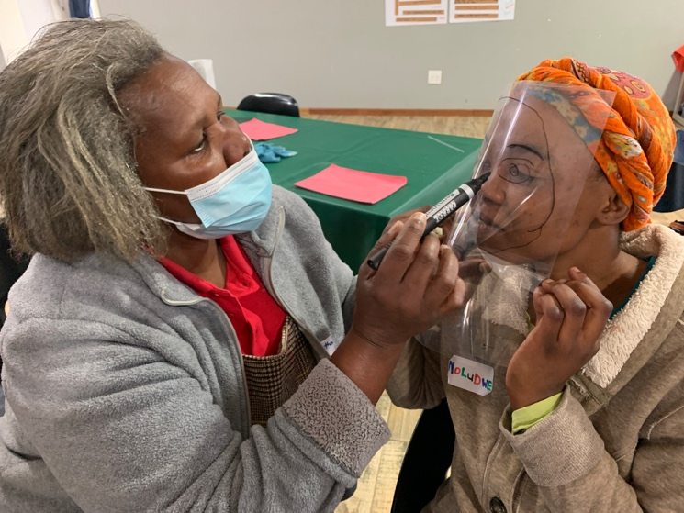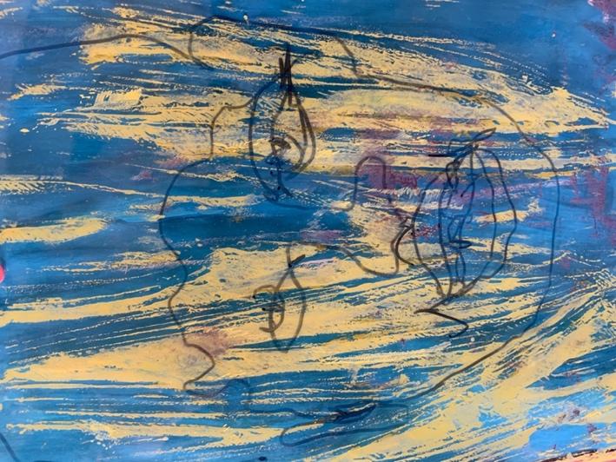

Photos 3 - 5 Getting ready for 2023. Participants planning play-based learning activities linked to the aims of the 0 – 4 years National Curriculum Framework.
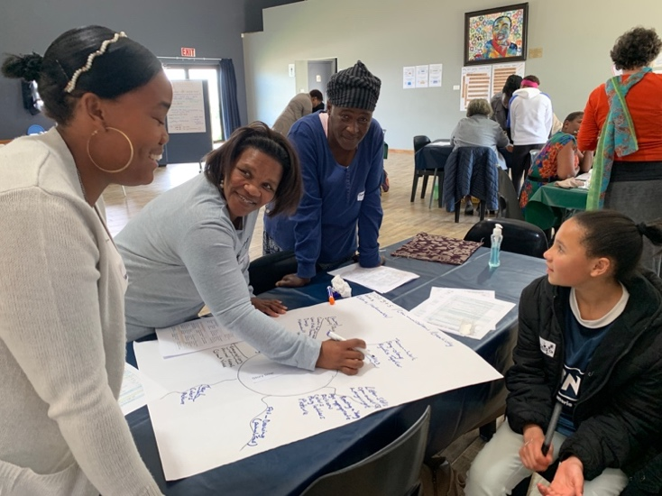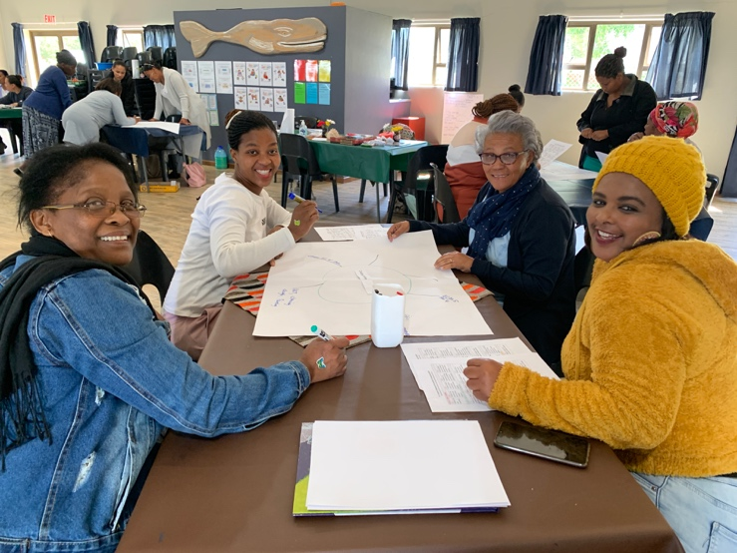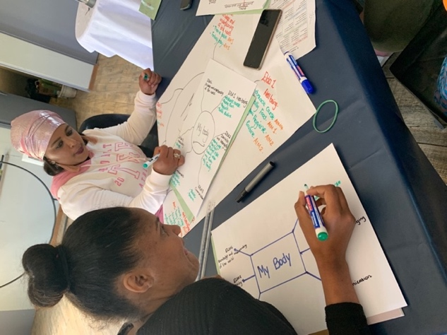

Photos 6 & 7: Kouga A+ apprentice facilitators, Nomalungelo, Aletta Korkee, and Felicity Toll assisting and co-facilitating with the Africa A+ team
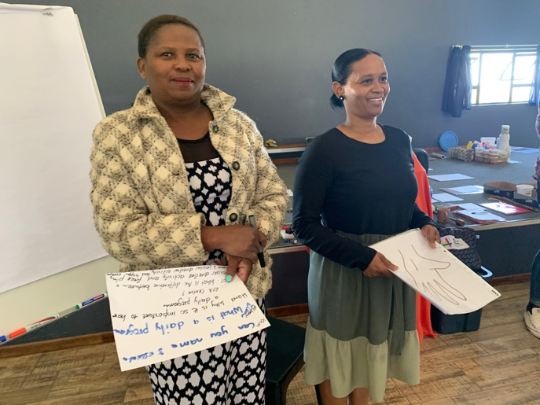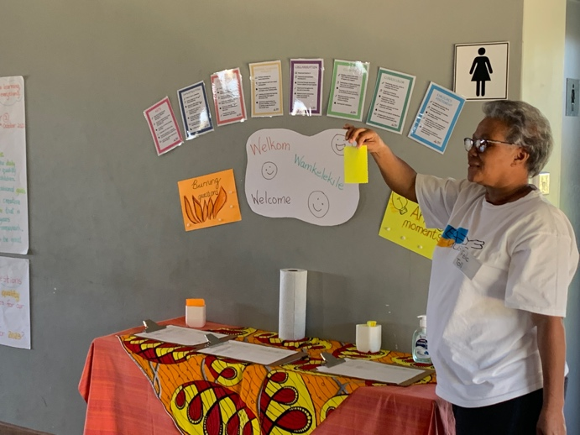

Photo 8: Participant s getting in touch with their own creativity.
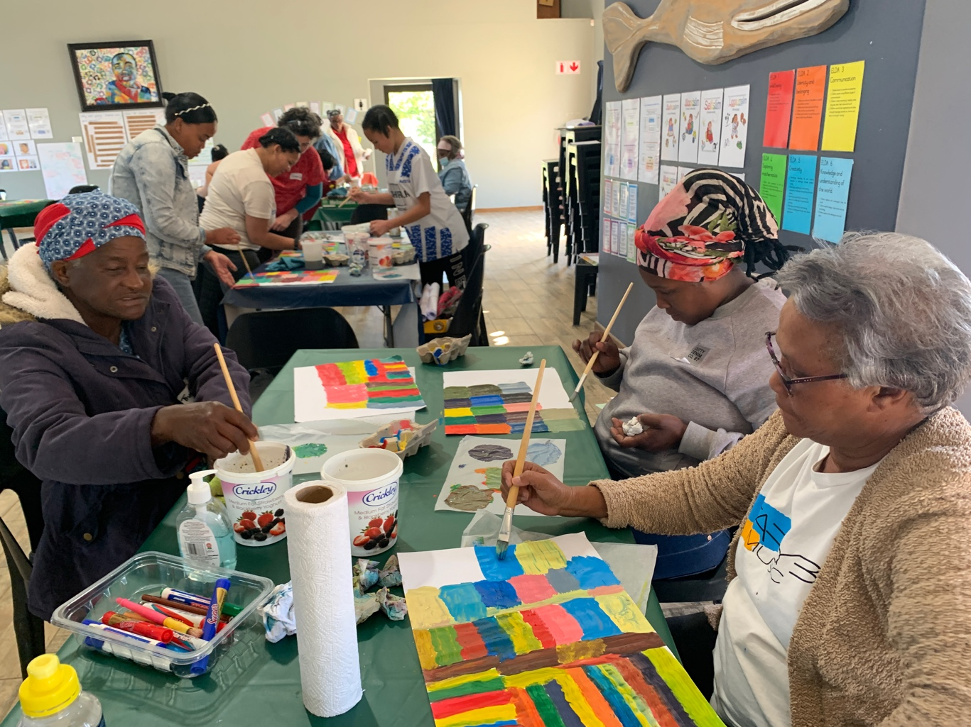

Photo 9: The Cohort 1 participants show their Maths Up poster books donated by Cally Cuhne
from RedInk.
