Africa A+ facilitated a three day Spring Conference for 11 of the Cohort 2 preschools participating in the Kouga Windfarm Trust ECD project in the Eastern Cape, South Africa. The conference was facilitated by two A+ facilitators and attended by 29 principals and teachers. Five Kouga apprentice facilitators assisted and co-facilitated as part of their training. Each day started at 8.30am with registration and ended at 4pm. The focus for the three days was on:
- Revisiting the A+ Essentials: Arts, Climate, Experiential Learning, Curriculum, Enriched Assessment, Infrastructure, Multiple Learning Pathways and Collaboration
- Nurturing creativity through the arts. A+ believes that teachers are more likely to nurture the children’s creativity when they are in touch with and enjoying their own creativity
- Getting ready for 2023 by setting personal and professional goals, and planning early learning activities linked to the aims of the 0 – 4 years National Curriculum Framework.

Comments written by the participants on their reflection forms in response to the following question “What has changed since you joined A+?”
- I have learned so many things that I never could have thought of (Nicolette)
- Jy kom leeg en jy gaan weg altyd vol (You come empty and you always go away full) (Natashia)
- I have learned a lot and have also learned to give children opportunities to be creative (Anon)
- Positief te dink (To think positively) (Susan)
- My critical thinking evolved and expanded (Carla)
- During an exercise where participants were invited to reflect in writing on what stops them being creative, anonymously, the following note emerged: “Art stopped me from be creative. I never thought to do art was part of exploring and collaboration and that you can make something out of nothing. What stops you from being creative in your ECD? “Nothing, cause kids will love it”

The highlights of the Cohort 2 Spring Conference were the participant’s enthusiasm, enjoyment, willingness to try new learning experiences and their growing confidence and creativity. Carole Scott’s activity on ‘loose parts’ had participants working together, using their imagination, problem-solving and creating with recyclables. Trevor Arosi and Prince Matsoni from the Windfarm Trust paid a visit on Day 2. All the participants received a story book and a Maths Up poster book donated by author Reviva Shermbrucker and by Cally Cuhne from RedInk. Creative sessions by guest artists, Kezia Gerber and Sharon Welman, put the participants in touch with and enjoying their own creativity. The collaborative nature and creative possibilities that the art activities offered, enabled extremely shy participants to blossom towards the end of the three days, and the therapeutic nature of Kezia Gerber’s art approach touched many hearts, showing once again the power of creativity.

The challenges were the power outages that disrupted video and slide presentations, music activities, and catering. Humansdorp was a safe community until gang activities and a turf war emerged this year. Six young men from local families were killed during the week of the Spring Conferences. The high turnover of teachers at ECD centres (particularly in poorer schools where salaries are low) continues to undermine implementation of training. A+ plans to support principals next year in how to facilitate staff development with new, unqualified and inexperienced staff.

Photos taken on the 3rd and 4th October during the Spring Conference:

Photos 1 & 2. Participants revisited the A+ Essentials
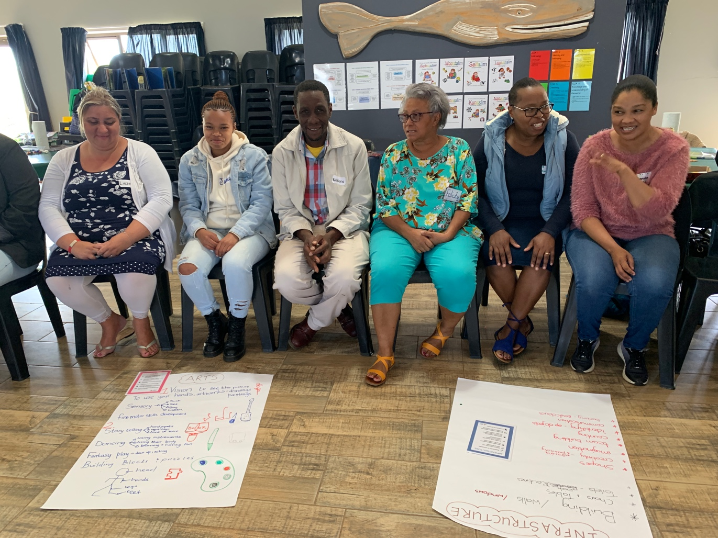
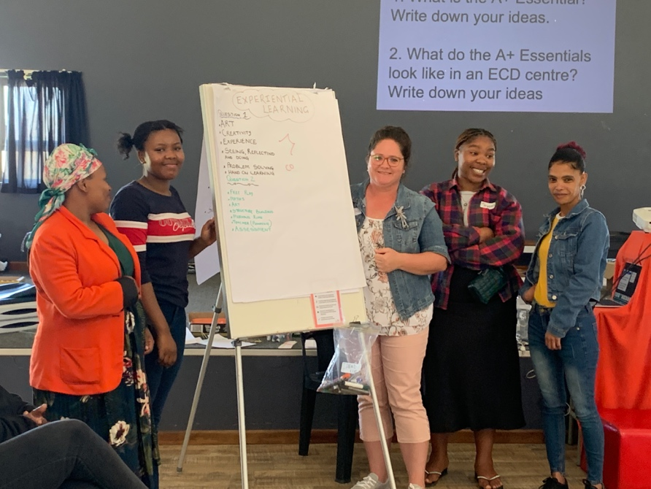

Photo 3-5: Participants getting in touch with their creativity and imagination by creating patterns with natural materials. Collaborating in pairs gave opportunity to get to know each other well and gave way to confidence and blossoming creativity.
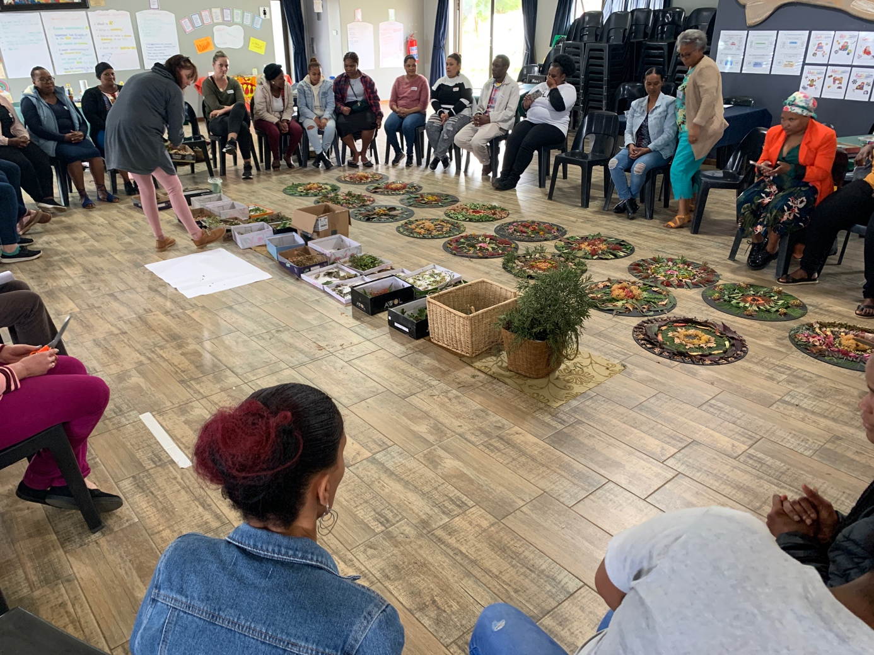

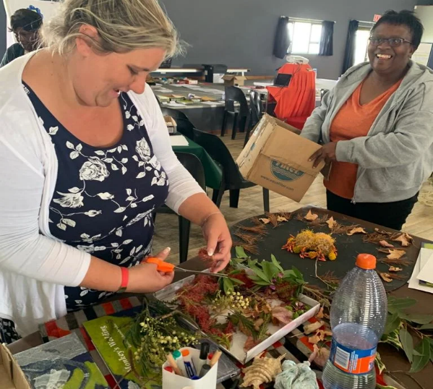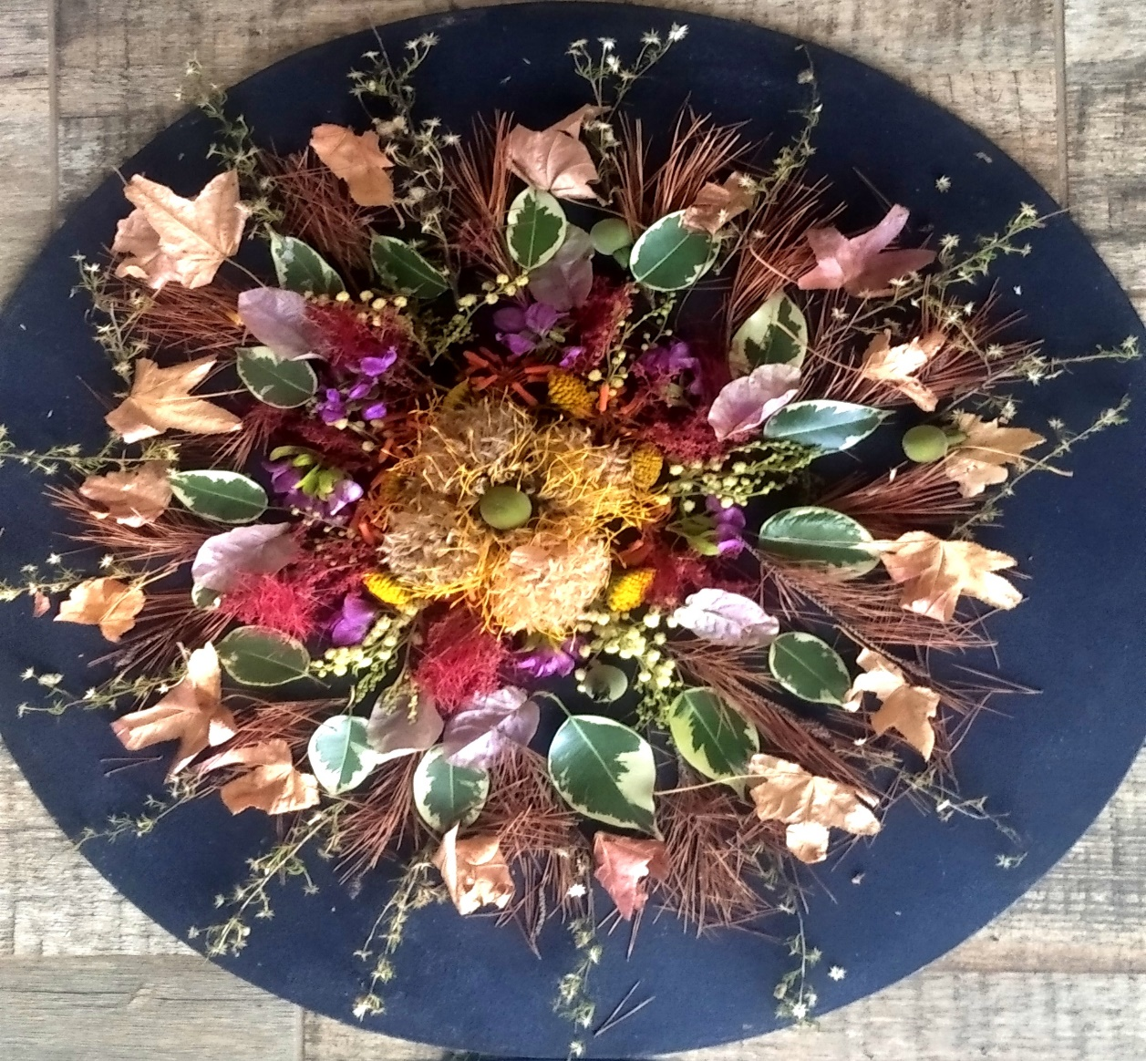

Photos 6 & 7: Carole Scott facilitated a session on working with ‘loose parts’. The purpose of the session was to get the participants exercising their imagination, problem-soving ,and teamwork skills.
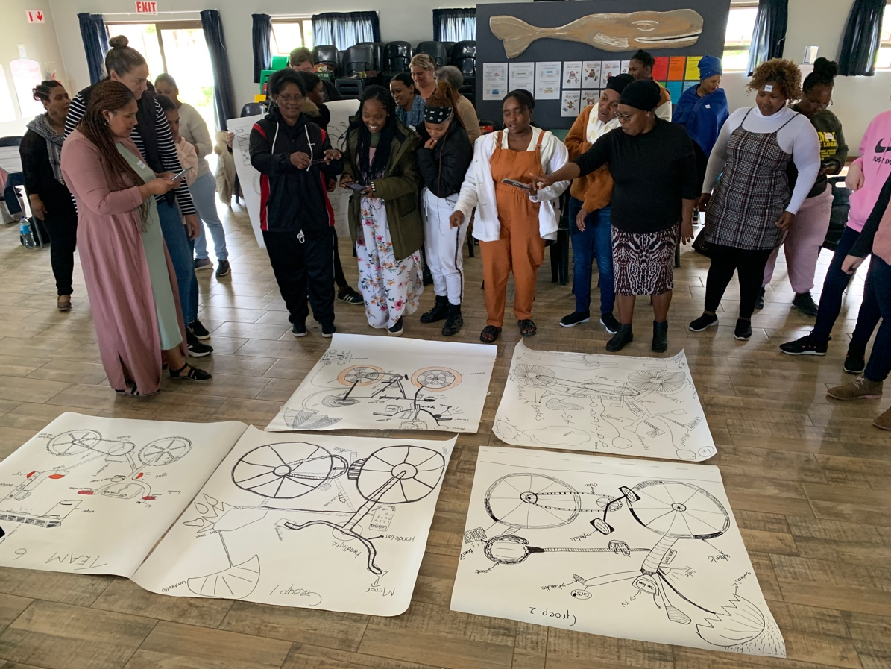
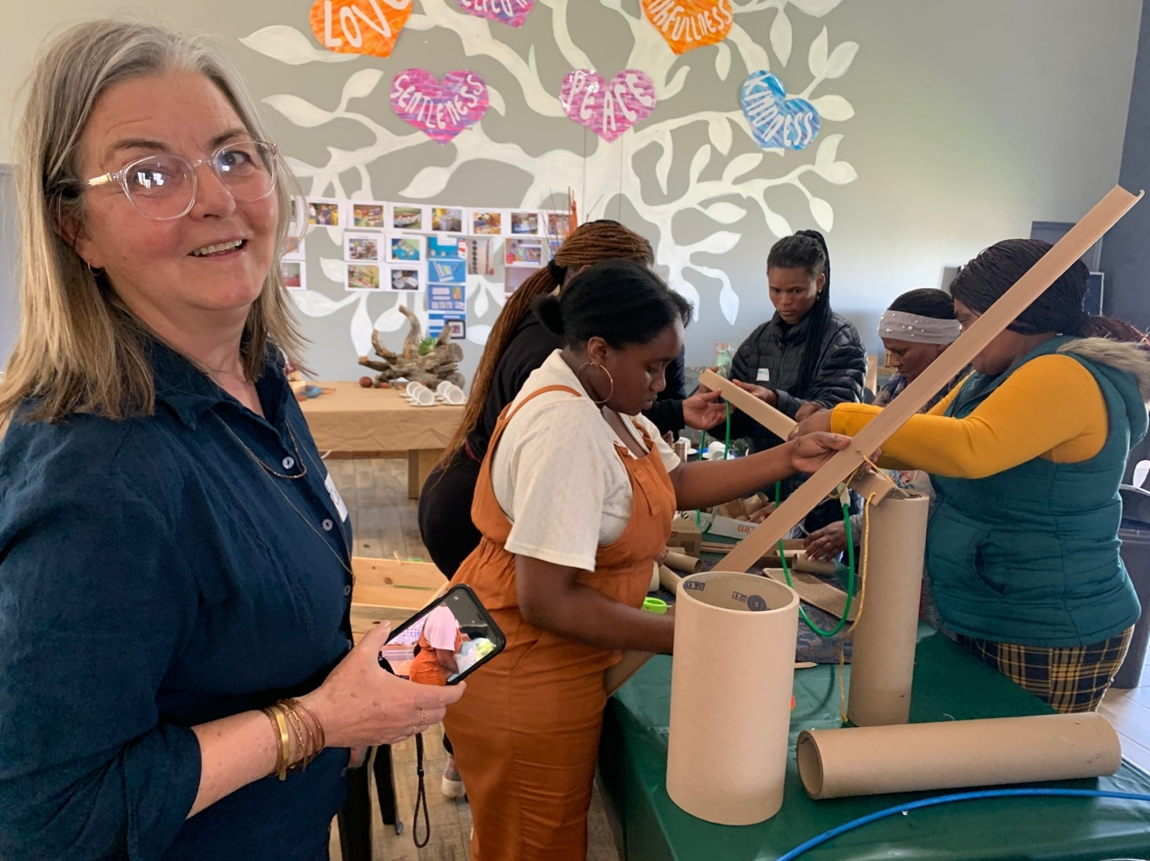

Photos 6 & 7: Participants working together tp create an ECD classroom from scratch using recyclables.
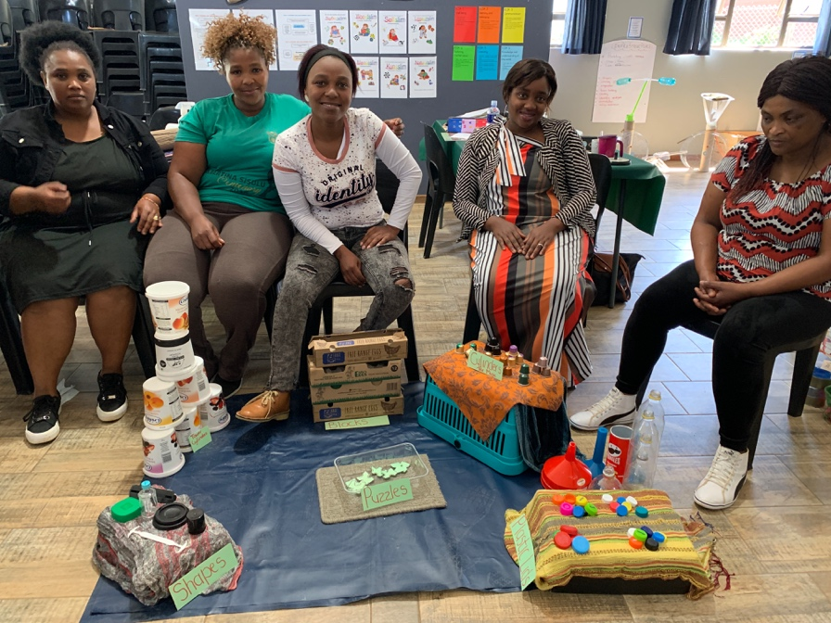
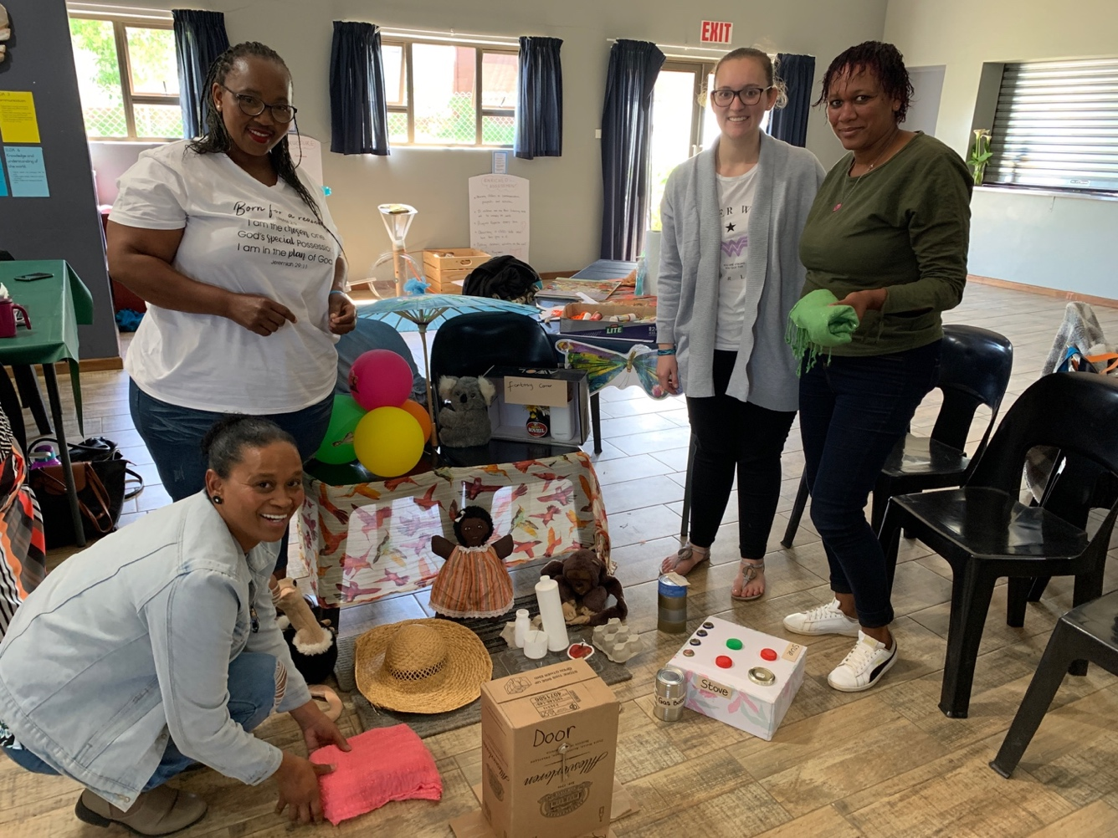

Photos 8 & 9: Getting creative with guest artists, Kezia Gerber and Sharon Welman.
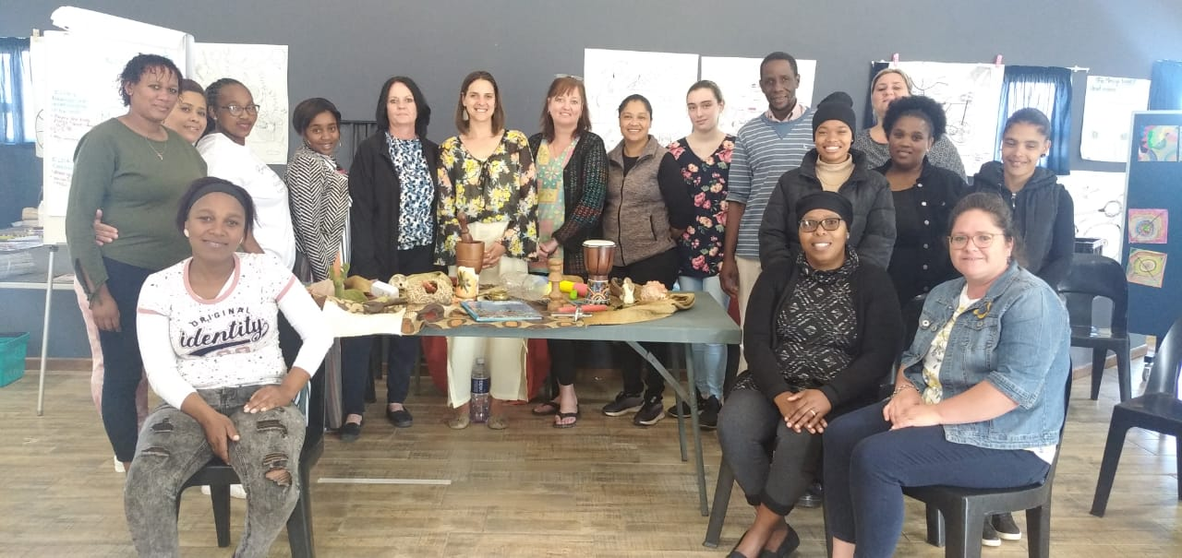
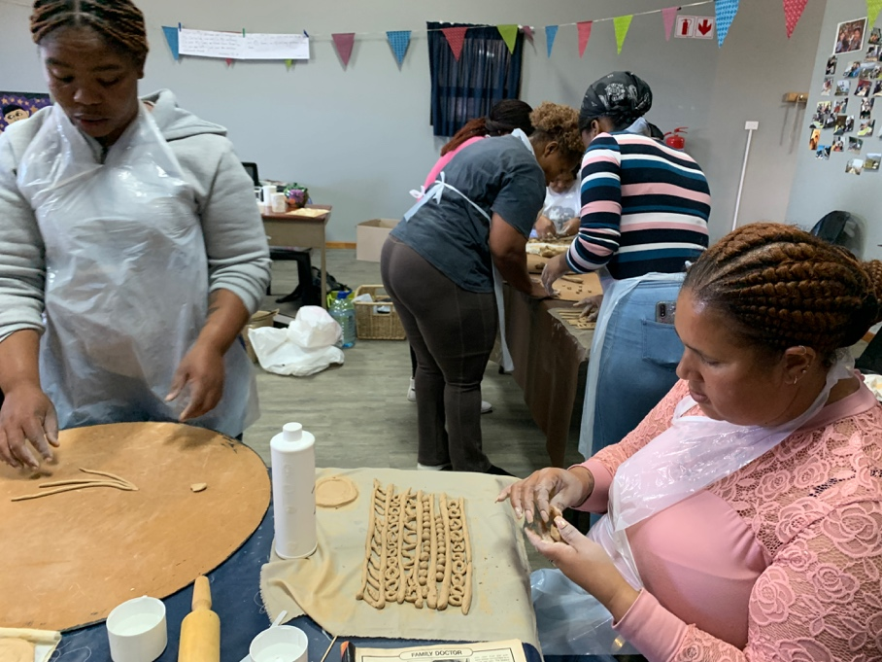

Photo 10: Cohort 3 participants at the Spring Conference.
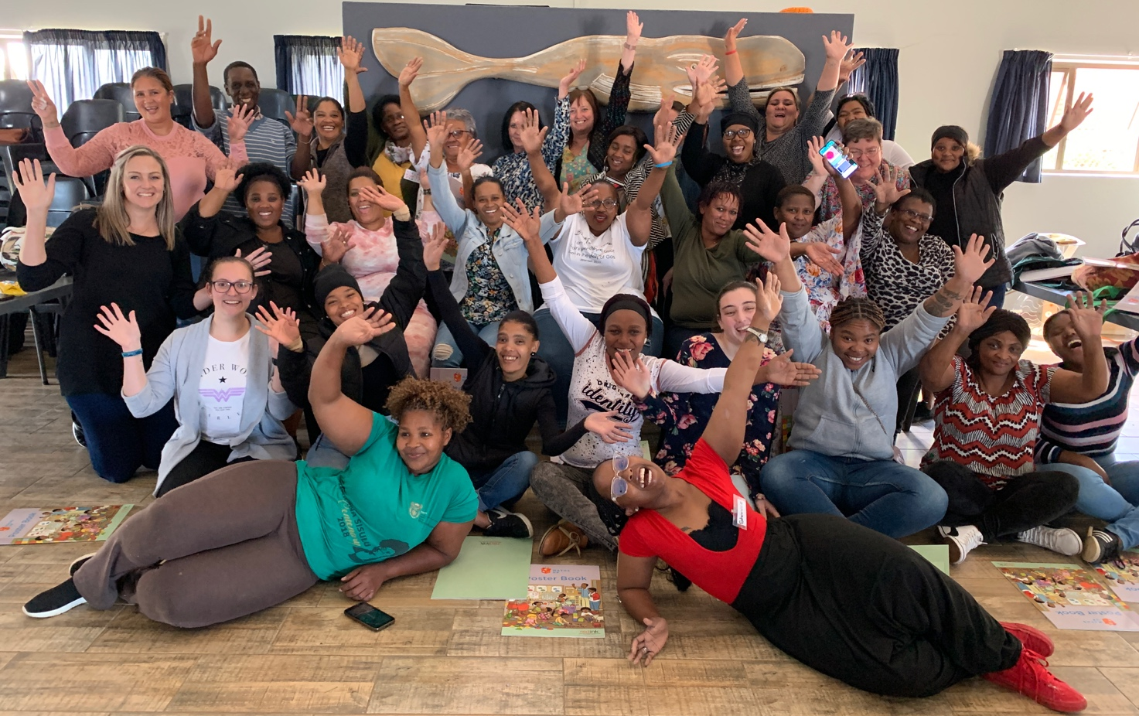

Photo 11: Apprentice facilitators, Nomalongelo, Aletta Korkee, Natashia Visagie, Elsie Vermaak and Felicity Toll, assisted and co-facilitated during the three day Spring Conference.
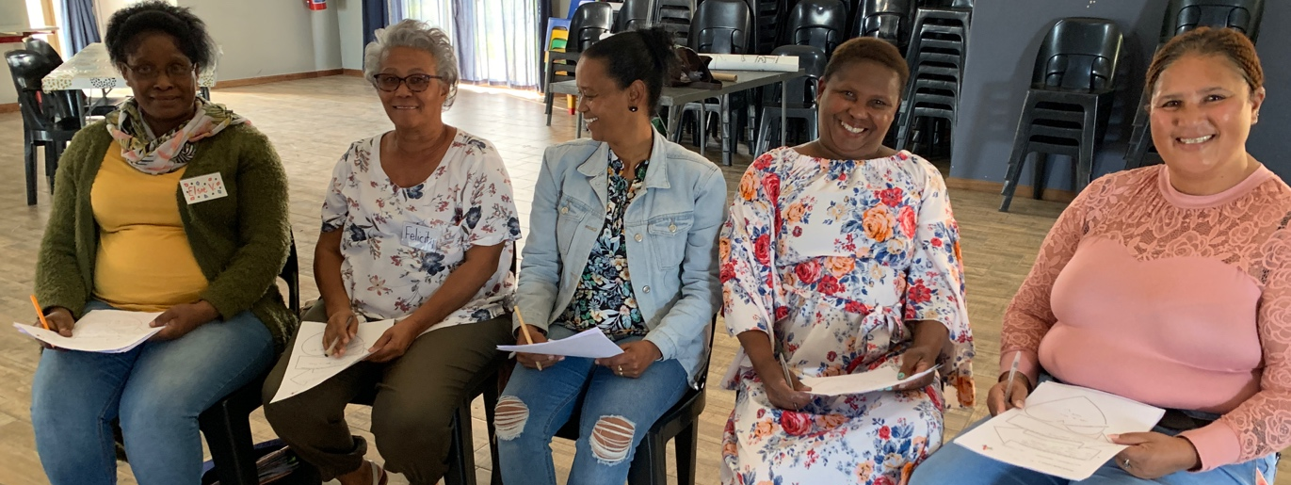

Photo 12: Working collaborative and creatively
