Africa A+ field trip: March 2023
The Africa A+ team completed their second 2023 field trip to Kouga in the Eastern Cape. The field trip activities included on-site visits to and demonstrations at … ECD centres, two ECD workshops for the Cohort 2 schools, one workshop each for the Cohort 1 and Cohort 3 ECD centre staff. During the trip Henry Dillon and the crew from Crayon Room spent a day recording A+ in action (the video will be posted when it is finalised.) The field trip activities are outlined below:

1) Facilitators’ learning session (27th March)
The Kouga facilitator’s three hour learning session takes place each field trip and is integral to developing a team of local facilitators who will continue to support the ECD centres after the Kouga Wind Farm ECD project has ended and A+ is no longer there.

2) A Stakeholders’ meeting (29th March)
The Centre for Early Childhood Development and A+ facilitated a stakeholders meeting at the Victory4All hall in Humansdorp. The purpose of the meeting was to provide a progress update on the Kouga Wind Farm ECD project. The meeting was attended by Prince Matsoni from the Wind Farm Trust, representatives from the Eastern Cape Education Department, community members, and the principals from the 39 ECD centres participating in the Wind Farm ECD project.
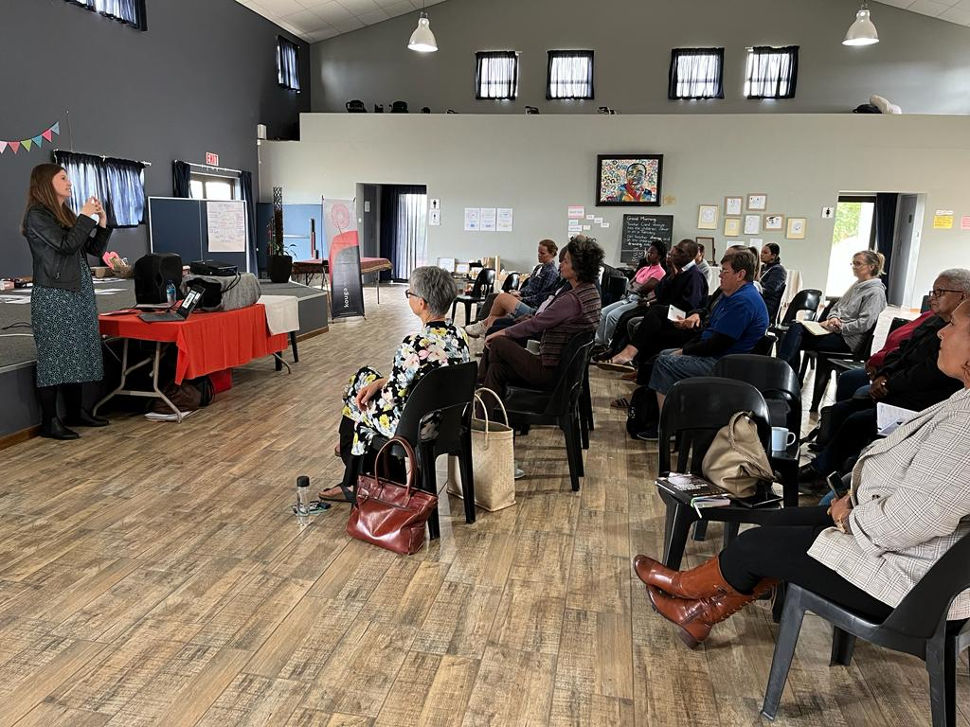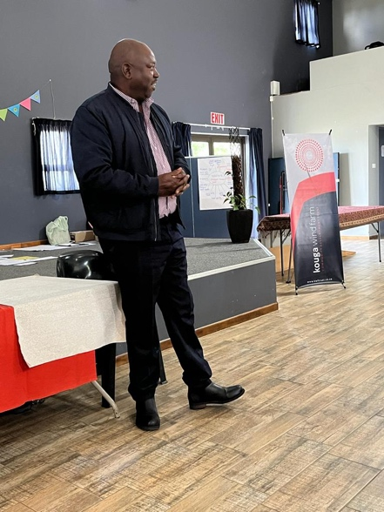

3) Cohort 1 workshops (30th March)
The focus of the workshop was about thinking critically about child development, the importance of play, and agency in children and teachers. The notion of agency was challenging but it made the participants think about themselves and their role in terms of children’s success. A participant wrote after the Cohort 1 workshop “I love the way A Plus teaches us. It’s perfect. Thumbs up.”
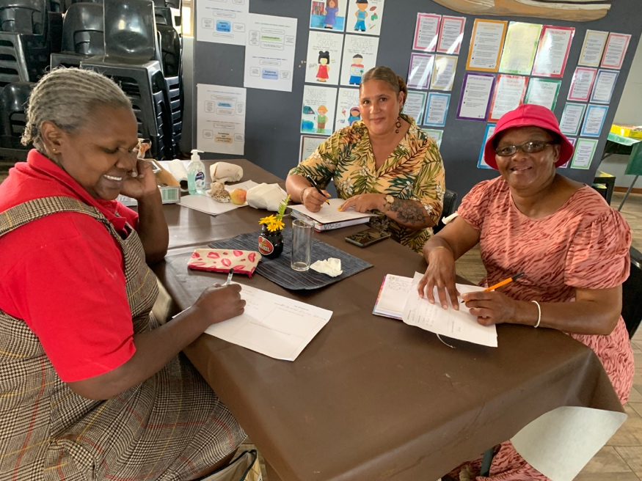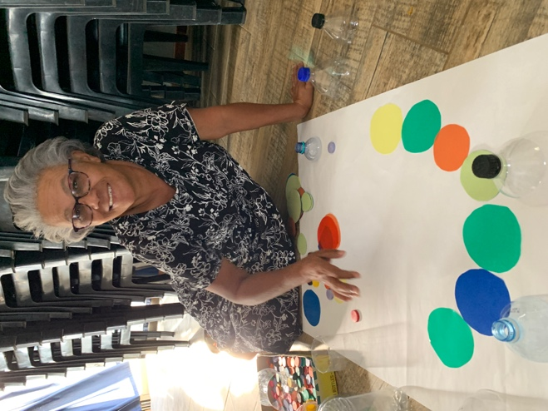

4) Cohort 3 workshop (30th March)
25 ECD principals and teachers attended the workshop at the Victory4All hall. The focus was on facilitating the children’s learning and creativity using loose parts. Participants first enjoyed getting in touch with their own creativity before planning ‘loose parts’ activities for children linked to the aims of the 0 – 4 years National Curriculum Framework (NCF).
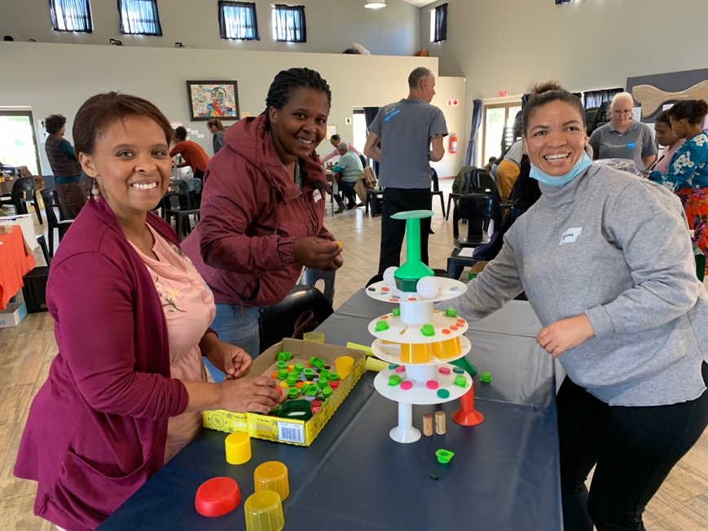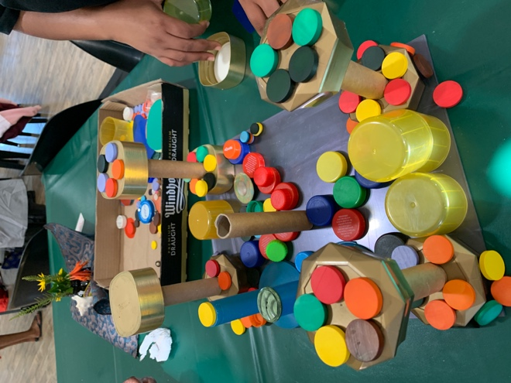
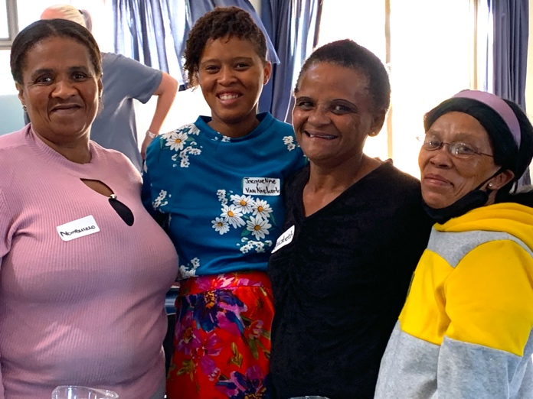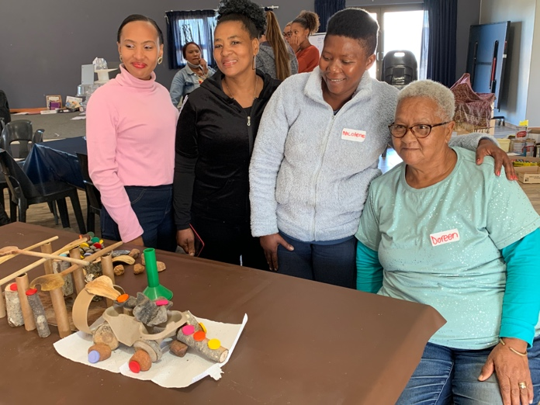
The Cohort 3 participants wrote the following reflections after the workshop:
- I used to think …” Loospart [loose parts] are just a bit of rubbish/dirt.” But I now think … That loospart are very learning full.”
- I used to think …. Teaching its hard.” But now I think … “it is not hard.”
- The most important thing about today was …. “Dit was baie indrikweking om nuut te wees en so baie geleer.” [it was impressive to be new and learn so much]
- The most important thing about today was …. “Learning how to use loose parts; be creative, thinking out of the box; incorporating loose parts as part of learning programme; in almost any or more than one area of the daily programme and NCF.”

5) Cohort 2 workshops (31st March & 1st April)
Cohort 2 is a large group; 48 participants attended one of the two workshops provided by A+. The focus was on how to facilitate the children’s learning and creativity using ‘loose parts’. Loose parts are a collection of found, recycled and discarded materials that A+ has collected and distributes to ECD centres for play-based teaching and learning.
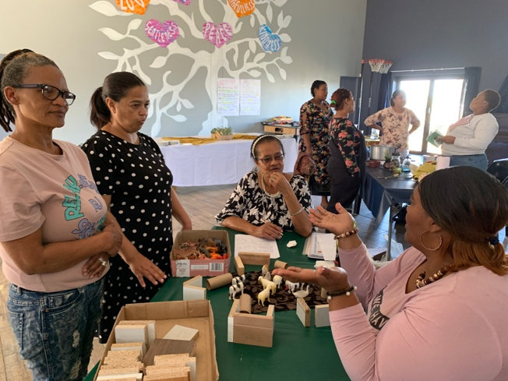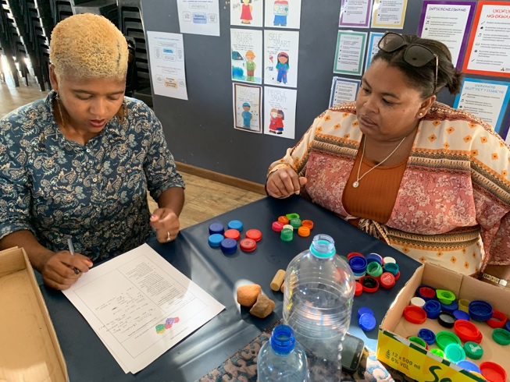
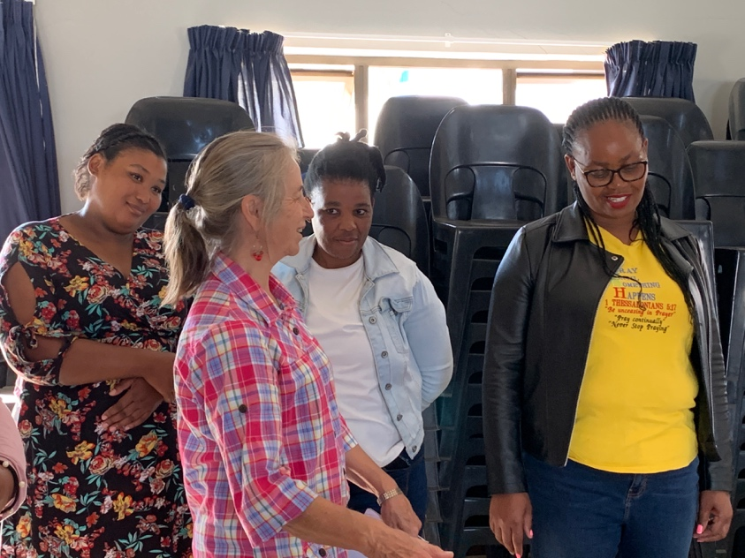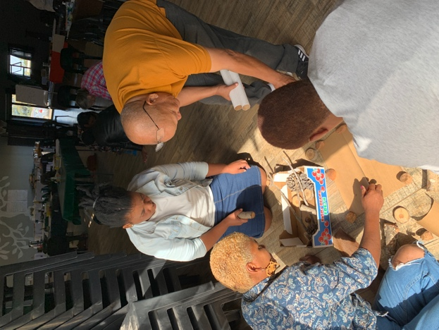

Some of the reflection comments written by the Cohort 2 participants:
      - I used to think … “I had to lead all the time – tell children what to do. My way or the highway”. But now I think …. “give learners the opportunity to lead, only guide”
      - I used to think … “to put children in boxes and to put a child into MY ideas and my line of work”. But now I think ... ”That it is okay to give them room to be creative and let there be ‘chaoos’ but in an orderly manner. I can still be in charge …”
      - I used to think … “That things [loose parts] that are used are rubbish and threw them away.” But I now think …. “That it can be used in so many valuable ways. That it makes learning so much interesting.”
      - The most important thing about today was …. “For the first time I learn allot. It was very interesting and excited to learn so many things I did not know”.
      - The most important thing about today was … ”learning how to get child to use his or her own mind to create something and to think out of the box.”

5) On-site visits to ECD centres (28th - 31st March)
The A+ and Kouga faciliators are now working together in terms of visiting ECD centres, helping the ECD staff to set up a stimulating learning environment, and demonstrating play-based learning activities with the children.
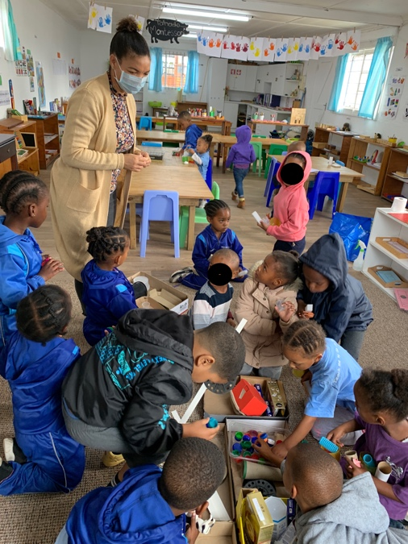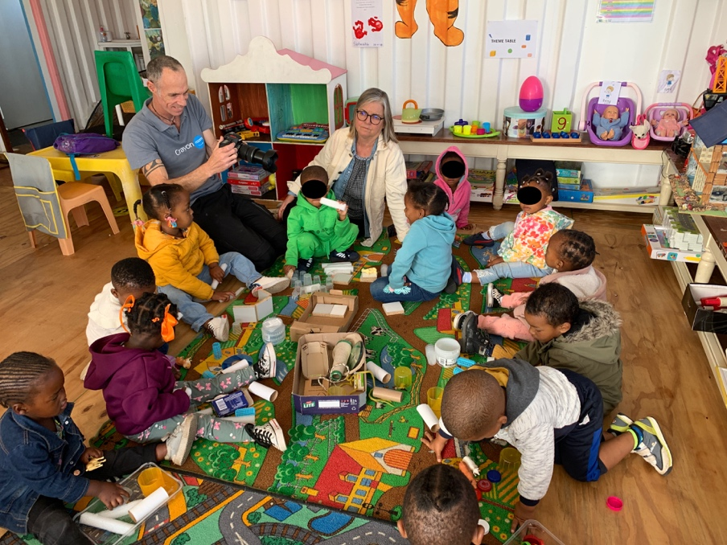

Highlights and challenges during Field Trip 5:
Highlights:
- Changing habits and mindsets takes time. It is exciting to see changes being implemented as a result of the workshops and on-site support. 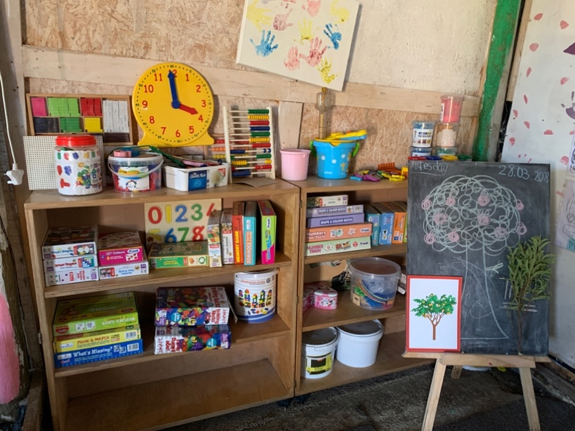 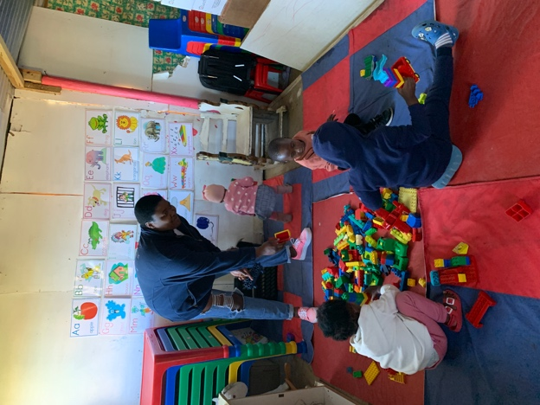

- It is encouraging to see teachers getting in touch with their own creativity and using the things in their environment to plan stimulating learning activities for children.
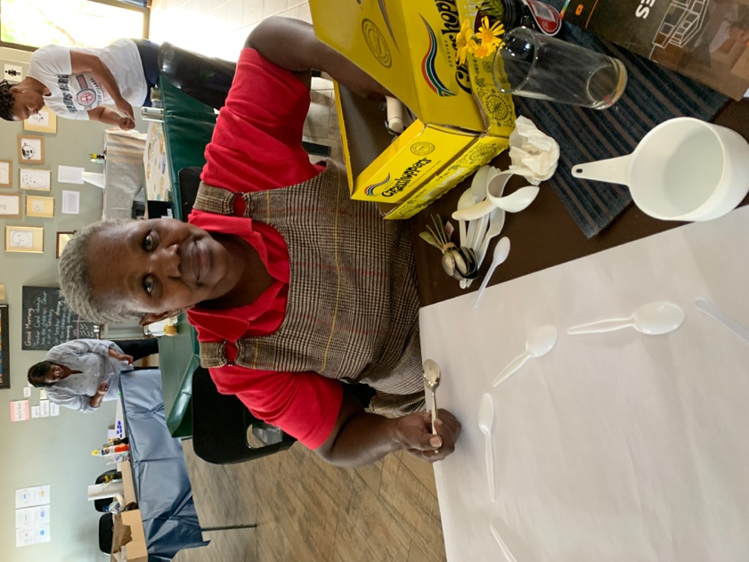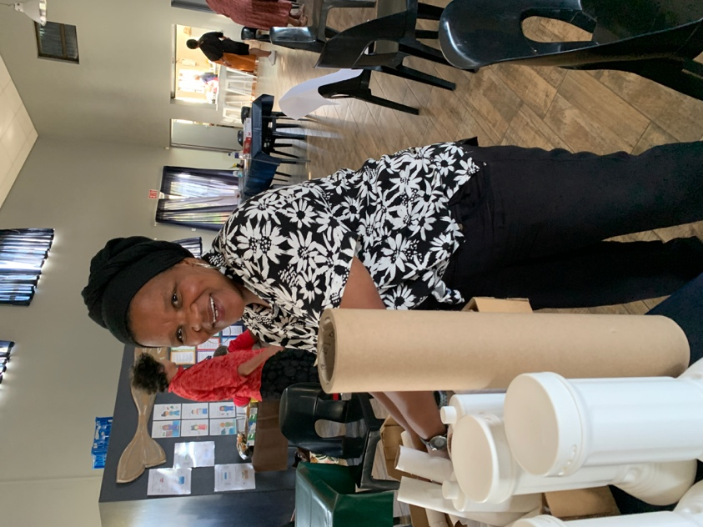

- The Kouga principals and teachers have developed into an ECD community who share and support each other. There is a joyful camaraderie and enthusiasm at the workshops.
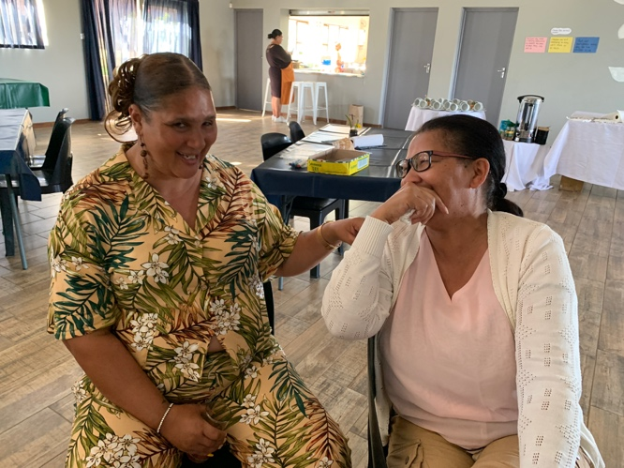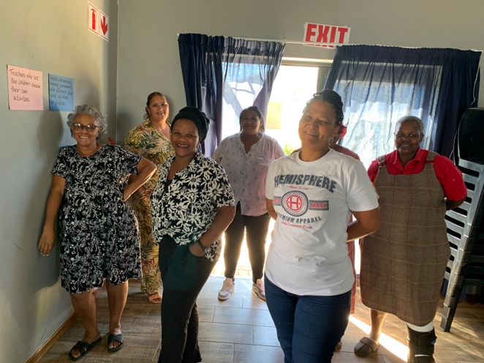

Challenges:
- Some ECD centres are slower to implement change. A+ encourages implementation by working alongside the staff to create a stimulating play-based learning environment.
Before: children waiting with nothing to do
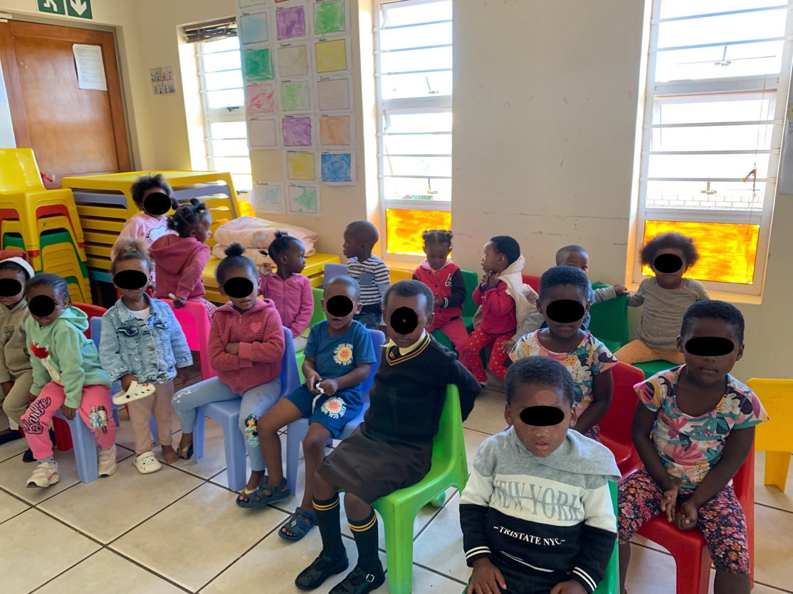

After: A+ and the teacher have created an inviting and stimulating learning environment where children can make choices and learn through play. The teacher understands that every minute is a learning and teaching opportunity.
