Africa A+ field trip: May 2023
The Africa A+ team completed their third 2023 field trip to the Eastern Cape. The field trip activities included a training session for the Kouga facilitators, facilitating four early childhood development (ECD) workshops at the Victory4All hall in Humansdorp, and on-site support visits to 15 ECD centres.

1) Facilitators’ learning session (15th May)
The Kouga Facilitators’ in training visited two model ECD sites, Talhado Montessori and Disney Centre, in Sea Vista, St Francis Bay. After identifing elements of a model site, the facilitators planned how to support the Kouga ECD centres in their care so that they can move nearer to being model sites no matter the context they find themselves in.
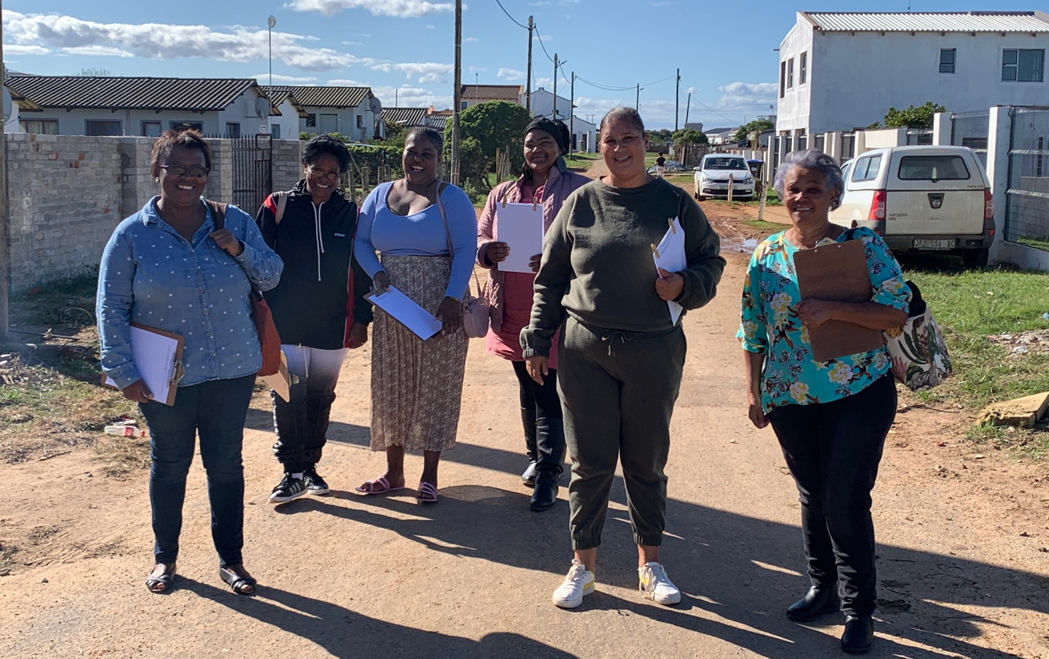
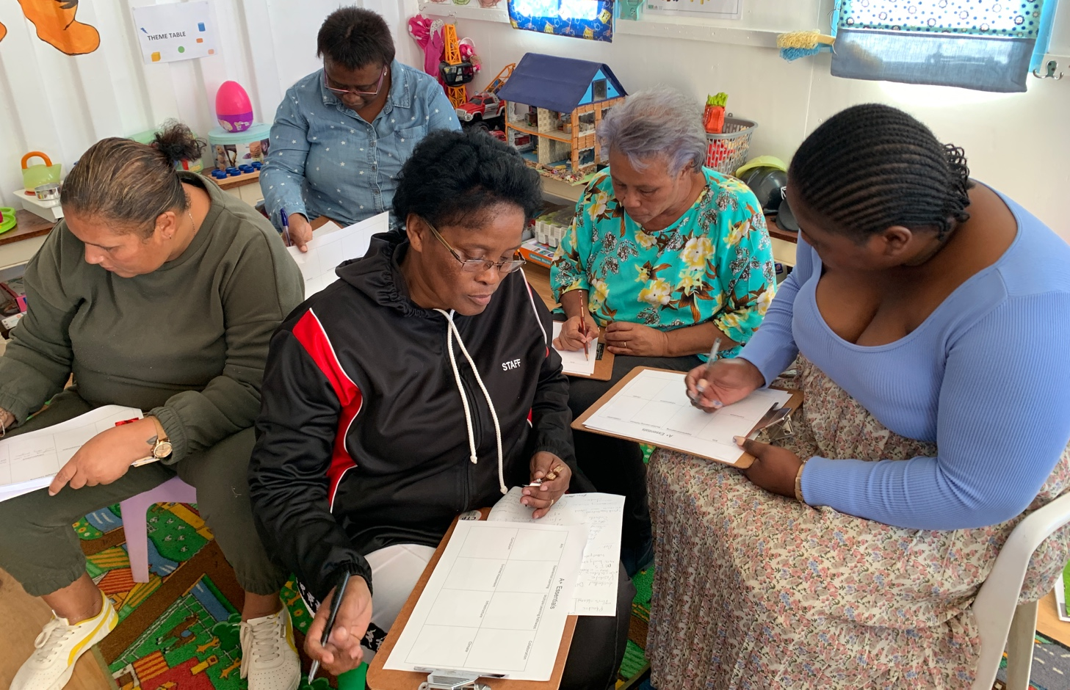

2) Introduction to using technology in the an ECD setting (16th May)
The GROW with ECD facilitators introduced a small group of ECD principals to their data free app, Giraffe https://www.growecd.org.za/quality-education-programme/?gclid=CjwKCAjw67ajBhAVEiwA2g_jEASlAouAav3UiL2PCnazNp8u48vBGWroX-nmb85DdD6gYMoE_n8JdRoCaP4QAvD_BwE
Comments written by the participants in their own words after the GROW workshop:
- That technology will make my admin much easier and that I will be able to involve my teachers as well.”
- “THERE IS AN EASIER WAY! ADMIN CAN BE FUN!”
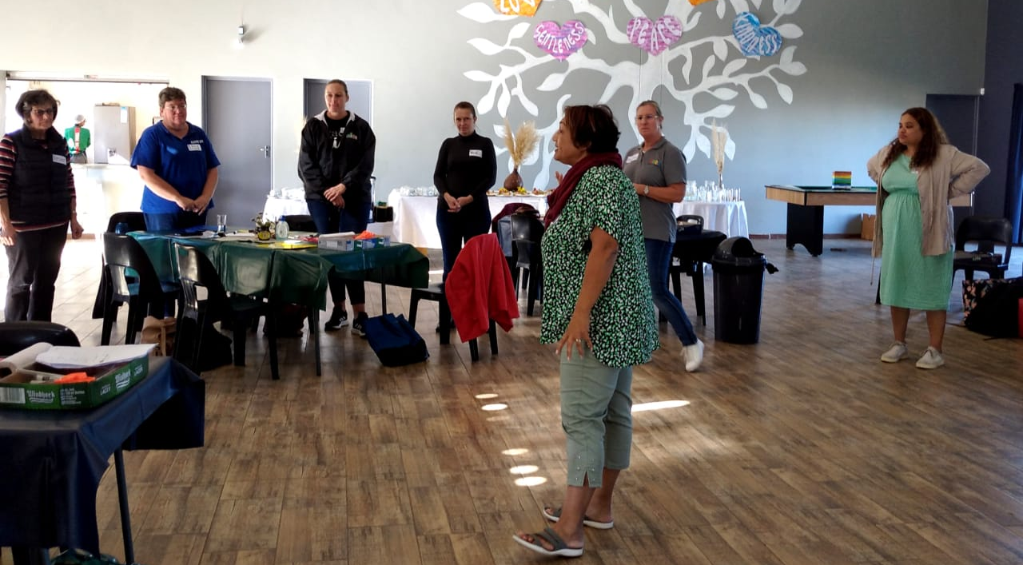

3) Cohort 1 workshop (17th May)
Principals and teachers from 6 Cohort 1 ECD centres attended the three hour afternoon workshop Two Kouga facilitators and two new ECD centres, Star Kids and Imizamo Yethu, also attended the workshop.
Comments written by the participants in their own words after the Cohort 1 workshop in response to the question: What are the two most important things you learned today?
- “How the brain develop and How important I as a ECD teacher are in that first five years.”
- “The crucial role we as ECD center facilitators play in early child development. Play can also be educational.”

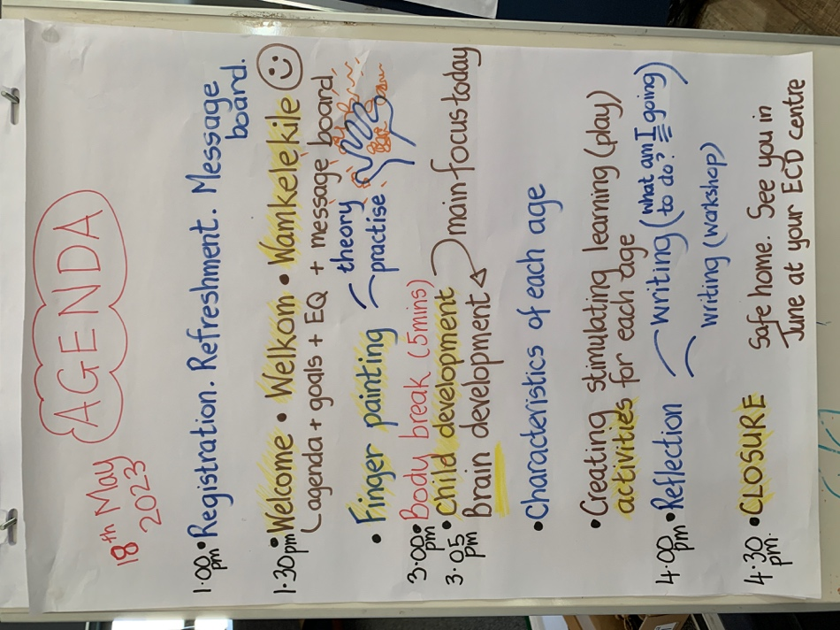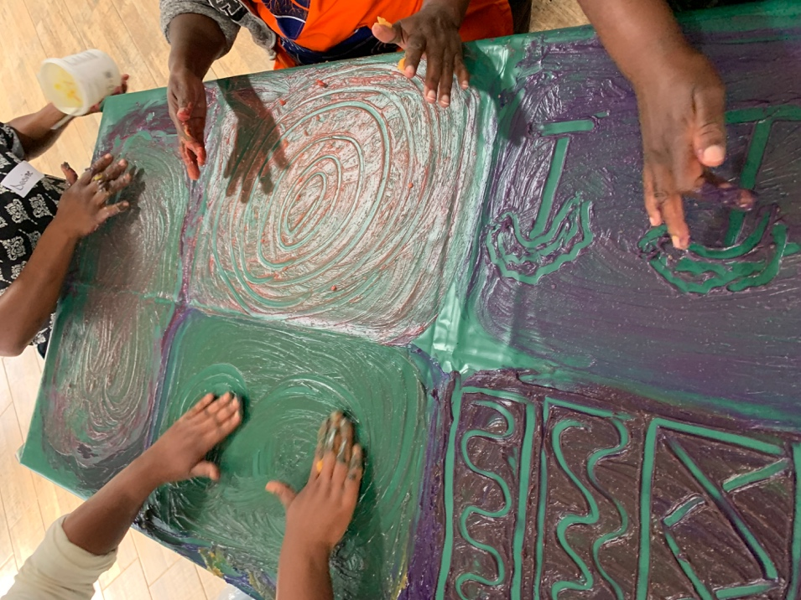
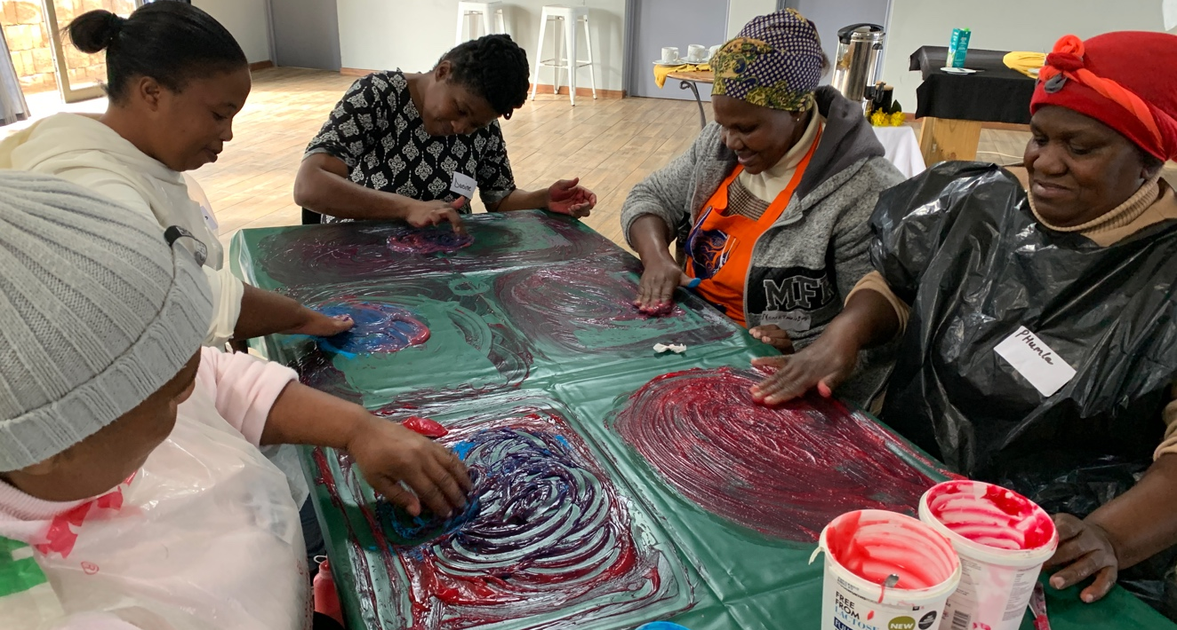
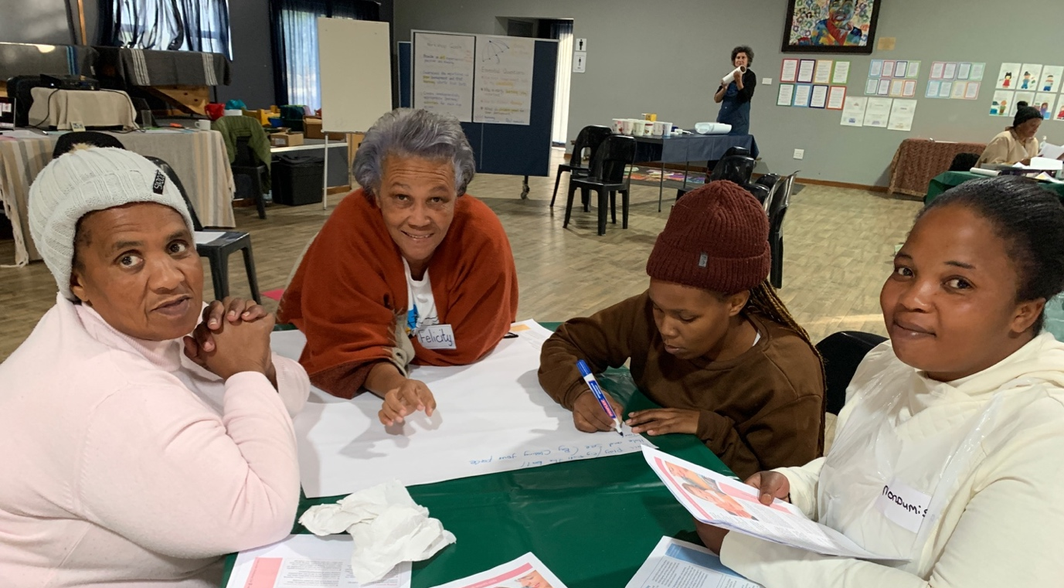
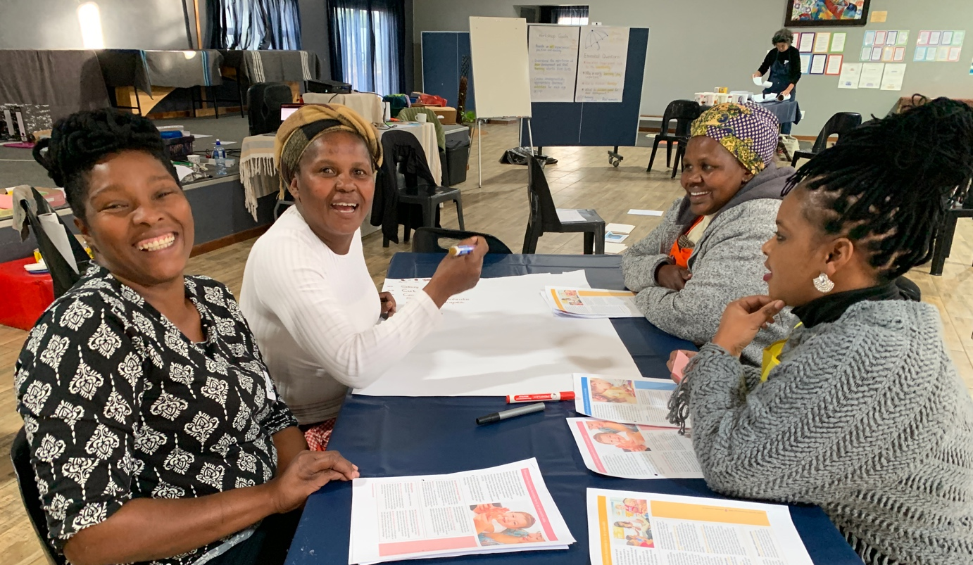

4) Cohort 3 workshop (18th May)
Principals and teachers from 14 ECD centres attended the three hour afternoon workshop. The workshop began with working creatively with fingerpaint before understanding the importance of stimulating children’s brain development in the early years. The participants worked together to create stimulating play-based learning activities for each age group.
Comments written by the participants in their own words after the workshop in response to the following question: What are the two most important things you learned today?:
- “That a child’s brain develop at a very early age. The sooner you start the better.”
- “Die brein moet aanhoudend besig wees al is dit deur speel. Brein sele gaan dood as did nie gebruik word nie.” (The brain must be constantly stimulated through play. Brain cells die if they are not used.)
- “How important even the first few months of their lives are. And how big the impact can be we make on them from Day 1.”

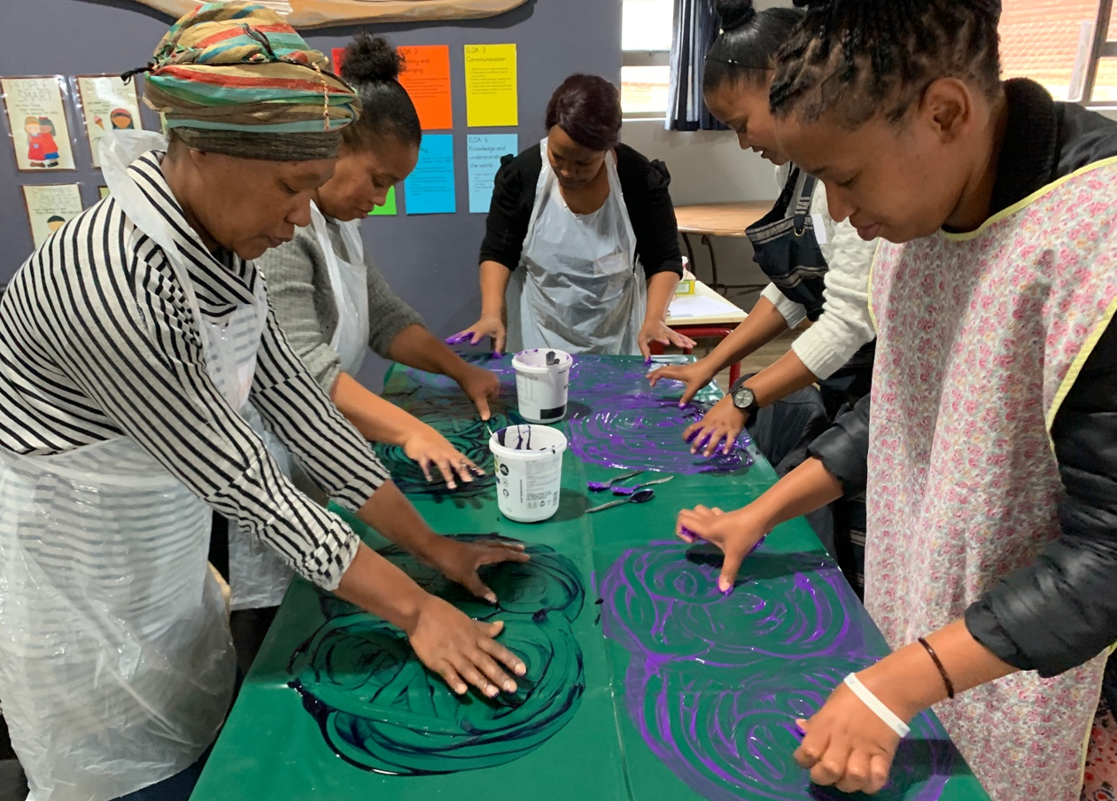

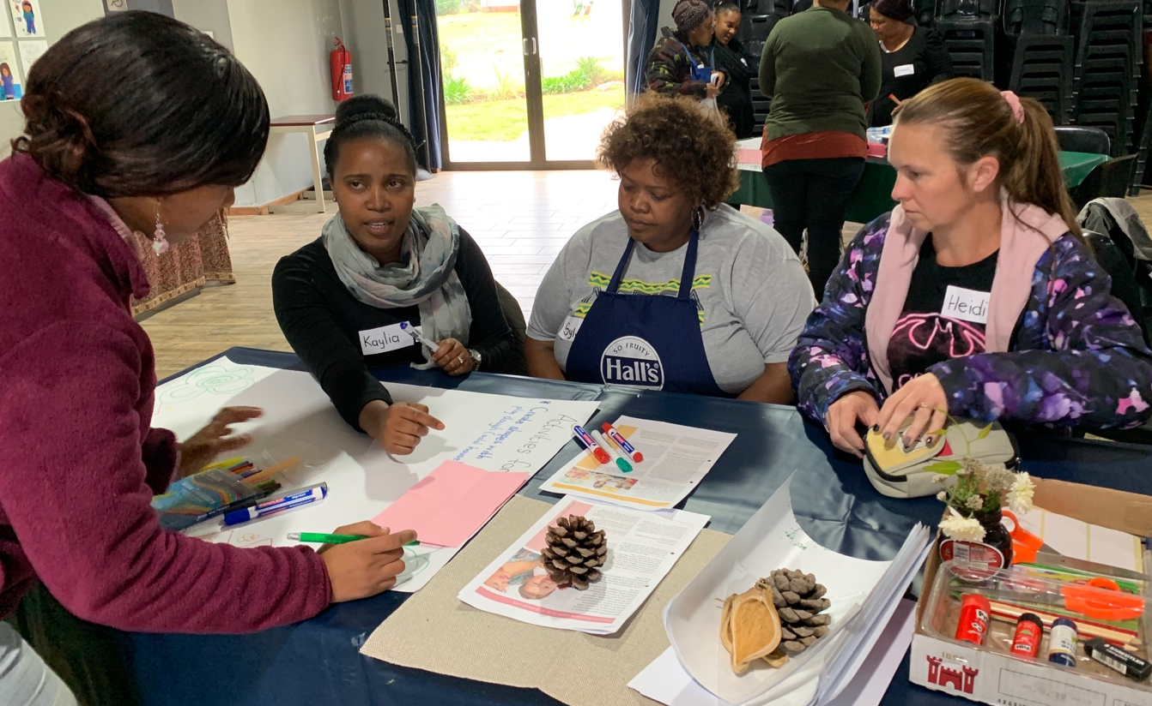

5) Grade R workshop 19th May)
Eleven Grade R teachers attended. Each ECD centre received and were orientated to the Grade R CAPS Home Language curriculum. The teachers learned about emergent literacy before working together to create play-based literacy activities for Grade R children.
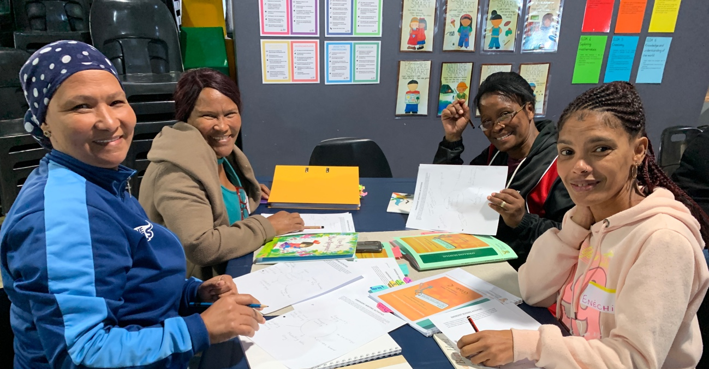
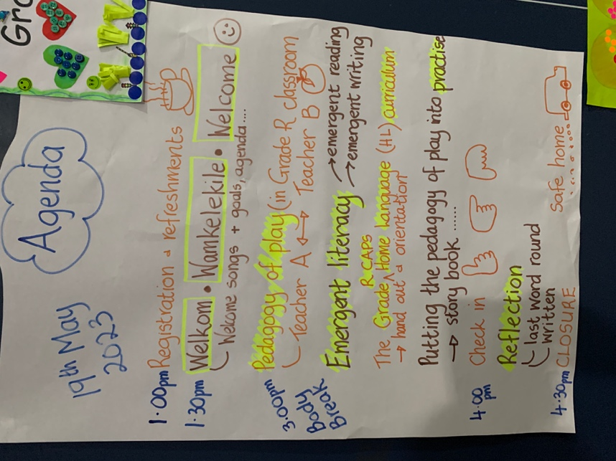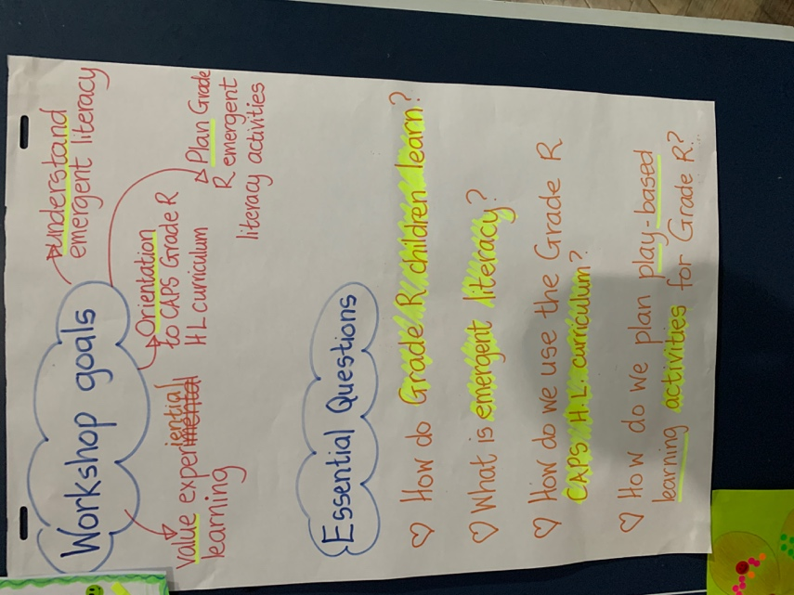
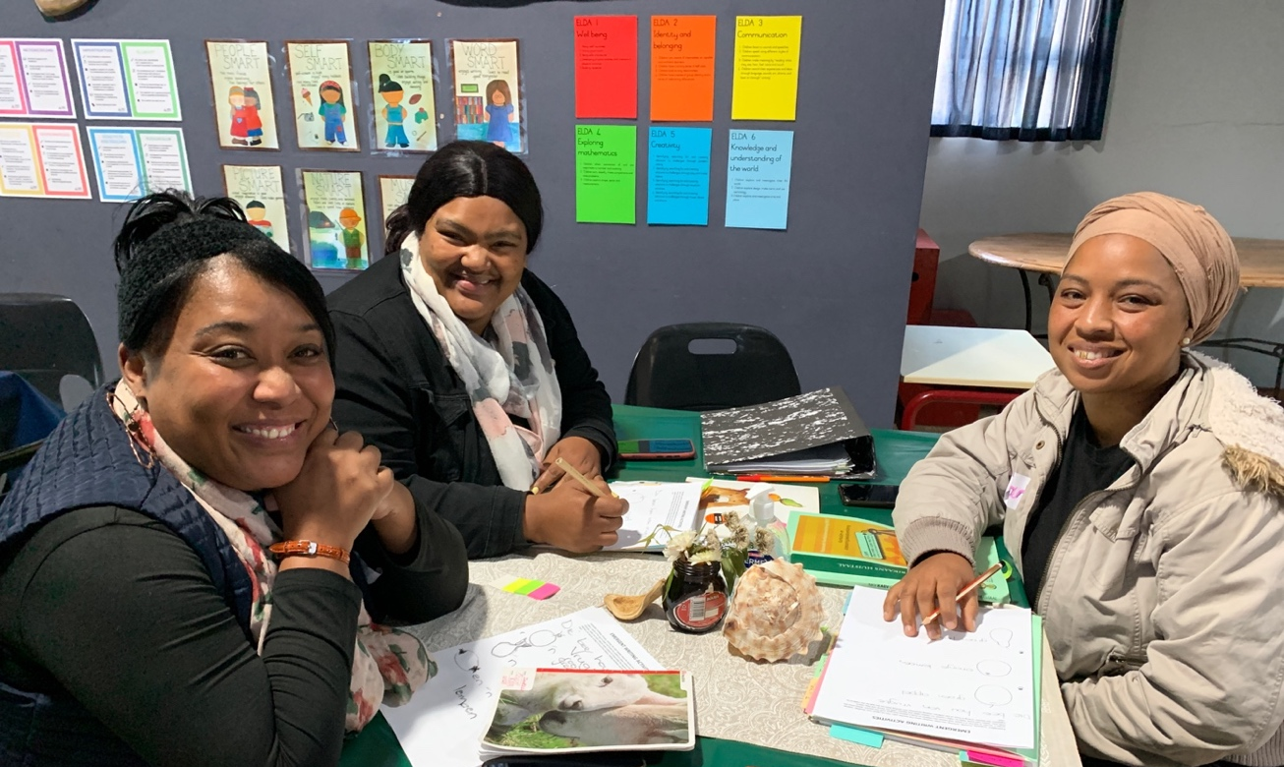
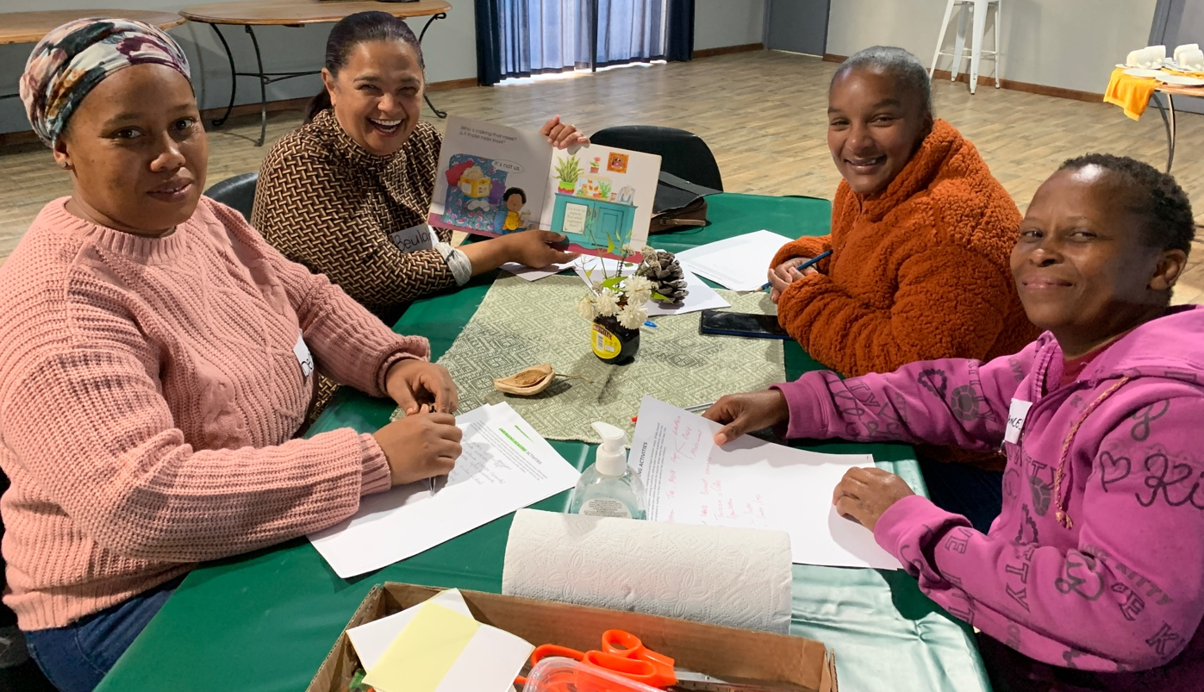

6) On-site visits to ECD centres (15th – 19th May)
Five of the 15 on-site support visits are described below:
- New ECD centres that have recently joined the Kouga Windfarm Trust ECD project:
  - Star Kids
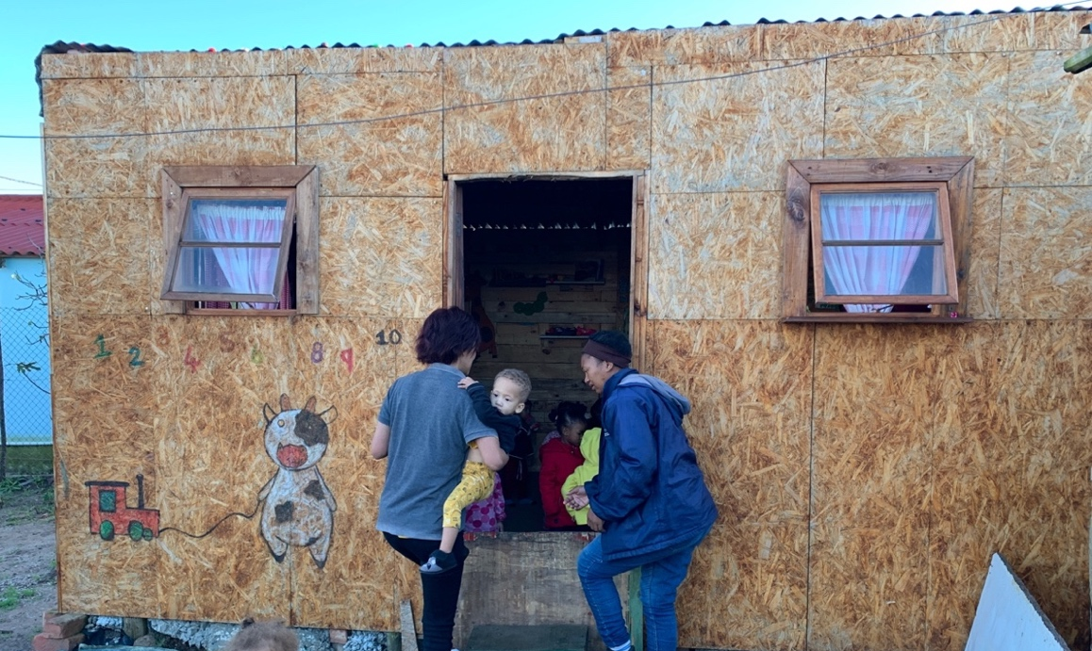

  - Buzzzy Bees
Although Buzzzy Bees has no equipment or toys, the staff can facilitate learning. A+ provided loose parts (recycled, found and discarded materials) and demonstrated how to work with children to get them to work together using their problem-solving, imagination and creative skills.
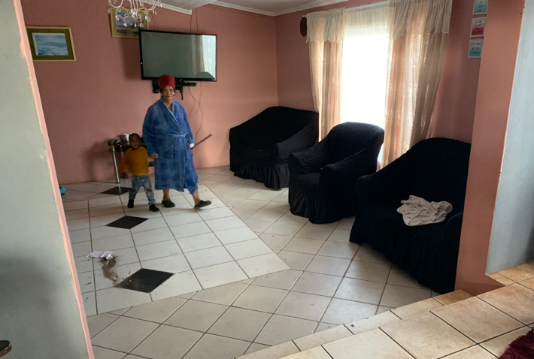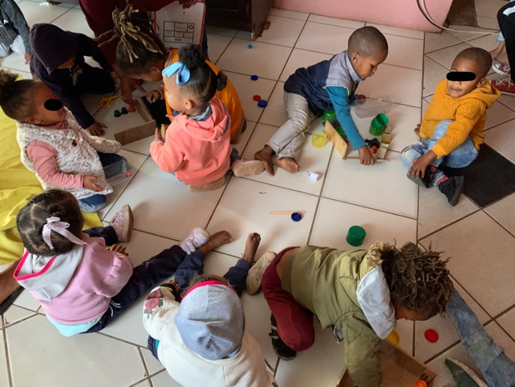

- Precious Pride
Principal, Natasha Blom, has started her own ECD centre. The toys and equipment were provided by the Kouga Windfarm Trust. ‘Loose Parts’ as facilitated by A+ showed Natasha how she could extend the children’s problem-solving, imagination, creativity, communication and collaboration skills.

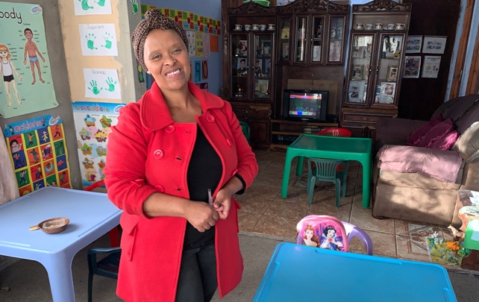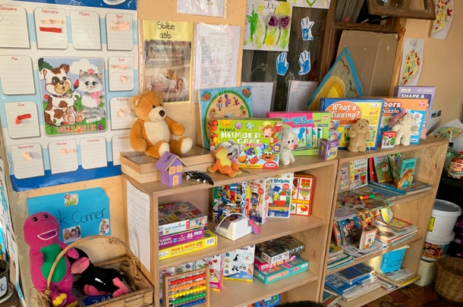
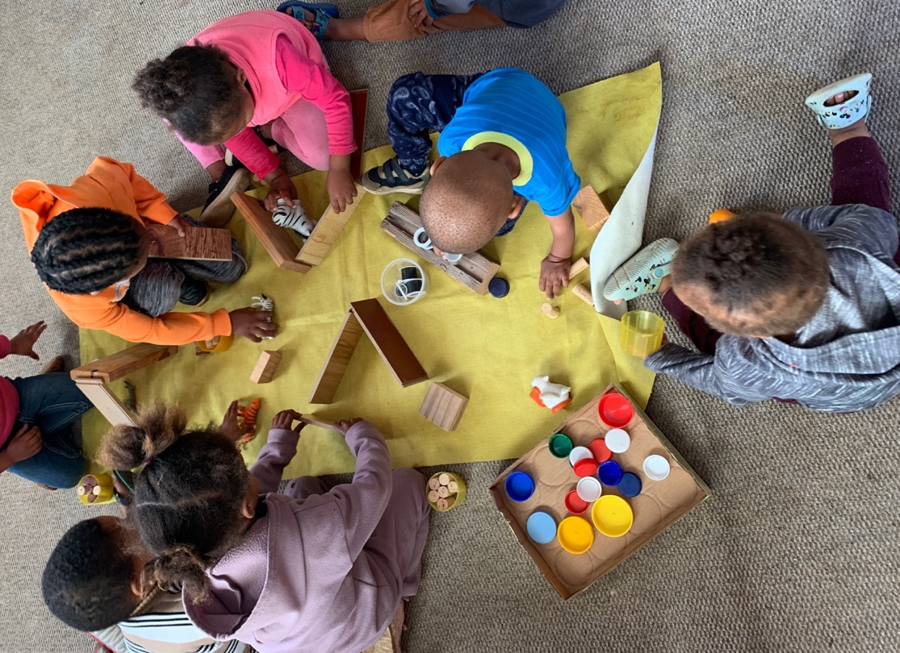

- Makhulu
Changing behaviour and ideas takes time. A+ and the Kouga facilitators support implementation of learning by visiting each ECD centre to assist in practical ways and to model the pedagogical approach taught in workshops. Here is an example
- Before A+ support visit to Makhulu. The staff tend to the physical needs of the children but there are no toys or play-based learning activities set out for the children. Babies are confined to cots (photo below):

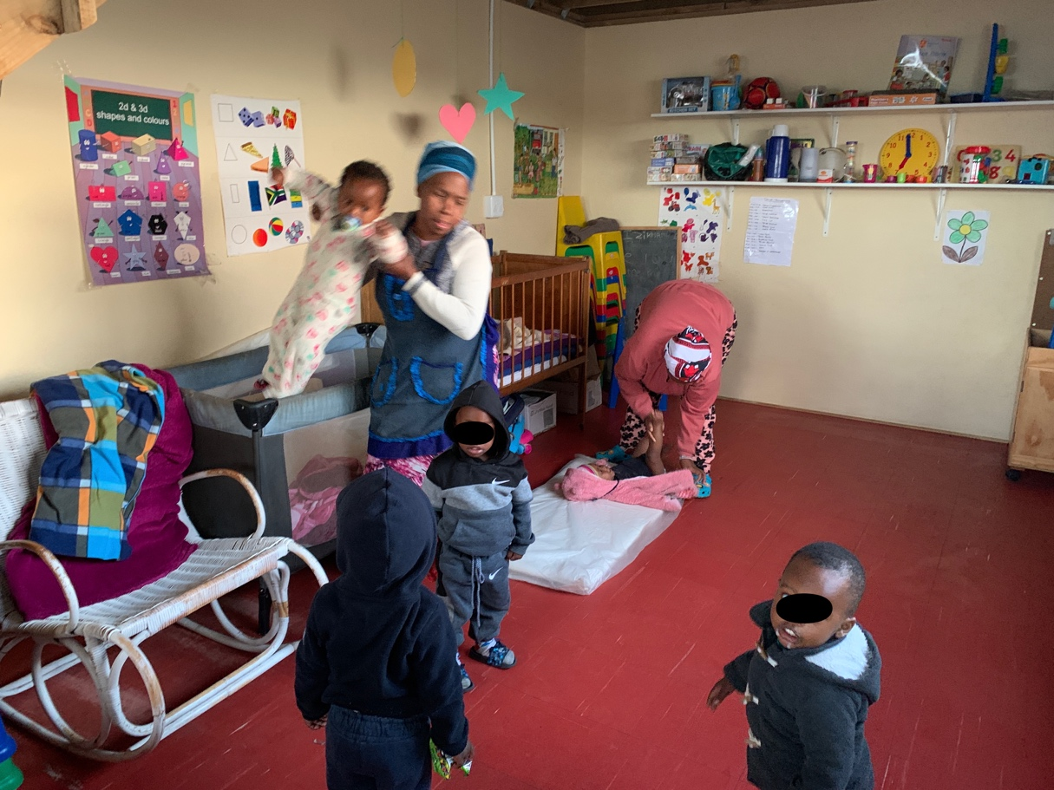

- After A+ support visit: The babies in the cots have toys, the teacher is engaging the children in conversation, and the toddlers and older children are busy with play-based learning activities (photos below):
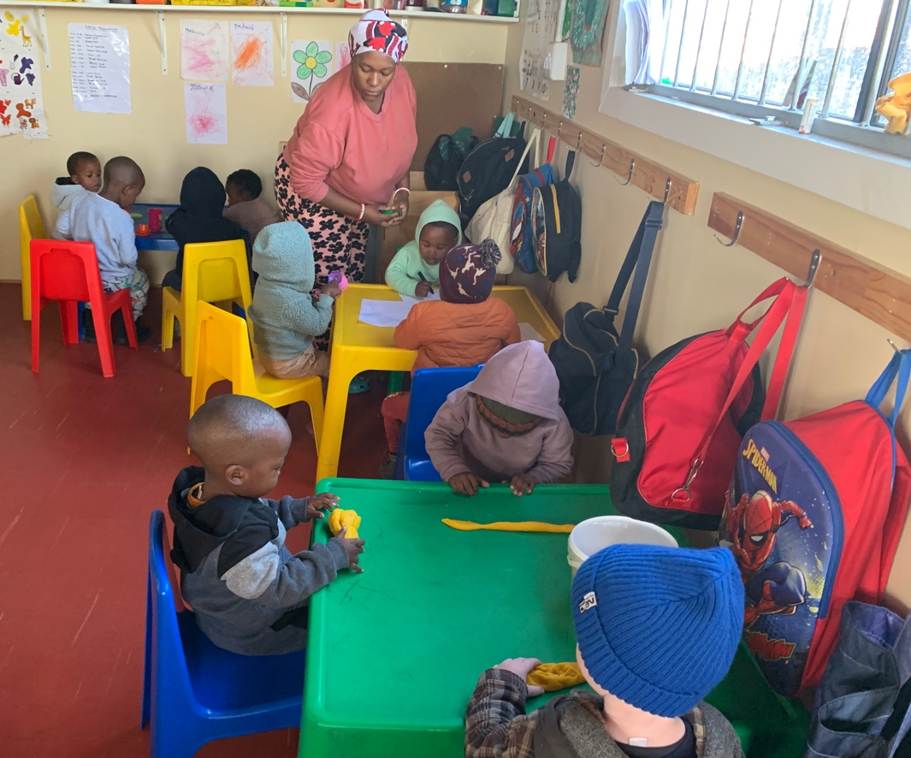
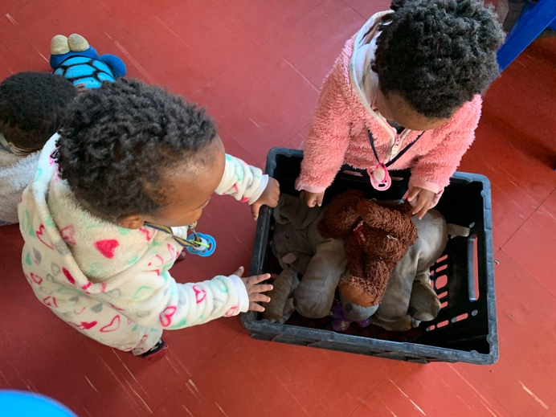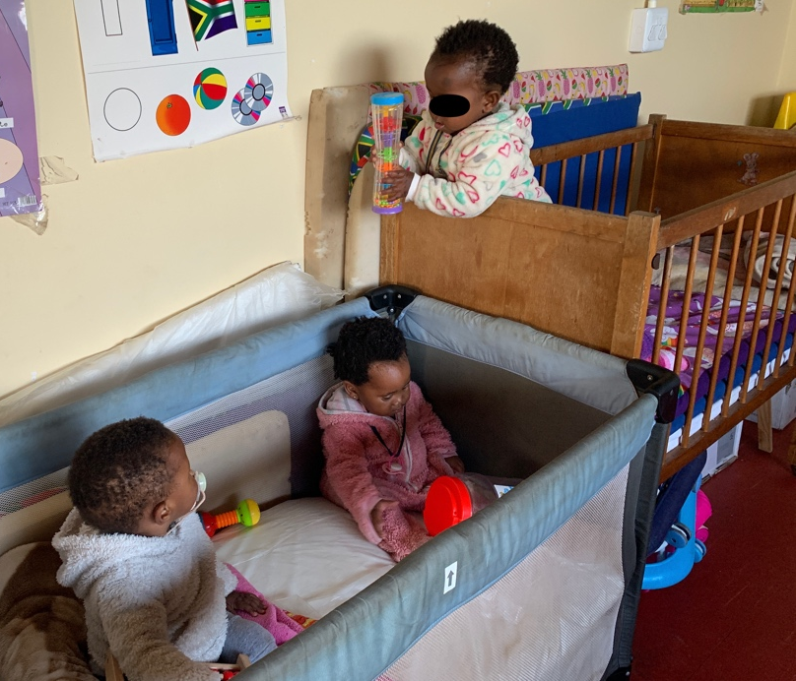
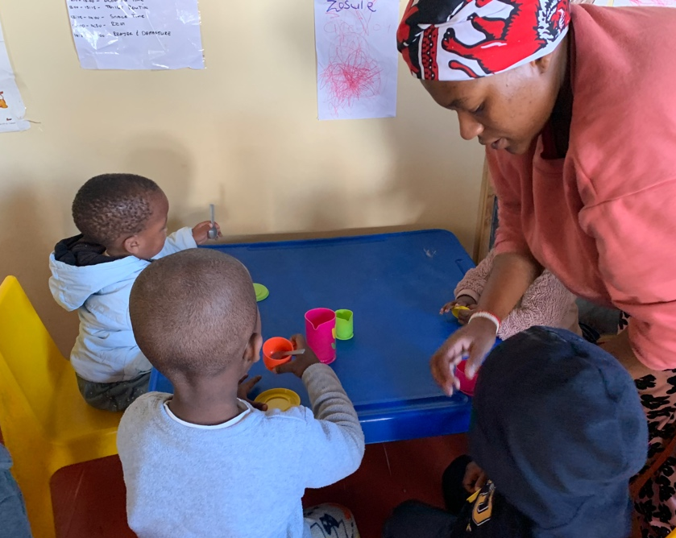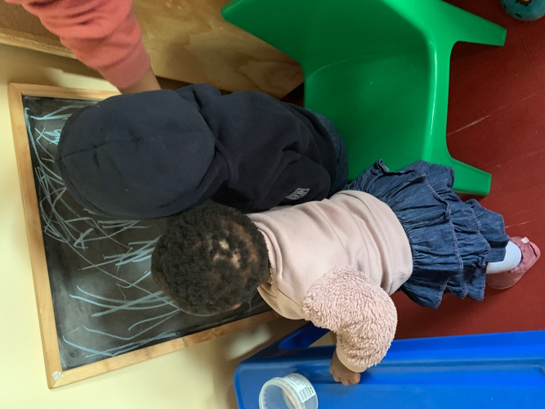

- Grace Kids
The teachers observed while A+ modelled how to work with a group of children in playful ways that facilitate learning basic concepts and skills.
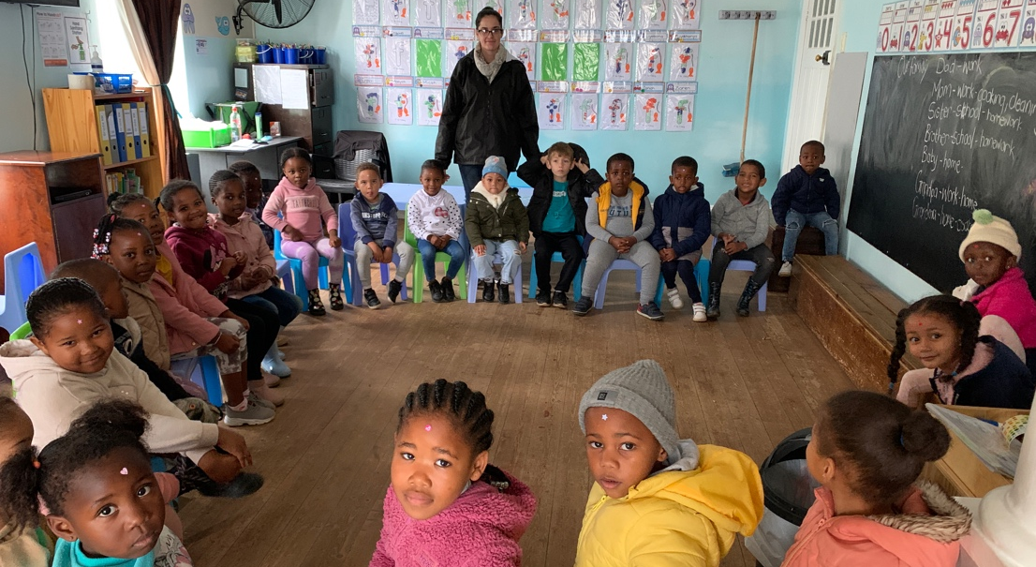

- Siyaphuhla
A+ believes that an enthusiastic ECD principal can facilitate the children’s learning no matter the context that the community may find itself in:
