KATHU SOLAR PARK ECD PROJECT
CONTEXT
This is Africa A+’s second project in partnership with the Centre for Early Childhood Development (CECD), but the first in collaboration with Kathu Solar Park (KSP). Following a needs survey conducted by the CECD in 2022, 21 schools were identified by KSP to form part of this project to significantly strengthen existing ECD programmes in the surrounding communities.
FIELD TRIP 1
During July 2023 the Africa A+ team undertook their first visit to Kathu, Olifantshoek and Kuruman. The first step was to establish community relations and to meet with stakeholders of the KSP ECD Project, in conjunction with the CECD.
Highlights of the visit included the A+ facilitation of the 3-day Facilitator’s Retreat, the initial process in identifying and appointing a team of local facilitators who will continue to support the ECD communities in implementing quality teaching and learning programmes, long after the project has ended. As A+ is an arts enhanced approach, an important aim of the programme is to enable adults to get in touch with their own creativity to fully understand the benefits of using the Arts in all learning.
Comments from some participants on what they found most helpful about the Retreat:
- Sharing ideas
- Working as a team
- The Agreements that we made together as a team
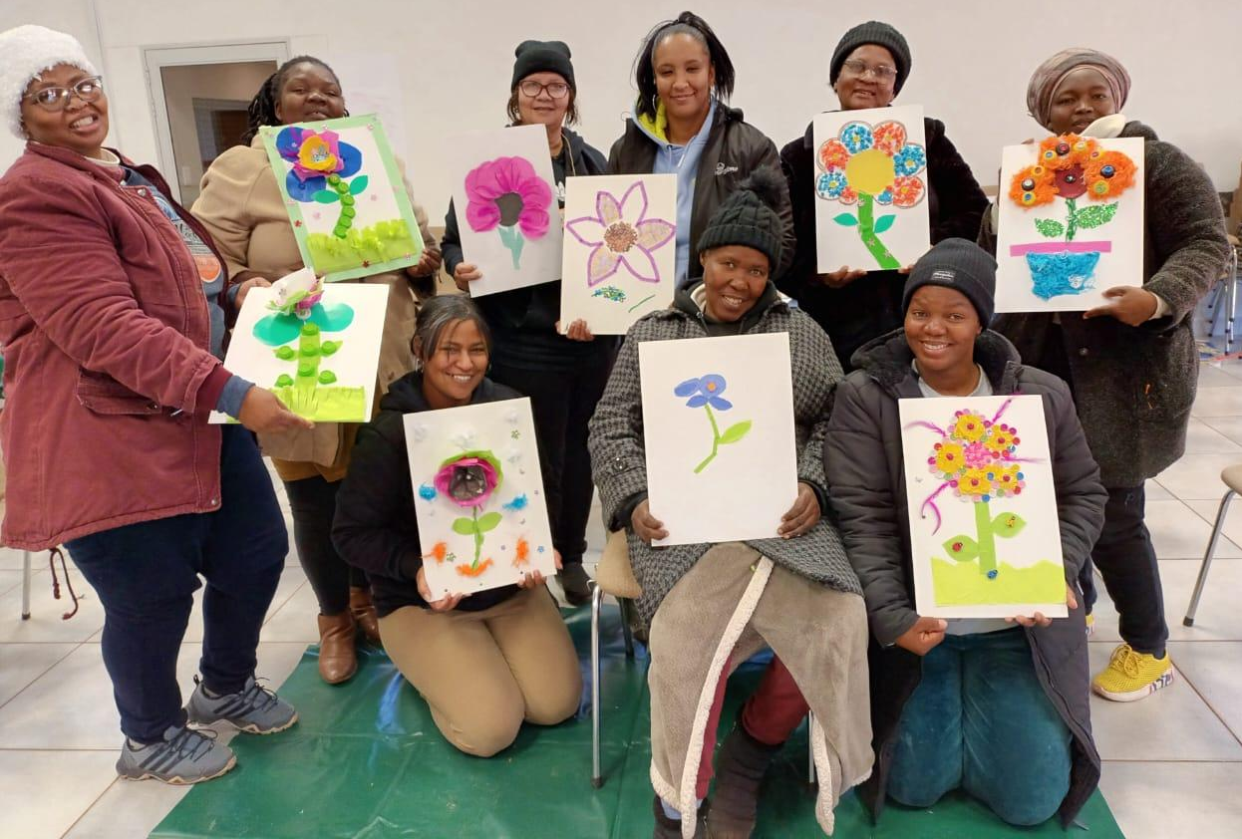

Understanding our own creativity is key to implementing the Africa A+ (Arts rich) approach in teaching and learning.

The Retreat was followed by a week of visits to 13 of the Early Childhood Centres, in the 3 areas, to conduct baseline assessments as part of the monitoring and evaluation process for the first Cohort. We were warmly welcomed at all the ECD centres, where we encountered women of great courage, passionate about the health and welfare of the children in their care despite non-payment of school fees being one of the biggest challenges they face on an on-going basis. It was most encouraging to discover that despite their many difficulties there is still a keen interest to invest time in their own professional development, to grow and learn as practitioners. Africa A+ is excited to be embarking on this journey alongside them!

