Africa A+ M&E field trip: 18 – 23 September 2023

The Africa A+ team completed their second field trip for Year 4 of the Kouga ECD Trust ECD project. A+ is working with 40 ECD centres in the Kouga area. During the week of 11 – 16th September A+ facilitated:

- Site support visits at 10 ECD centres. The value of A+ modelling teaching during a site visit is beautifully expressed by Elsie Vermaak, the principal of Siembamba, in her WhatsApp message:
“..... staff are really great full [grateful] for the site visit. one of them call me asite [aside] and said she see now why I encourage them to work with lose [loose] parts and do it hands on. sometimes they get cross when I encourage them. but now everything is clear to them.”

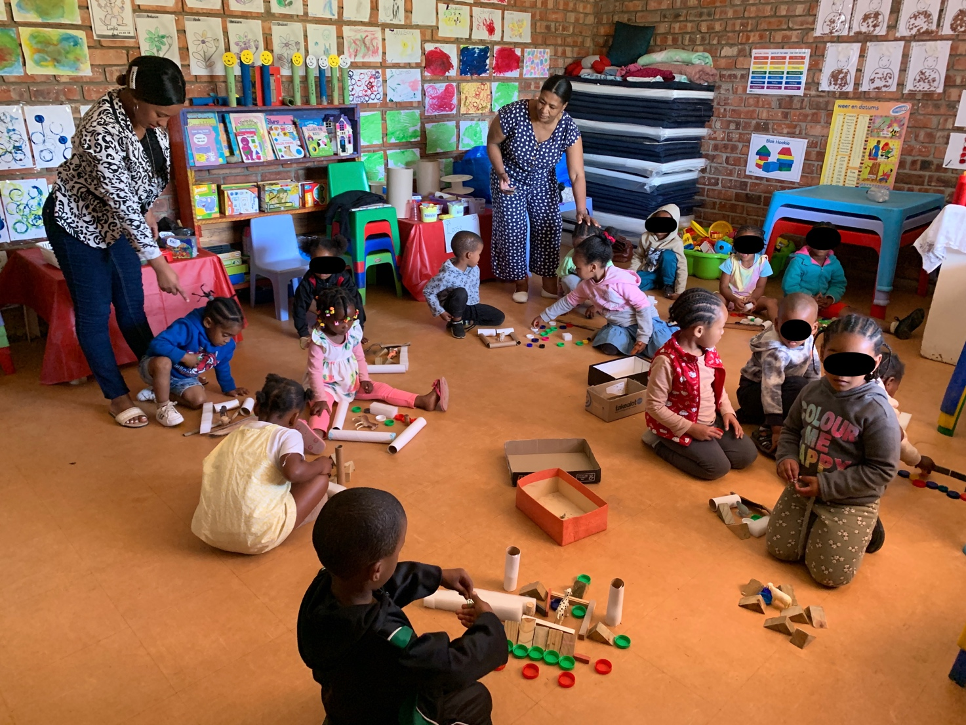

- Kouga facilitators’ training session: the local facilitation team in training spent the 18th September
setting up their first solo training: the Cohort 1 Spring Conference on the 19th September. Although the conference was planned with the support of A+, this was their first time the Kouga facilitators were going to facilitate a training event independently of A+.

- Cohort 1 Spring Conference: The eight Kouga faciliators facilitated their first professional development, the one day Cohort 1 Spring Conference, on the 19th September at the Kruisfontein Civic Centre (the planning for the Cohort 1 Spring Conference was done at the one day Facilitators’ Retreat on the 12th September). Although A+ was there to support, the Kouga facilitators facilitated the Cohort 1 Spring Conference entirely on their own. Their facilitation went beyond A+’s expectations; the Kouga facilitators were prepared, worked smoothly as a team, and engaged meaningfully with the participants who responded enthusiastically.

The Cohort 1 participants wrote the following about the Cohort 1 Spring Conference:
  - ‘Honestly speaking – I enjoyed every single thing.’ (Samkelo)
  - ‘Everything was well-planned and exciting. This was not a waste of time but a very fruitful day. I learned a lot.’ (Elbe)
  - ‘The[y] was very good the facilitators.’ (Annie)
  - ‘The team work was great.’ (Catherine)

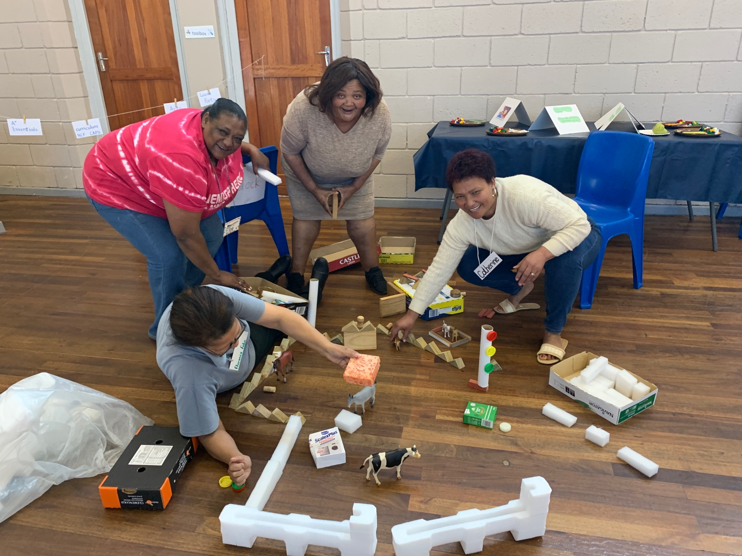

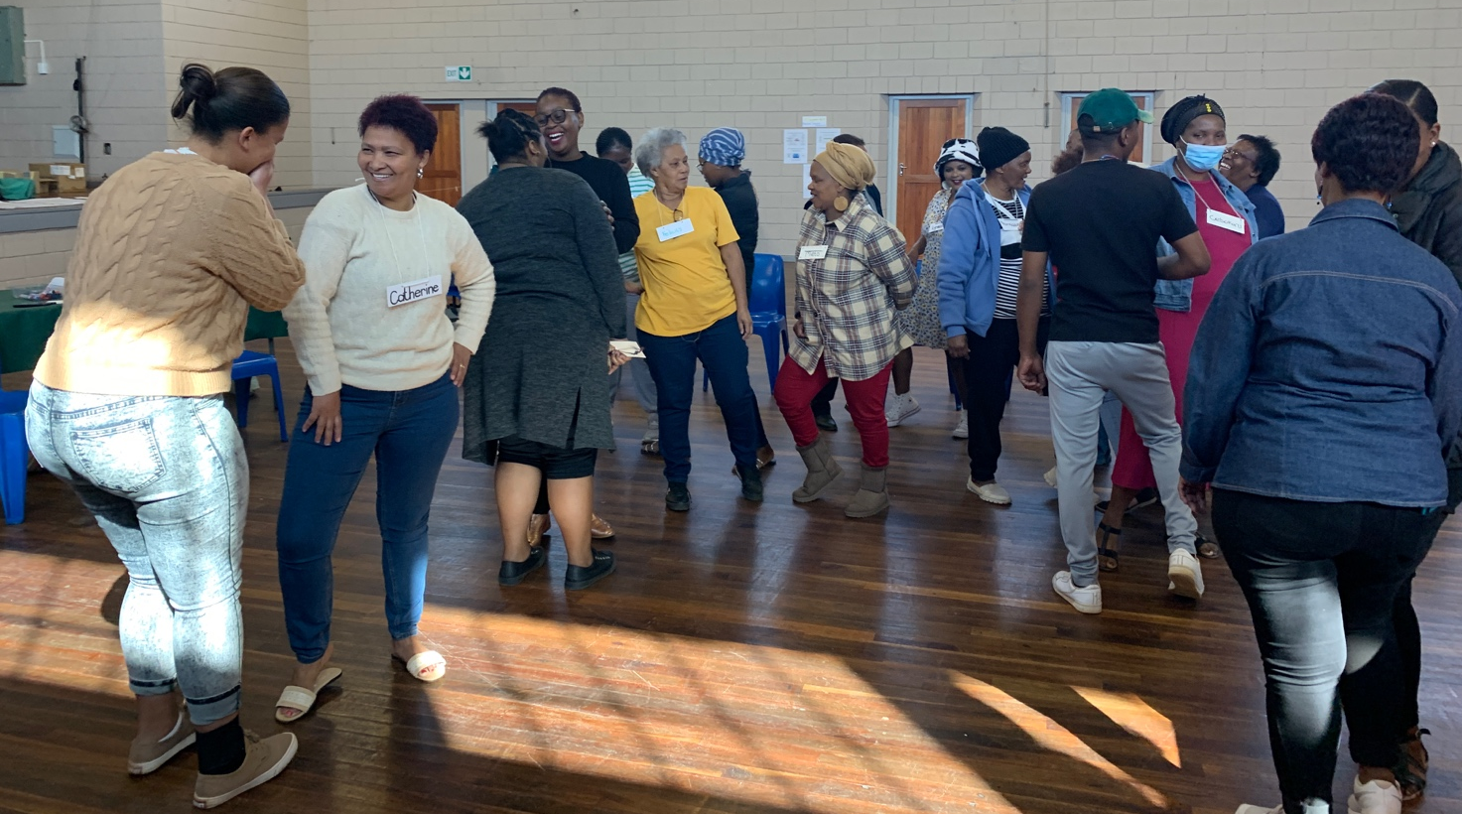

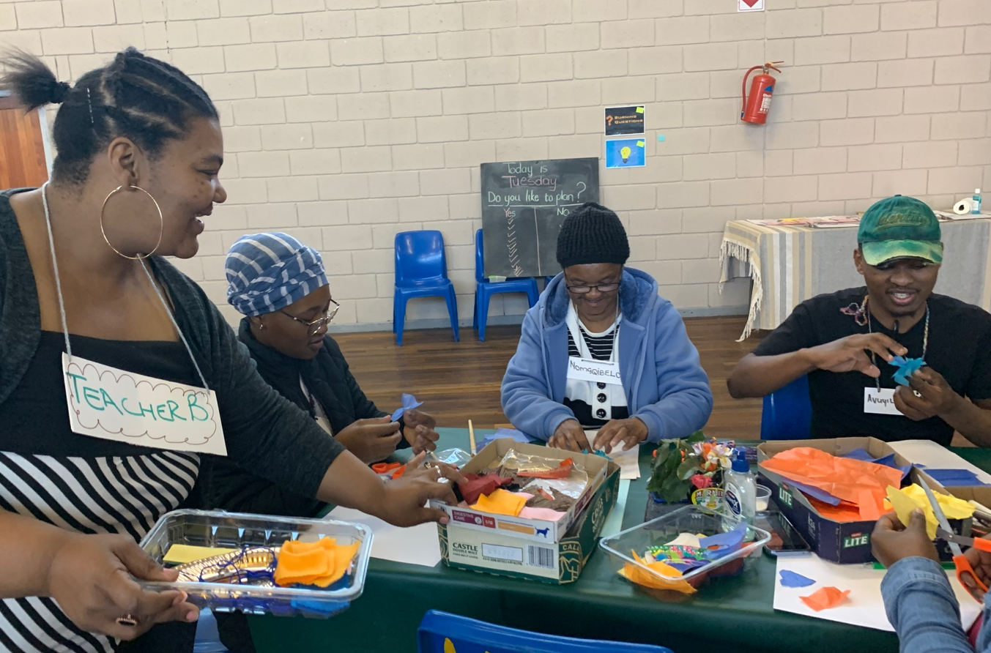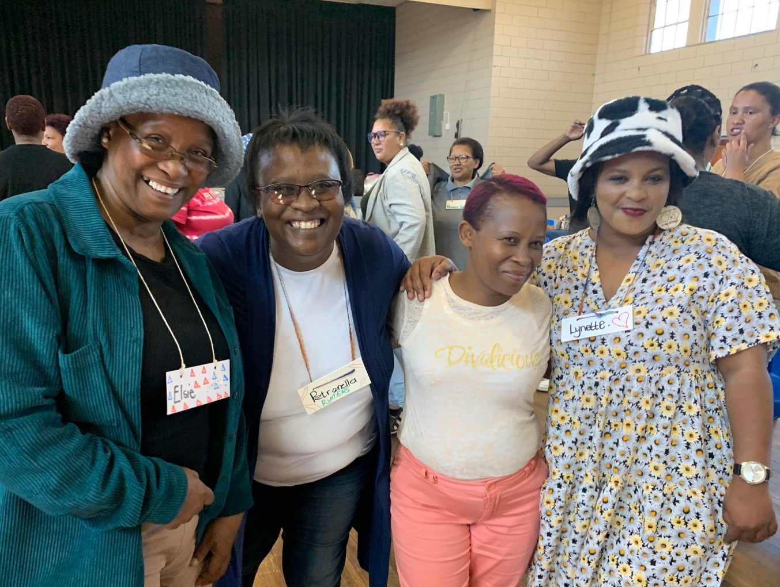
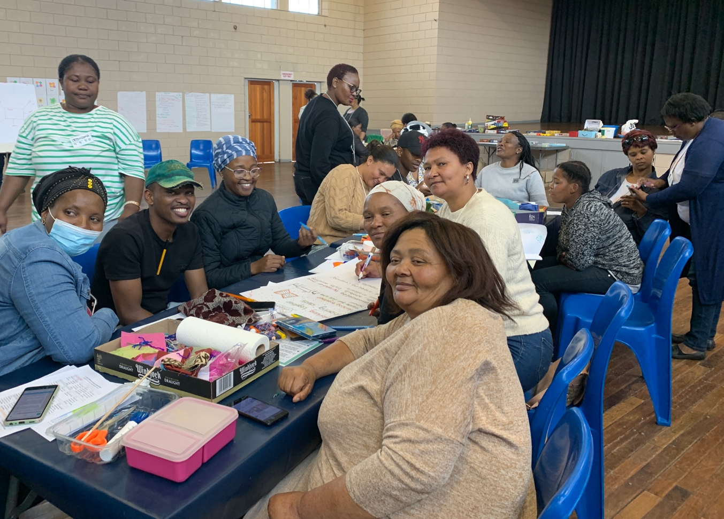

- Grade R workshop The Grade R workshop on the 20th September began with a play-based Grade R mathematics activity followed by the Grade R teachers from Dienkie Dot sharing what they learned during the two day Eastern Cape Education Department’s Grade R training in August. The Grade R centres now have all the relevant Grade R CAPS curriculum documents: Grade R SBA, Grade R Life Skills, Grade R-3 Home Language and Grade R Mathematics. Two participants noted in their own words:
  - ‘To preciate what Anaya and Yolandi bring to us hear in the Kouga. They teach us a lot. They see that we get what need to plan, all the documents.’ (Catherine)
  - When asked what the challenges were Lynn-Kelly noted: ‘Actually nothing. I love the Grade R training.’
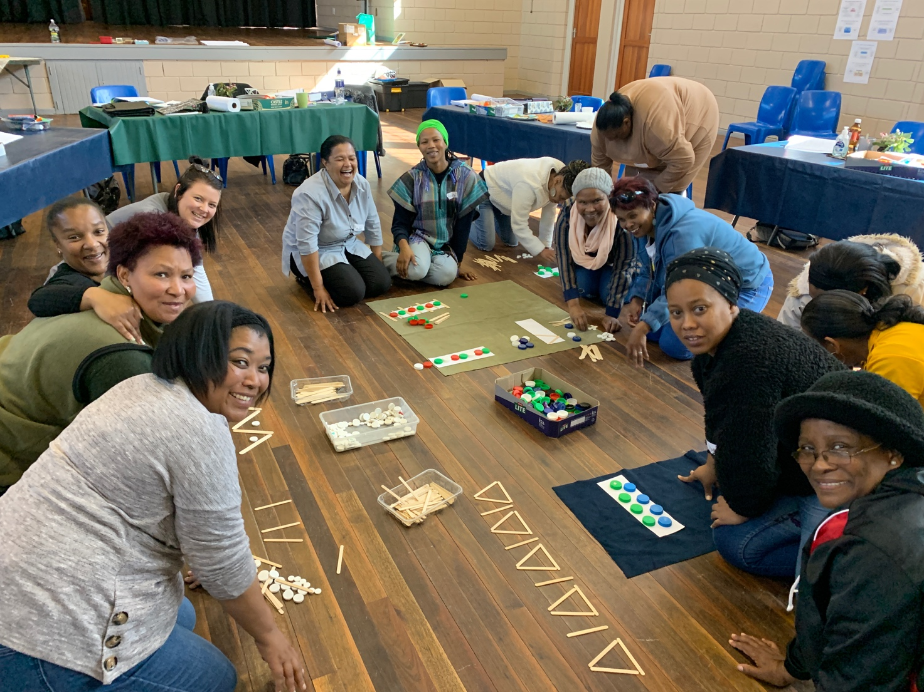

- Leadership (staff development) workshop
This 21st September workshop was open to all the principals/school leaders; in particular to ECD centres who have a high turnover of teachers that keeps their ECD centre at entry level. This workshop follows up on the previous staff development workshop in May 2023 which introduced the idea of regular staff meetings as a way of developing staff personally and professionally. The workshop begins with the principals taking a close look at their leadership styles and the impact on those they lead. Each principal was provided with a hard cover staff meeting book into which they set up a schedule of staff meetings, identified dates for and planned their first staff meeting.

When asked “How are you feeling about staff meetings?’ Amy wrote ‘Excited, cause now I know what to do.’

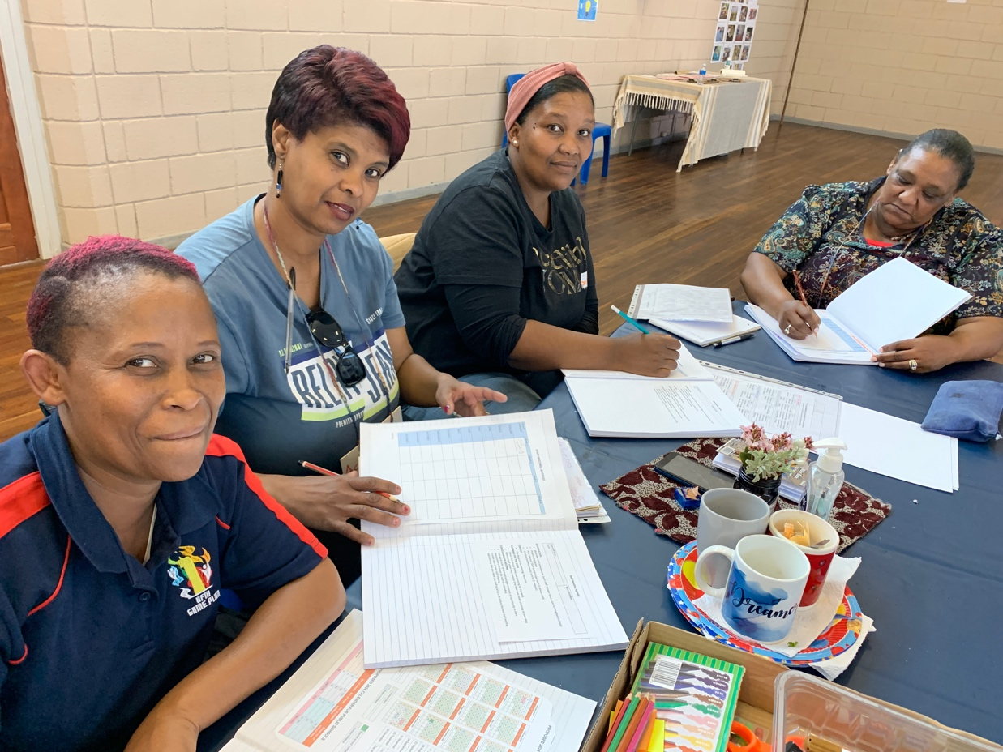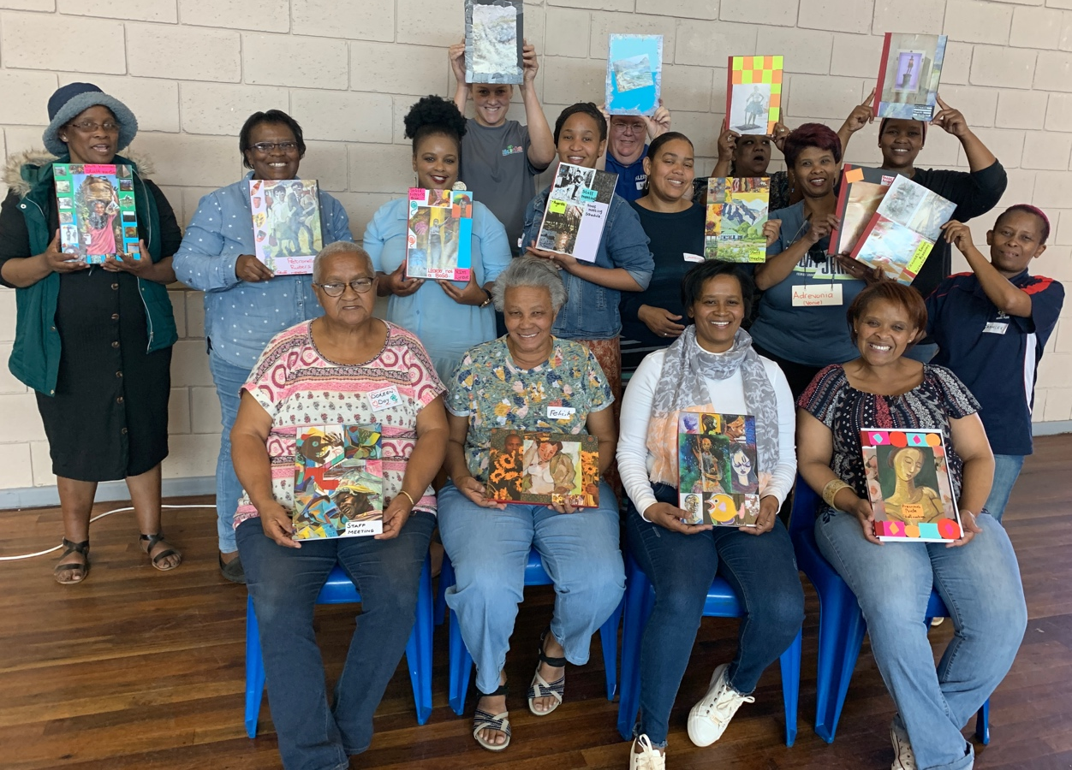

- Loose parts workshop
This 22nd September workshop was open to the principals and teachers at all of the 40 ECD centres. The purpose of the workshop was to work creatively with ‘loose parts’ (repurposed recyclable, found and discarded materials) and to use them in the classroom for joyful and meaningful teaching and learning.

