Africa A+ field trip: October 2023

The Africa A+ team completed their last field trip for 2023 (in November and December the ECD centres’ attention turns to graduations, meetings, reports and concerts). During the week of the 2 – 6th October the A+ team facilitated the following with the 40 Kouga ECD centres;

- Facilitators’ Learning Session (2nd October 2023)
Each field trip includes a learning session for the eight local facilitators in training. Today’s three hour session focused on successful teamwork, a reflection on 2023, and making plans for how best to support the Kouga ECD centres in 2024.
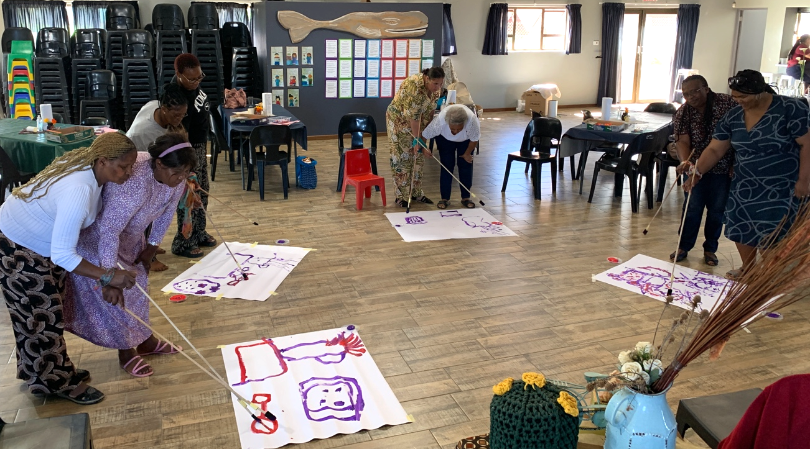

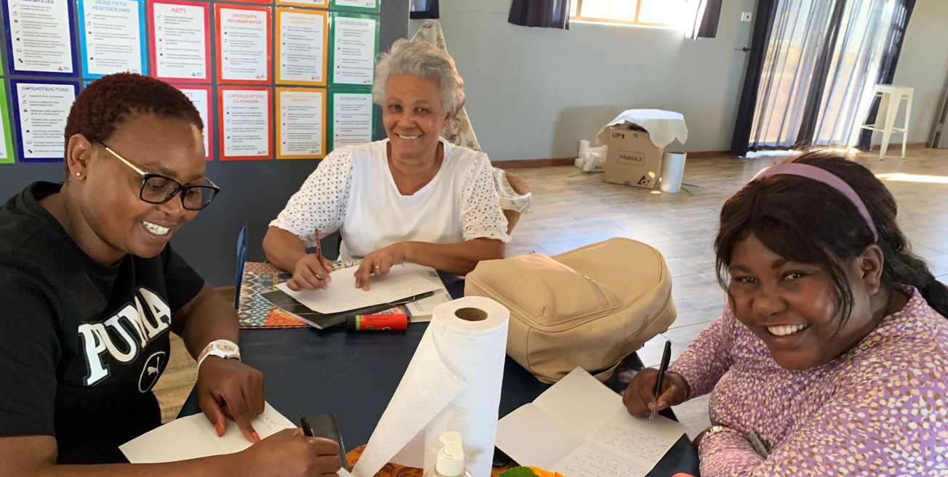
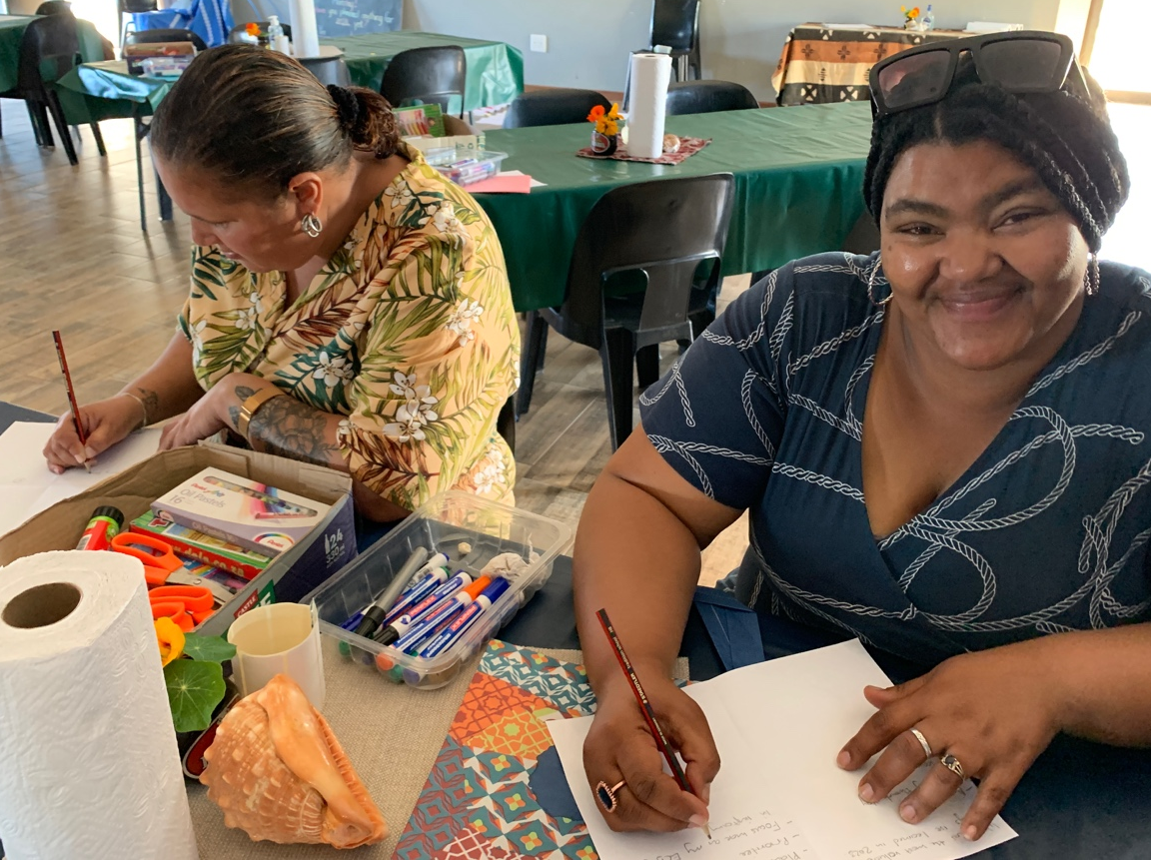

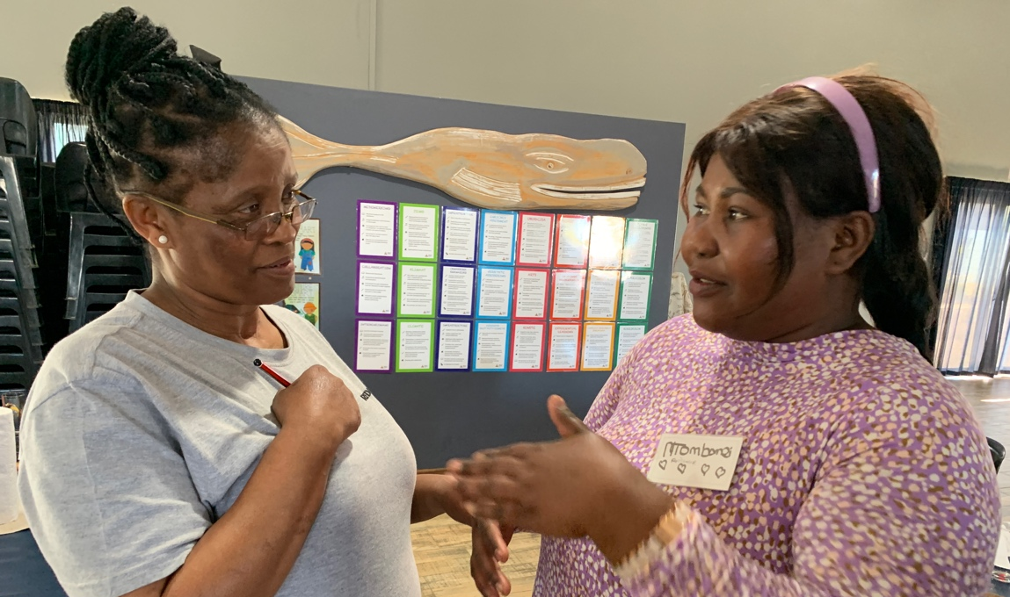
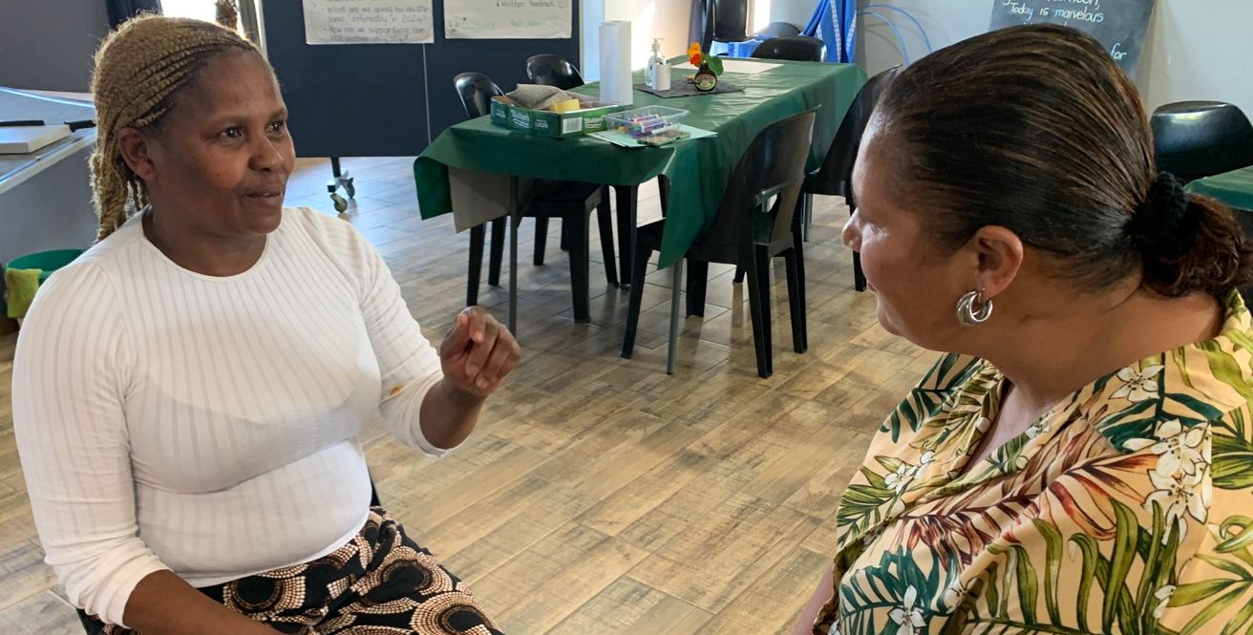

- Cohort 2 Spring Conference 1 (3rd & 4th October 2023)
Principals and teachers from nine Cohort 2 ECD centres attended two days of professional development. The focus was on the NCF curriculum, creativity, working with loose parts, reflection and planning 2024. The highlights were the participants’ enthusiastic engagement and the creative workshops facilitated by guest artists, Graham Jones and Theresa Hardman. If we want our ECD centres to nurture the children’s creativity then we must first make sure that the teachers are in touch with and enjoying their own creativity.

Feedback from the Cohort 2 Spring Conference participants in their own words (italics) when asked to complete the following two sentences: “I used to think …” and “But I now think …. :
- I used to think … “ Teacher led classes was the way to go because that is how we were taught”.
But I know think …”Giving learners the opportunity to explore and investigate for themselves encourages freedom of creativity leading to well rounded adults” (Nadine)
- I used to think …” teaching children is hard and draining.’ But I now think … “ teaching is more easy when everyone is happy and it’s enjoyable.” (Babelwa)
- I used to think …”that children can be put in your box as a teacher and that the way that you teach.” But I now think… “ that all children are different and no one that think the same. we are all different and think and learn on different ways.” (Sunelle)
- I used to think …”I can’t talk in front of people.” But I now think … “I’m confident enough.” (Eunice)
- I used to think …”dis om iets in ‘n kind se kop te kry.” (that it is something you must put into a child’s head). But I now think … “Dit gaan oor speel en leer.” (It is about play and learning) (Susan)
- I used to think …”Everything should be complicated and technical to get the best results.” But I now think….. “With basic easy things you can bring out the best.” (Liza)

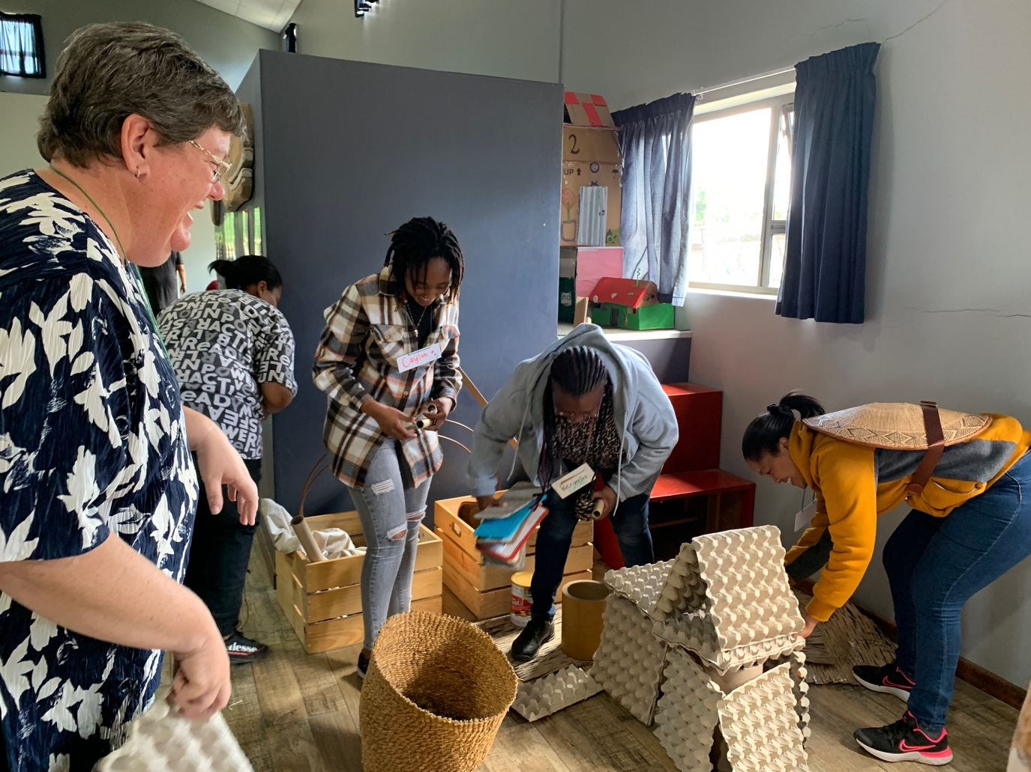

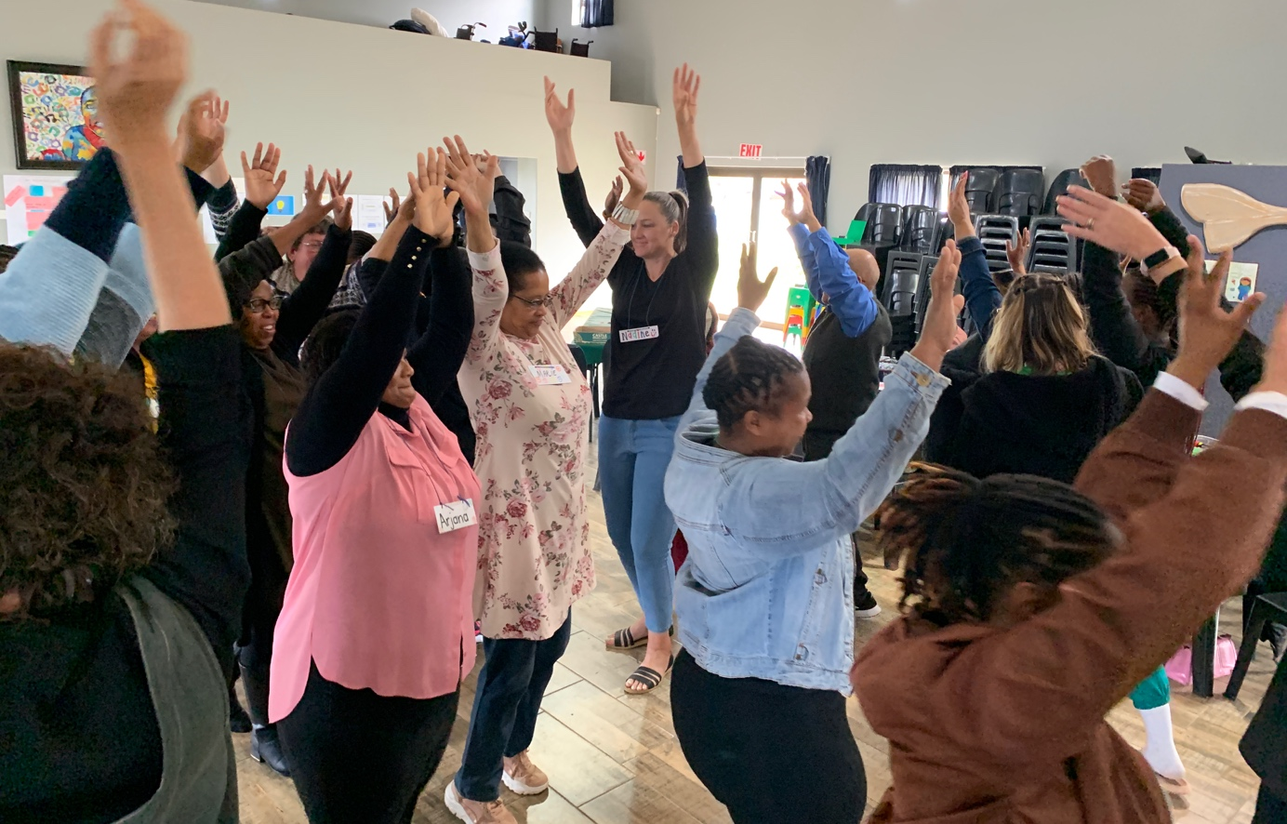
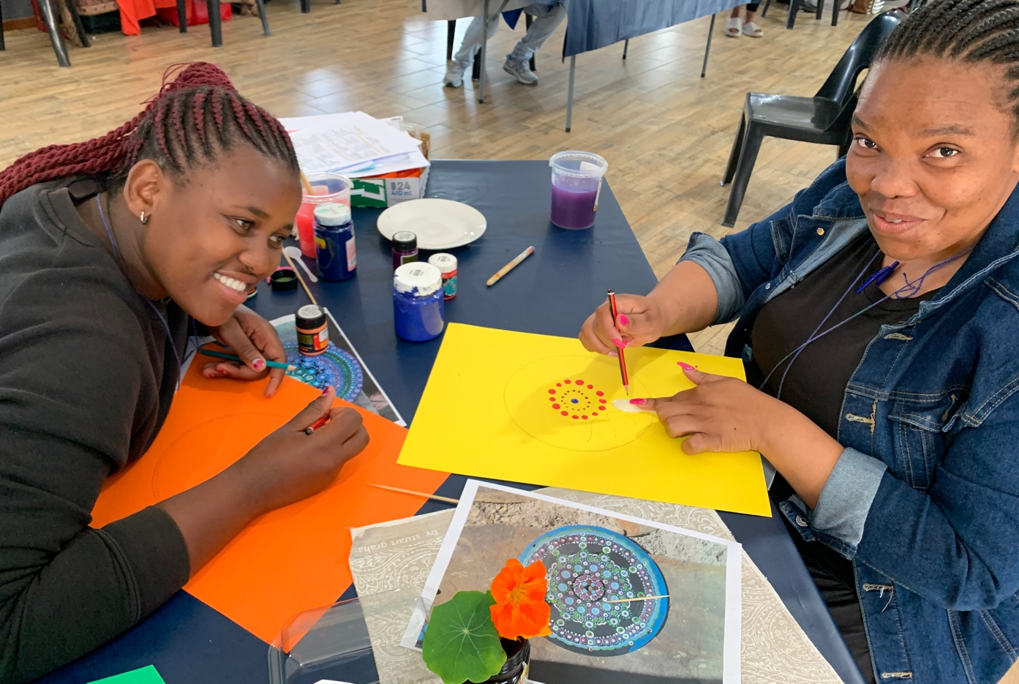

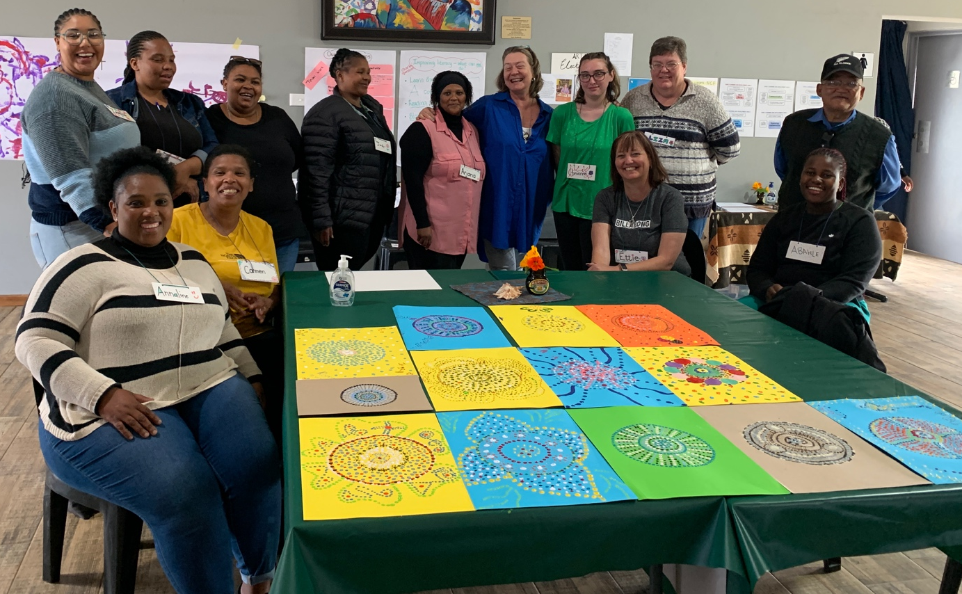

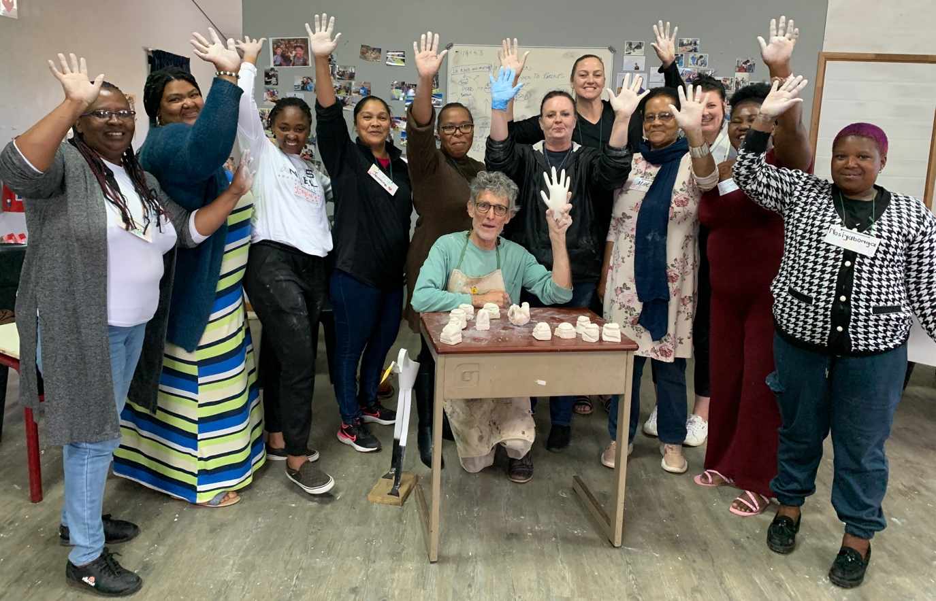

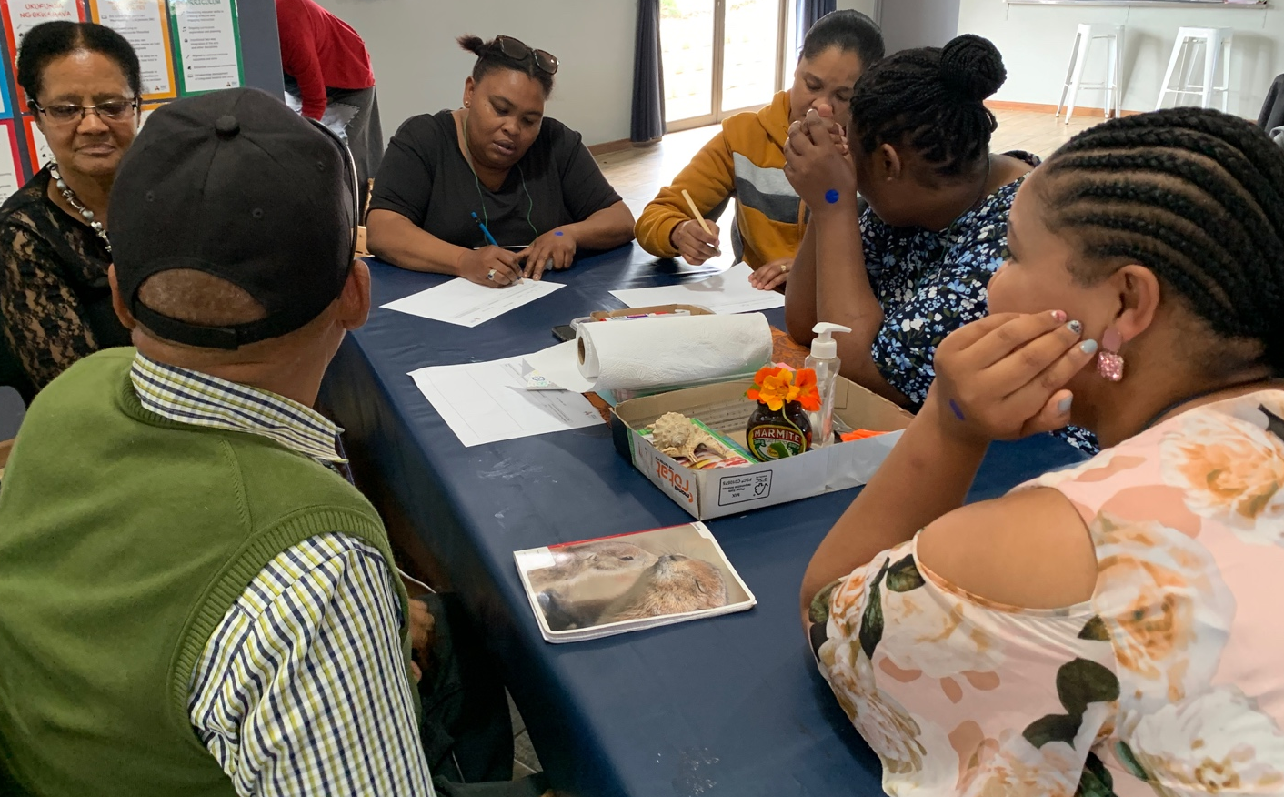

- Grade R workshop (5^{h} October 2023)
The Grade R workshop focused on informal assessment of children through observation and documentation. The Kouga Grade R teachers are feeling confident; they all have a dedicated planning file, the essential Grade R CAPS curriculum documents, planning and assessment forms. In 2024 the focus will be on deepening the teachers’ understanding of Grade R pedagogy and turning it into joyful classroom practice.
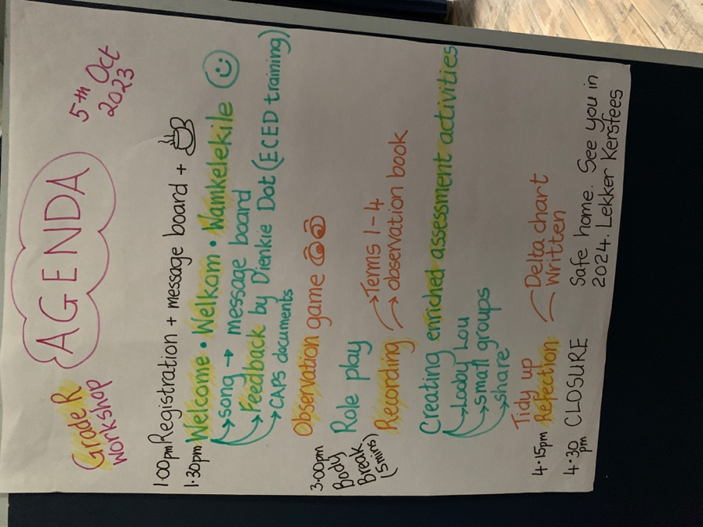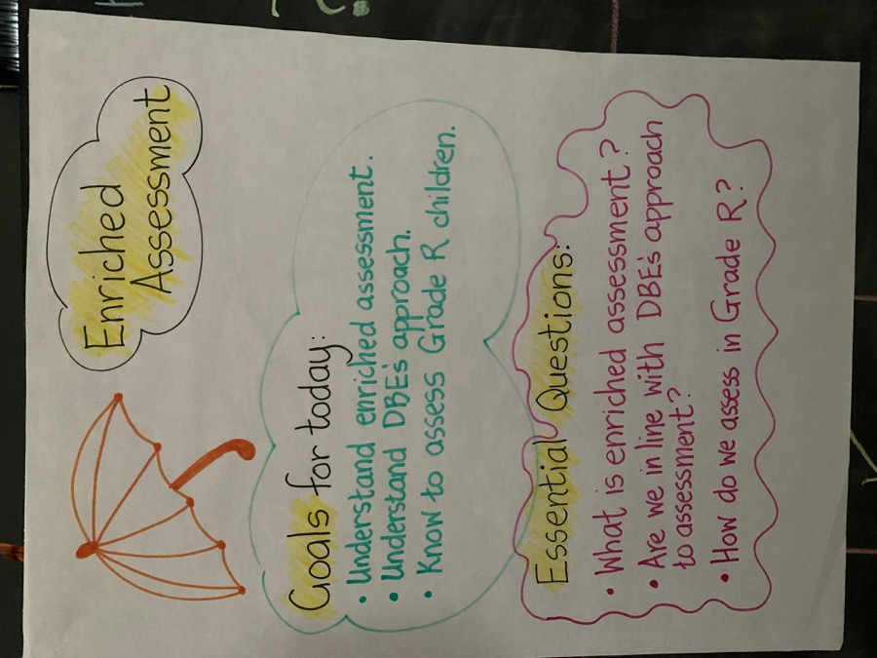

- Leadership (staff development) workshop (6th October 2023)
Although open to all participants; the goal of the Leadership workshops is to support ECD centres who remain at entry level as a result of high teacher turnover. This workshop built on September’s Leadership workshop which had introduced regular staff meetings as a way of developing staff personally and professionally. The goal for 2024 is for principals to plan and facilitate weekly staff meetings that motivate, develop and nurture their teachers.
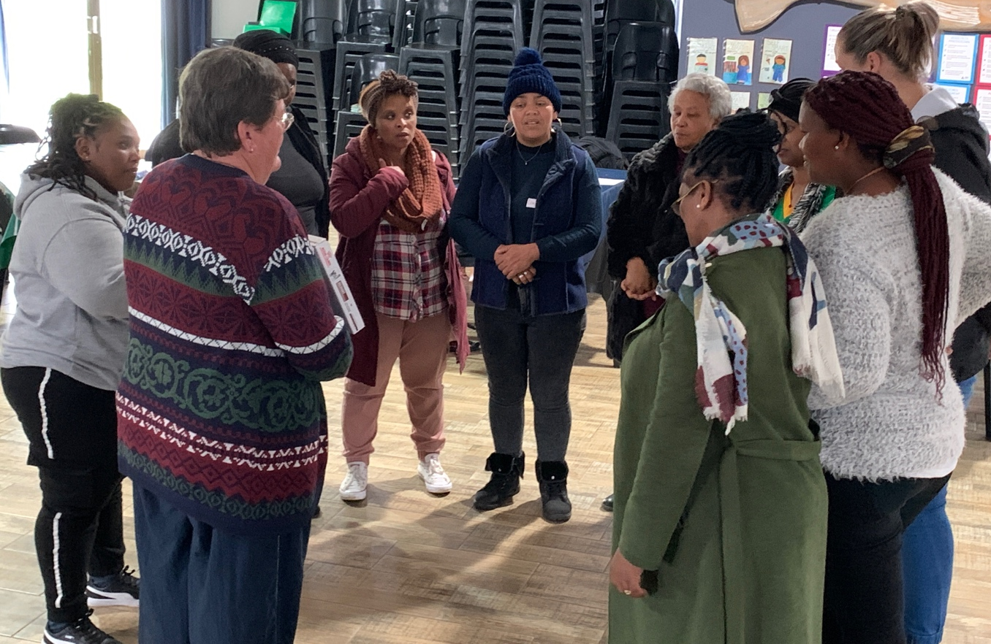

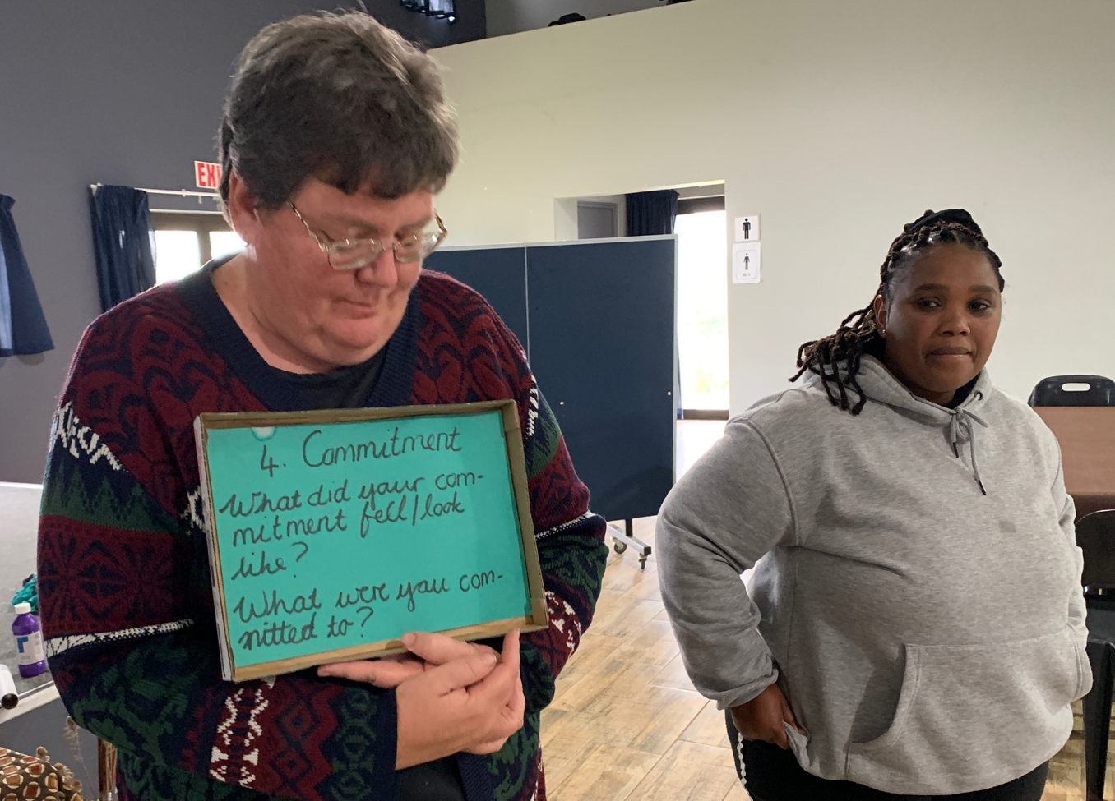

- Site visits (2, 5, & 6th October mornings)
While most of the Kouga ECD centres are making steady progress, some ECD centres find implementing a child-centred, play-based pedagogy challenging. It takes time to change mindsets and behaviour when outdated child development ideas and practices are entrenched. When A+ visits an ECD centre, they support this change by working with the children modelling developmentally appropriate teaching practices and classroom management skills.

