Africa A+ field trip: April 2024

The Africa A+ team completed a field trip for the Kouga Windfarm Trust ECD project from 7 – 14th April 2024. A+ facilitated 16 onsite visits and six workshops in the week. Here is a snapshot of each activities that took place.

- Site visits (8th, 10th, 11th & 12th April)
Two kinds of demos (on-site demonstrations of play-based teaching with children) took place in the week:
1. The Kouga facilitators in training each demonstrated a play-based learning activity with a group of children at an ECD centre. The A+ facilitators observed the demo which was followed by a reflection and feedback from A+.

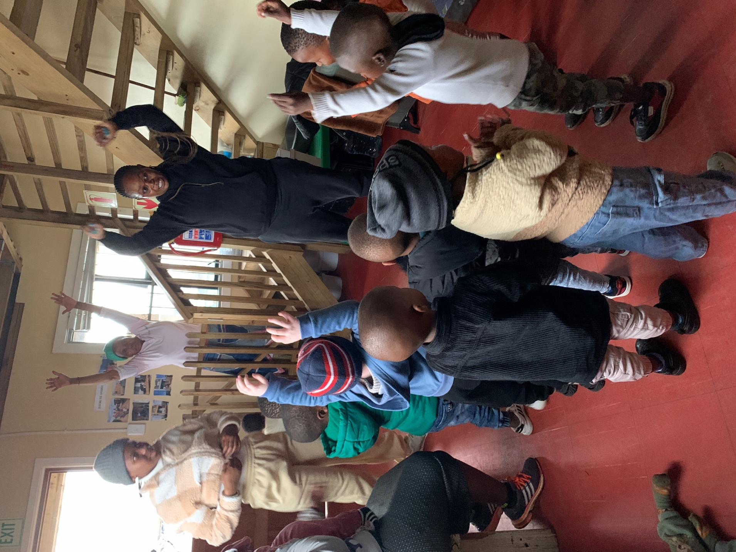

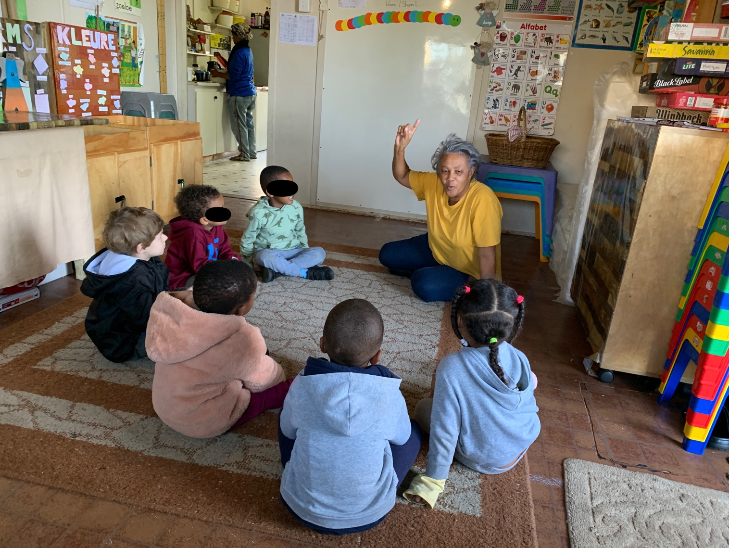

2. The two A+ facilitators did on-site demos at eight ECD centres to demonstrate play-based teaching. The principal and teacher are observing Anya Morris doing a demo.

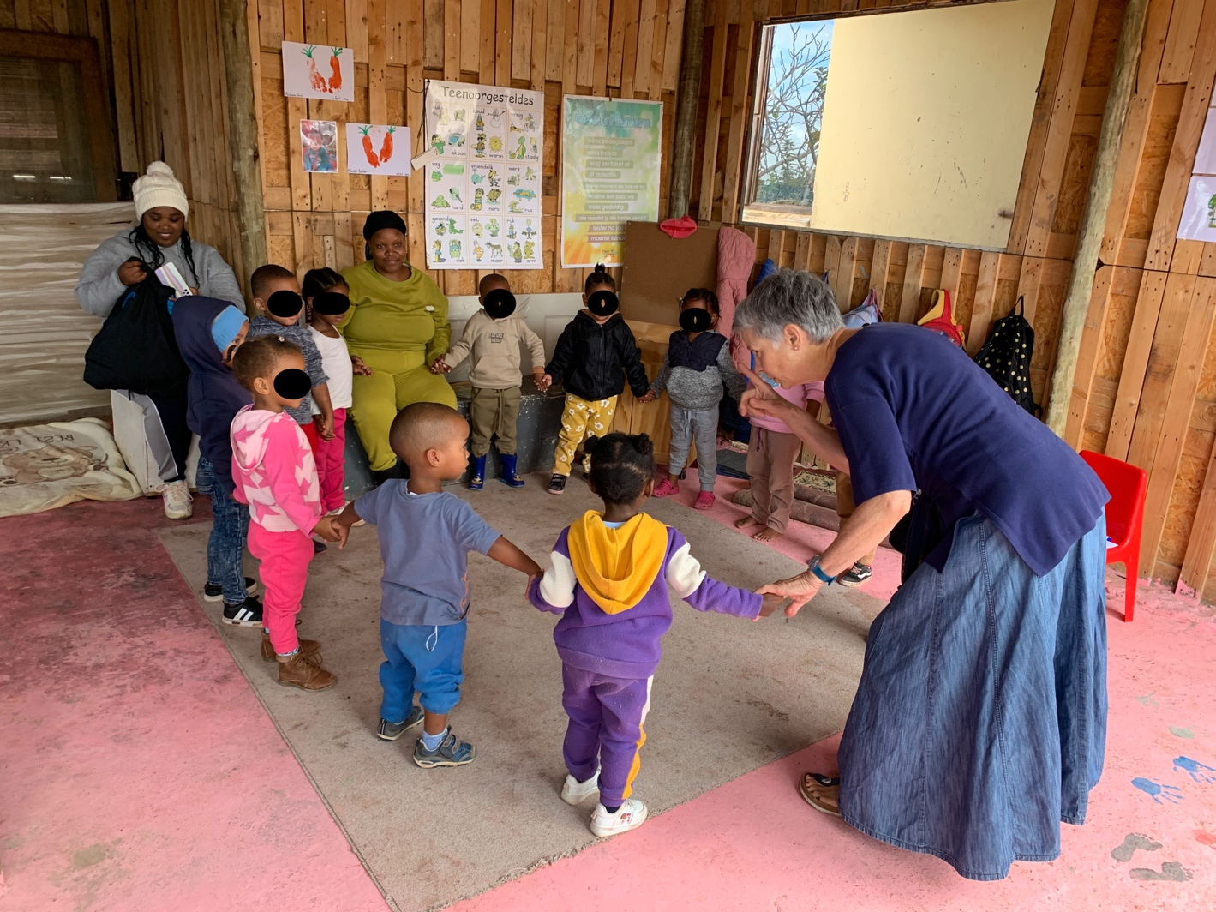
- Kouga Facilitators’ workshop (8th April 2024)
Every A+ field trip includes a three-hour learning session for the eight local facilitators in training. The focus this week was on understanding the impact of mentoring in relation to how they support the Kouga ECD centres. One of the facilitator’s reflections supports the idea that if we want teachers to nurture the children’s creativity then we first need to get the teachers in touch with and enjoying their own creativity: ‘For me to do more art at my centre cause at first I don’t know that I’m enjoying art work and it gives me peace of mind then. Now I will change my ways of doing it and do it more and new things about art work.’

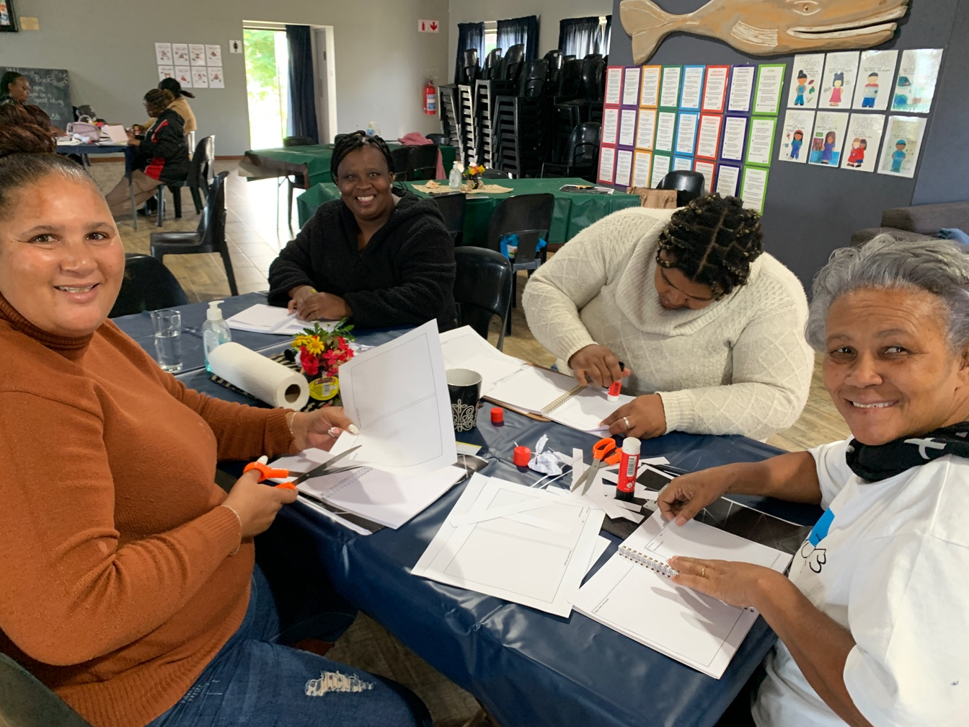

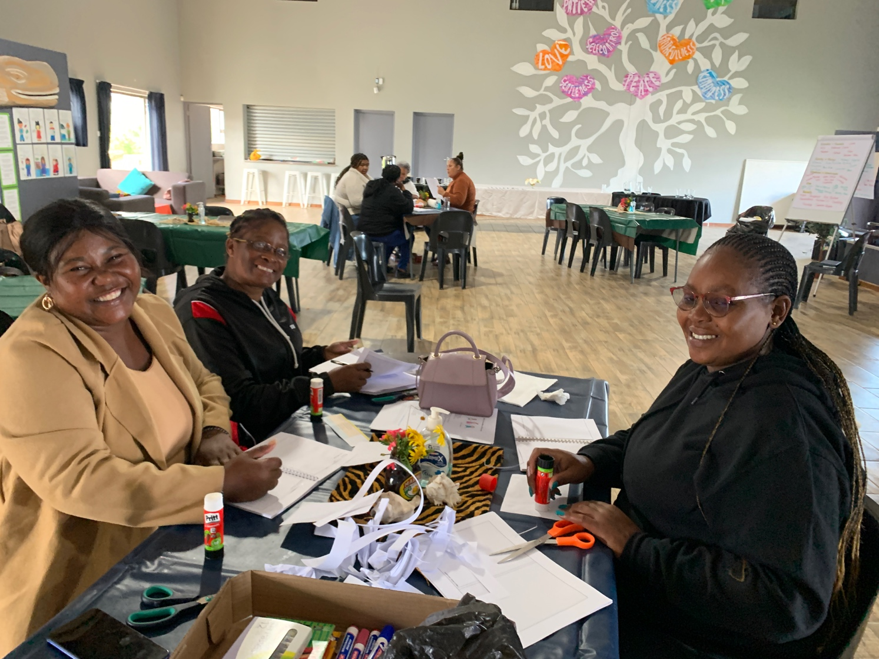

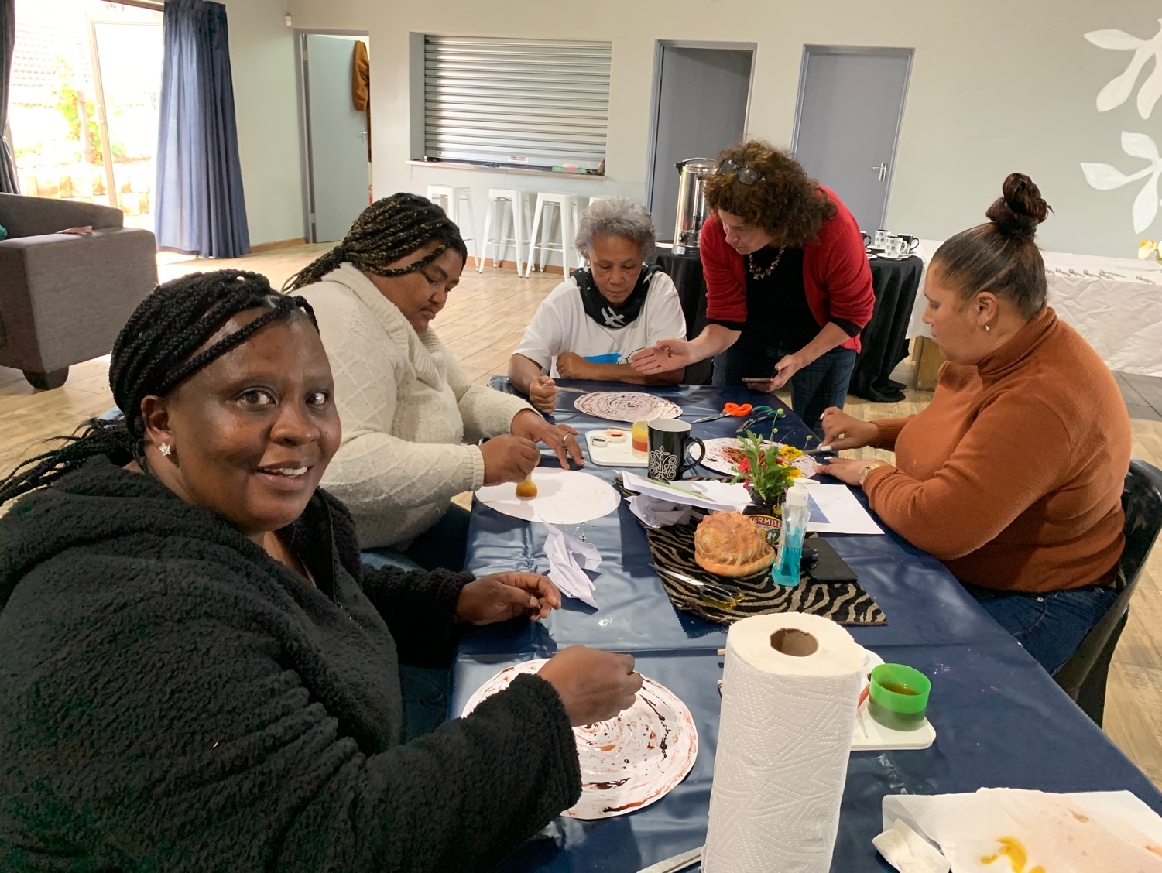

- Cohort 2 workshop on Babies and Toddlers (9th April 2024)
The three hour workshop was attended by 26 principals and teachers. This workshop was planned in response to A+’s observation that ECD centres tend to underestimate babies and toddlers and as a result their classrooms offer little stimulation. The workshop began with a creative art activity before the participants learned that 90% of the human brain is developed by 5 years old and that parent/caregiver responsiveness is critical for babies’ well-being and development. The participants created ‘treasure baskets’ for the babies and toddlers at their ECD centre using recyclables and everyday materials. The workshop ended with participants planning baby and toddler activities and making links to the 0– 4 years NCF curriculum. A facilitator reflected: ‘…. I have learned so much today. Laughing with colleagues. Being asked deeper questions and thinking deeper’.
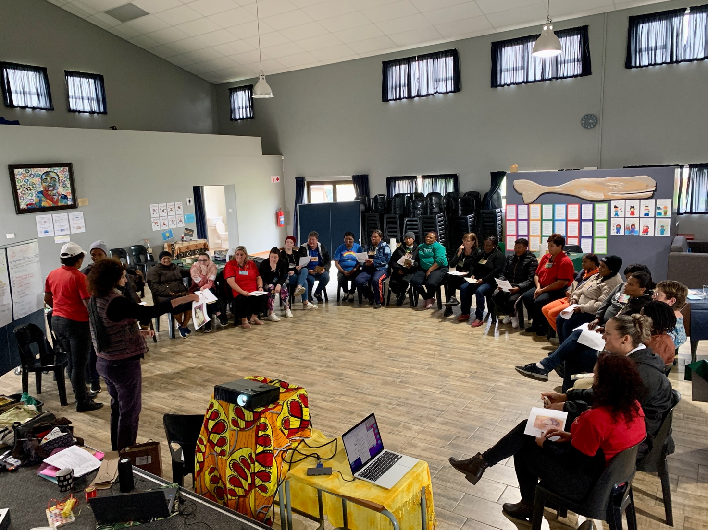

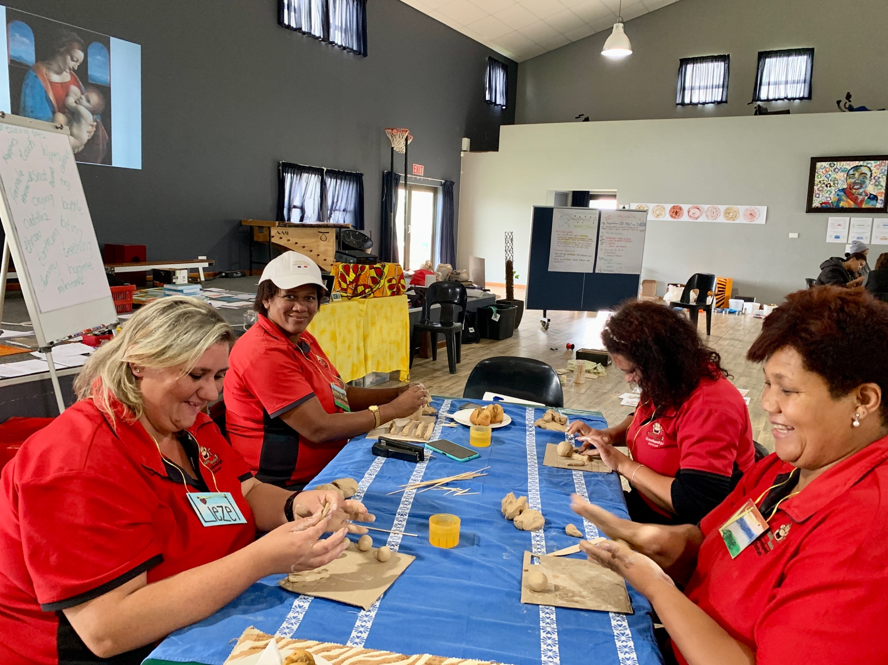

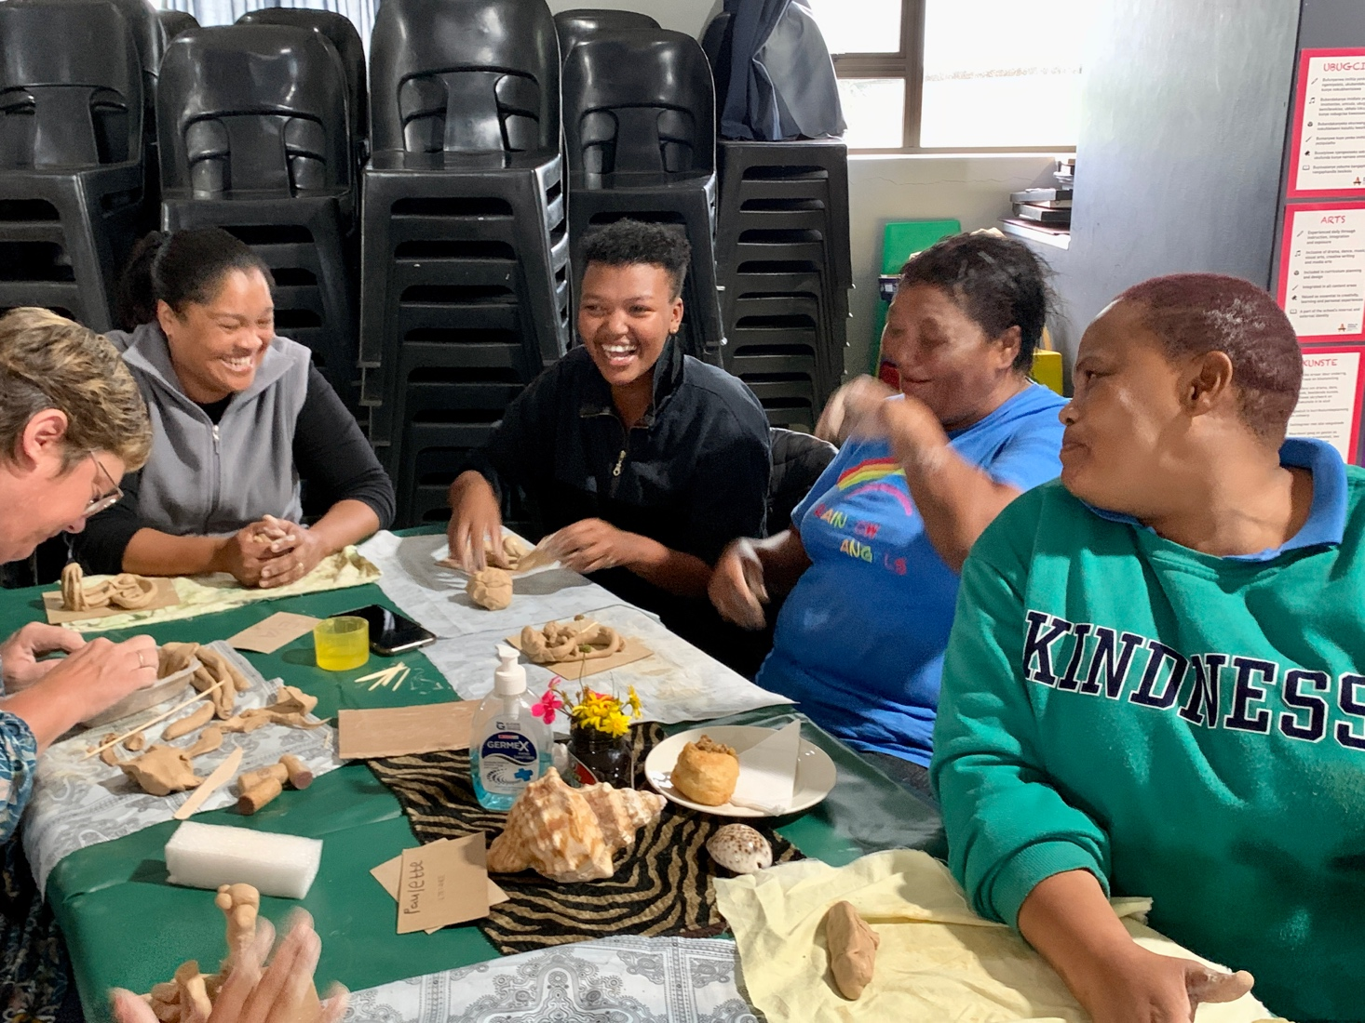

- Cohort 3 workshop on Babies and Toddlers (10th April 2024)
The baby and toddler workshop was repeated for Cohort 3 and was attended by 23 principals and teachers. A facilitator wrote in her reflection that after today she would: ‘Om altyd te weet dat babas leer deur alles. En hulle hou van voel en vat. Om altyd did veiligheid van did kinders te check in al die opsigte’ (To always know that babies learn through everything. And they like to feel and touch. To always check for the safety of children in all ways).

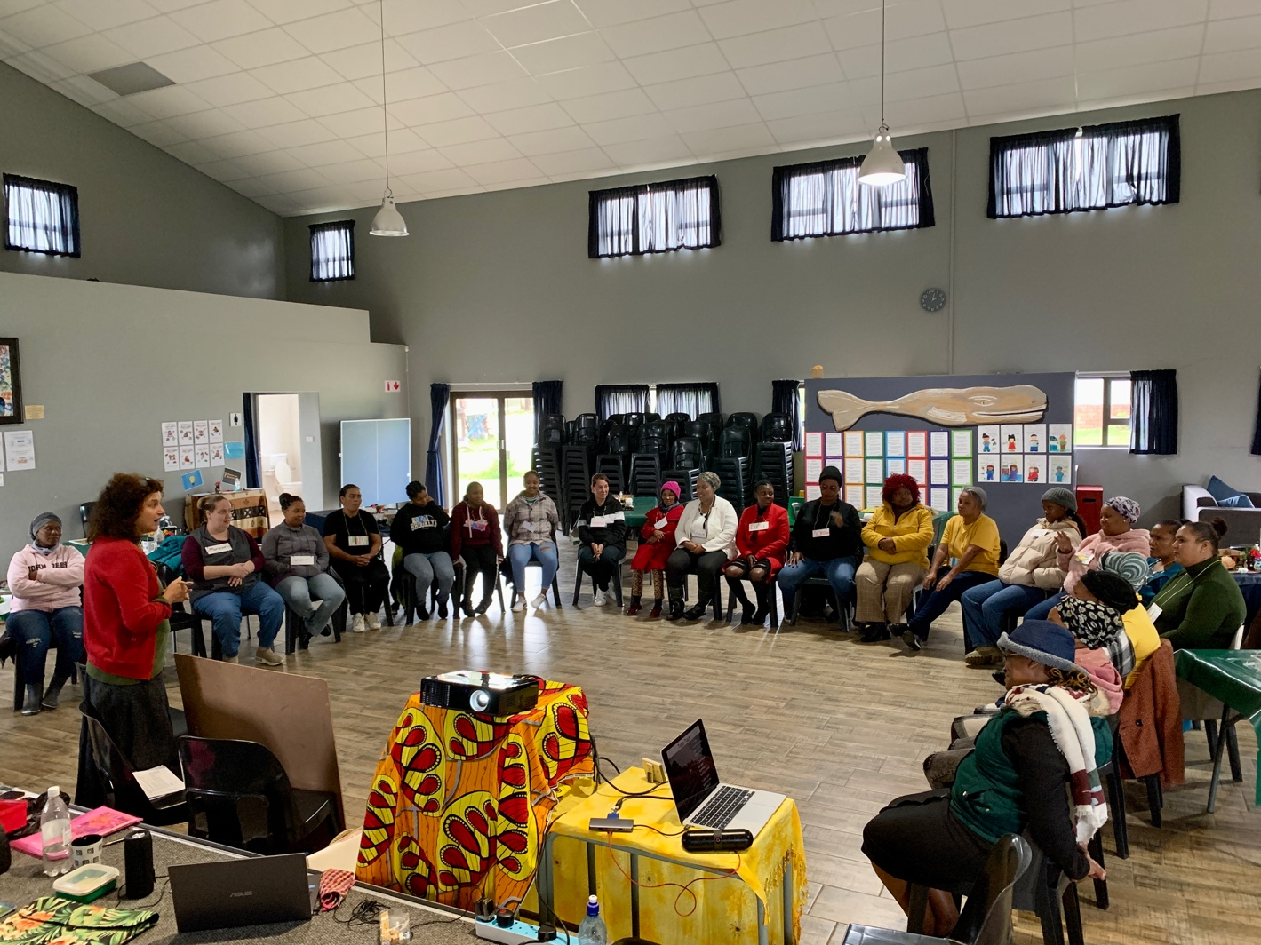

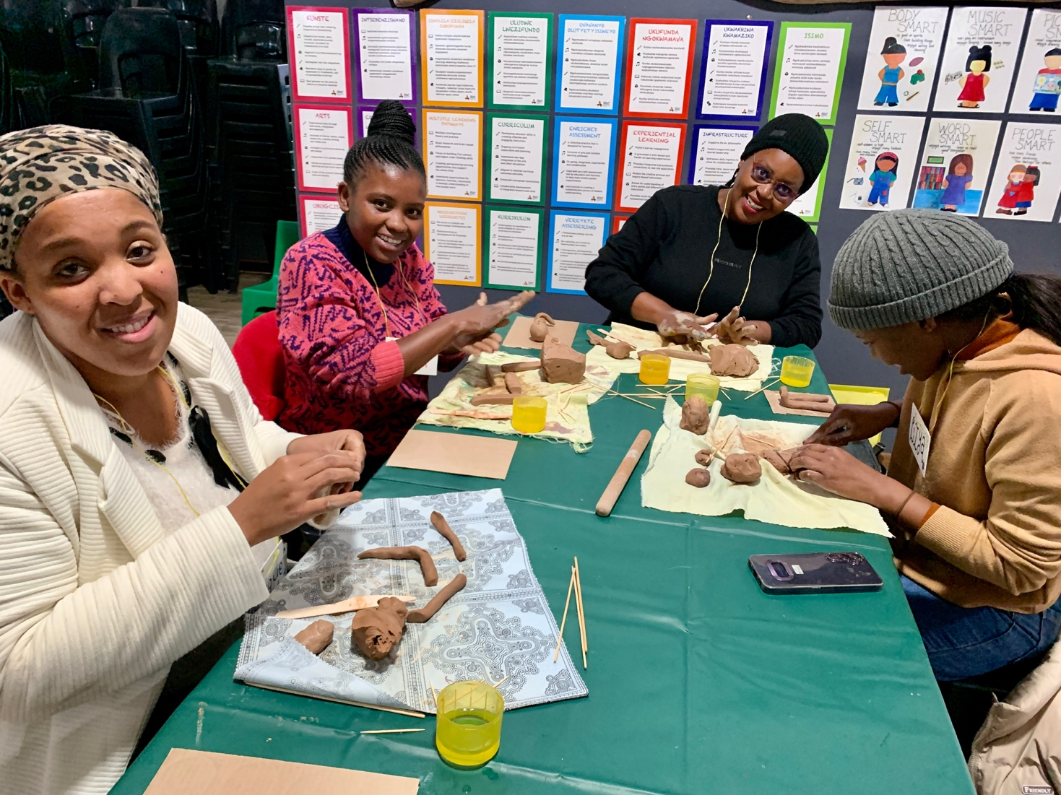
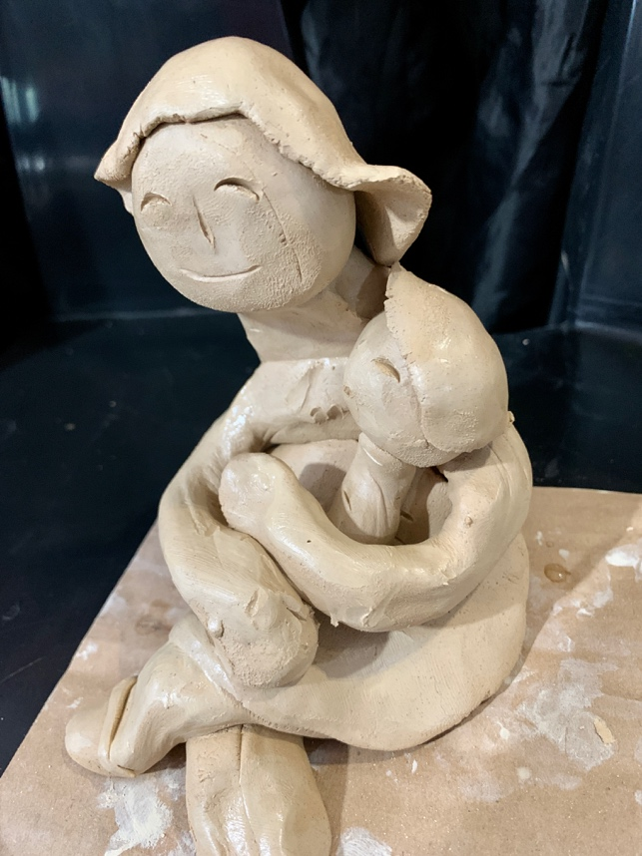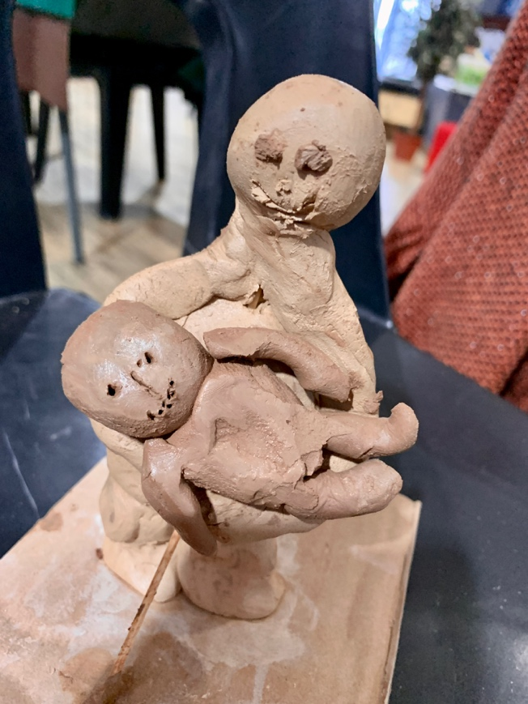

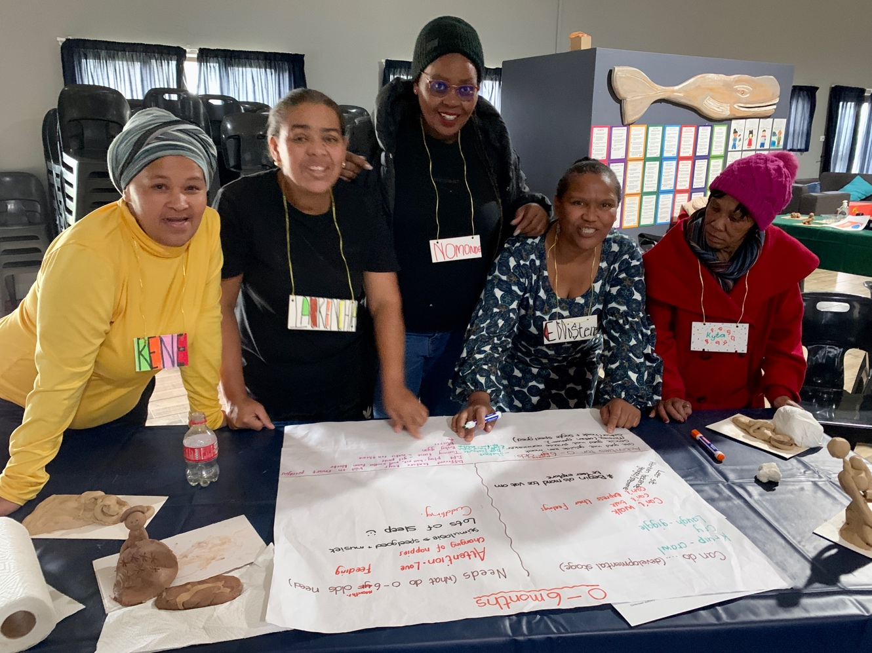

- Leadership workshop (11th April 2024)
The workshop was attended by 20 principals. The workshop on nutrition was planned in response to A+’s observation that parents still send children to school with sweets and chips in their snack boxes. The participants read food labels, sorted food items (healthy/unhealthy), and thought critically about their food choices before making a poster on healthy eating and setting out a parents’ workshop. Two participants wrote:
    - ‘I am feeling very great. I love being at your classes, It helped me a lot’
    - ‘I am so excited for this type of things, It is very learningful and I gained enough knowledge to carry over to our school’

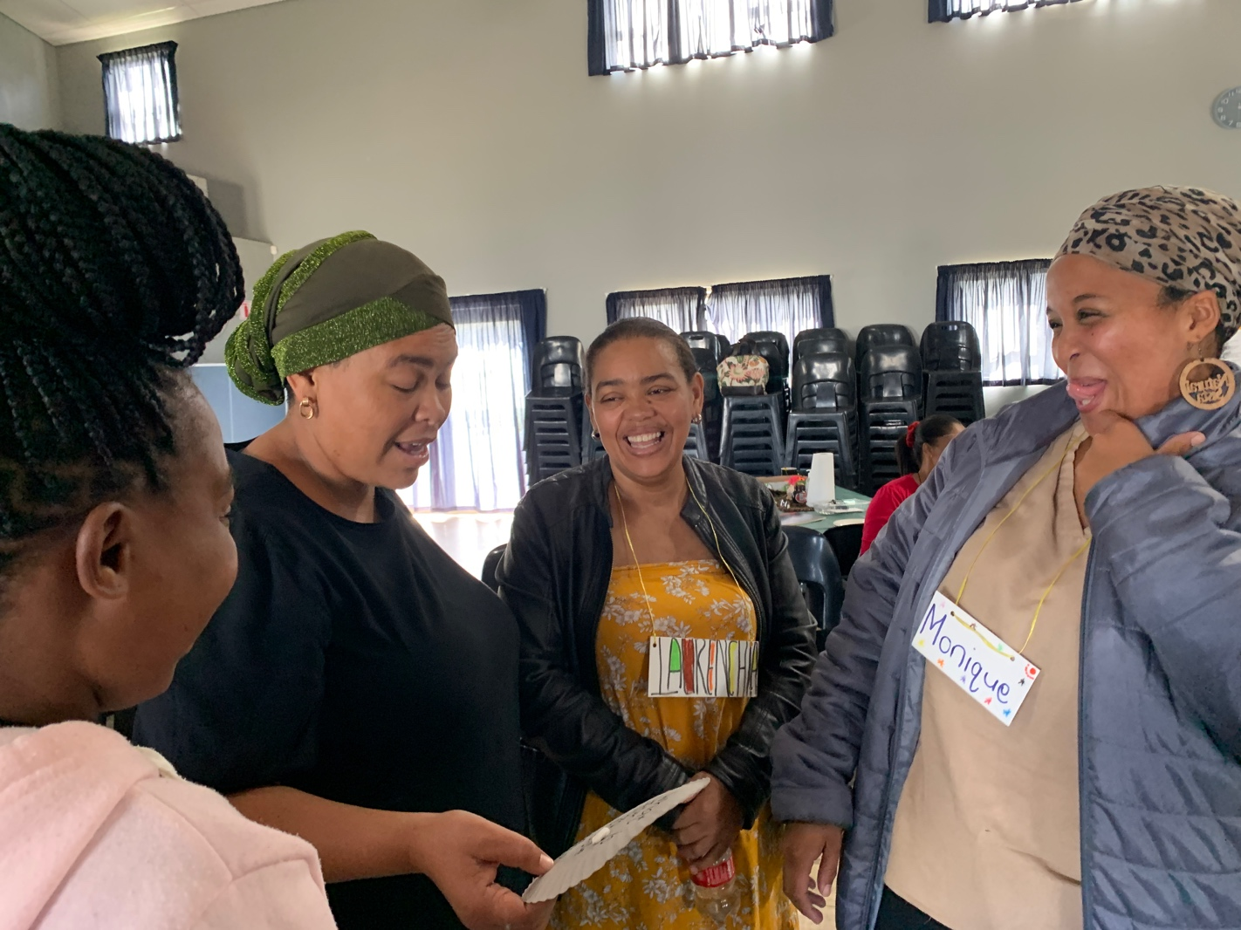

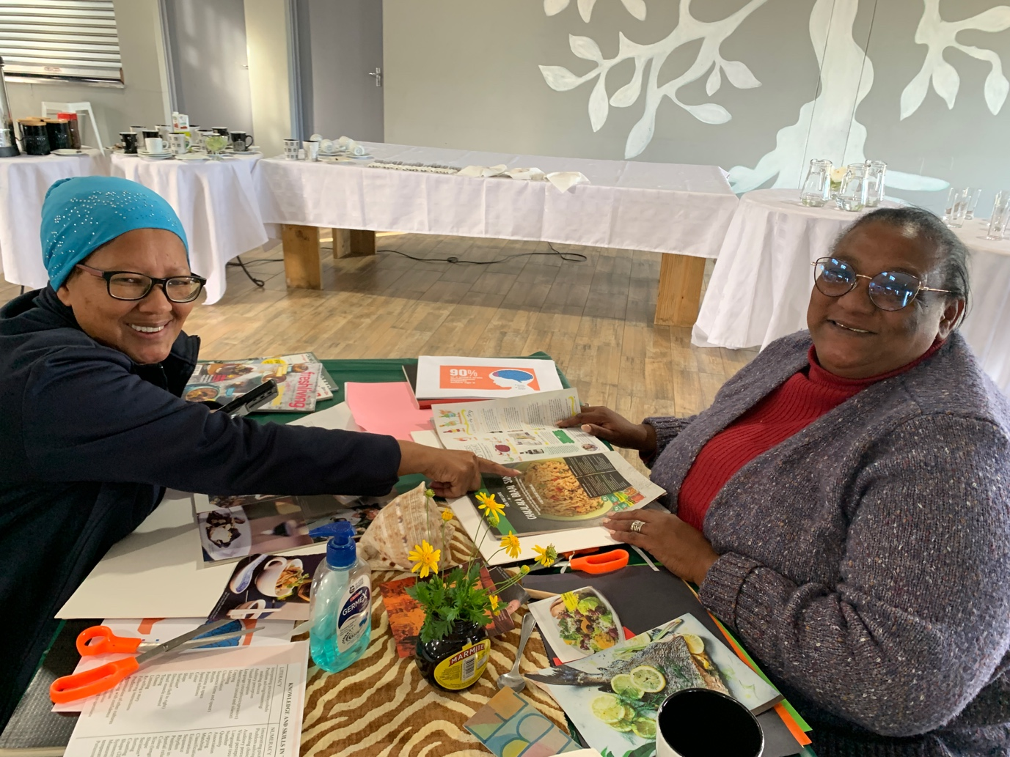

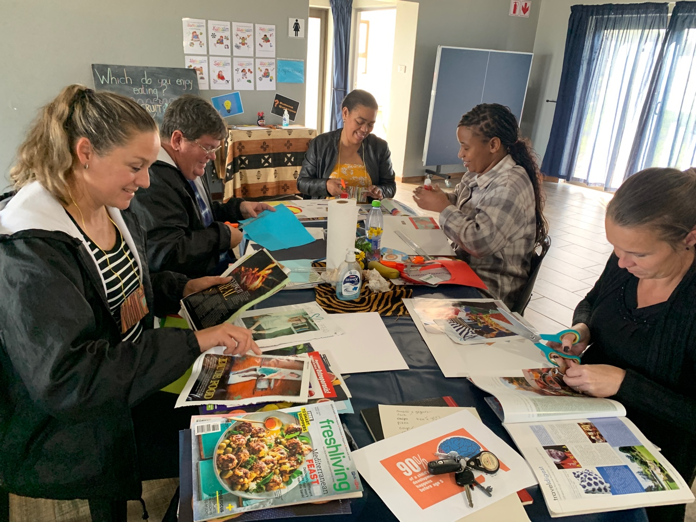

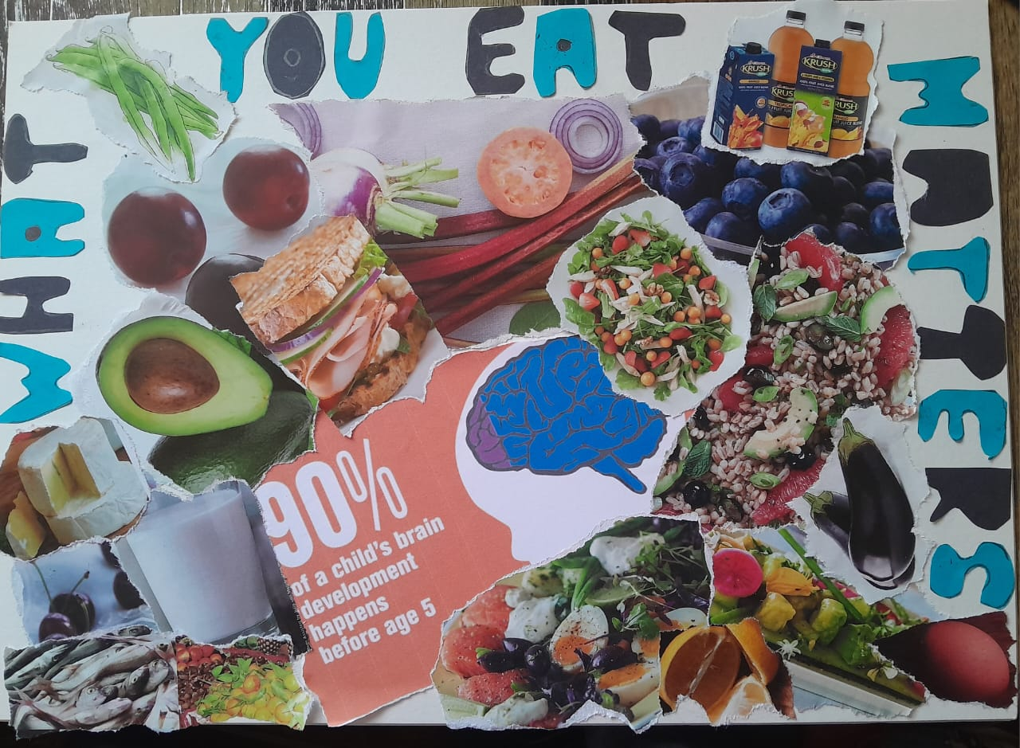

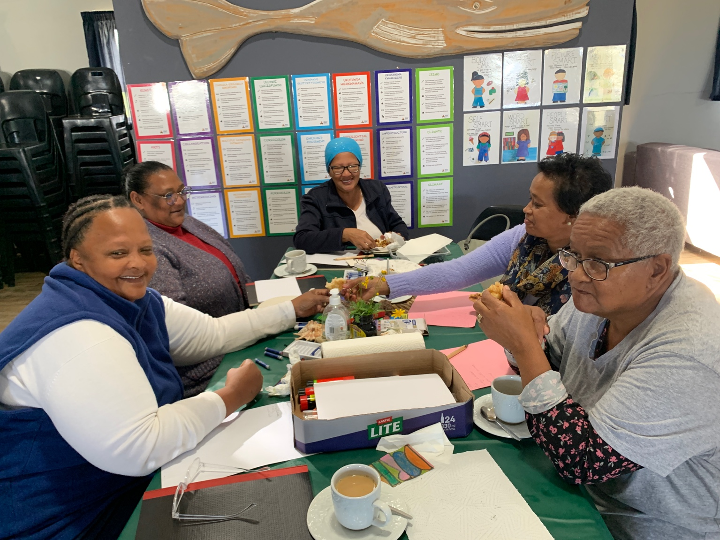

- Grade R workshop (12th April 2024)
22 participants enjoyed the practical application of the CAPS mathematics curriculum. First, they set up groupwork and then they created play-based mathematics activities using found, discarded and recycled materials.
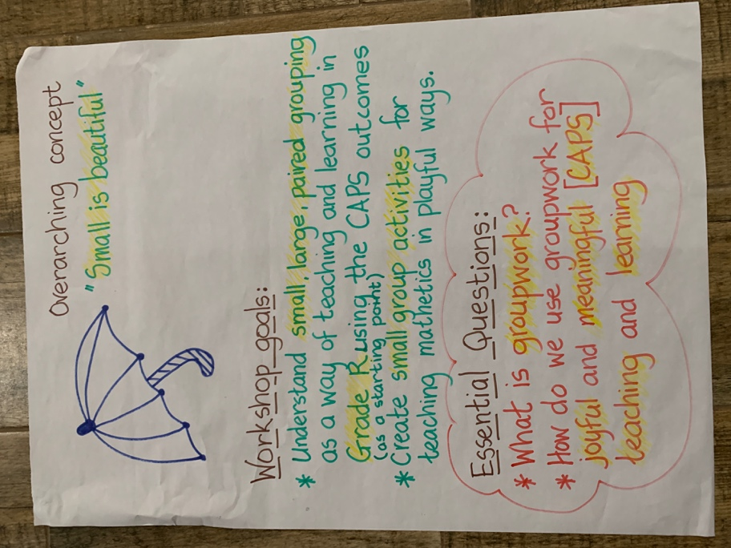

When asked to comment on what was helpful today, two participants wrote:

‘Practical example of classroom games – making learning fun.’ ’(Martha)

‘Anything you can give us. Because everything is learningful. It is great.’(Catherine).

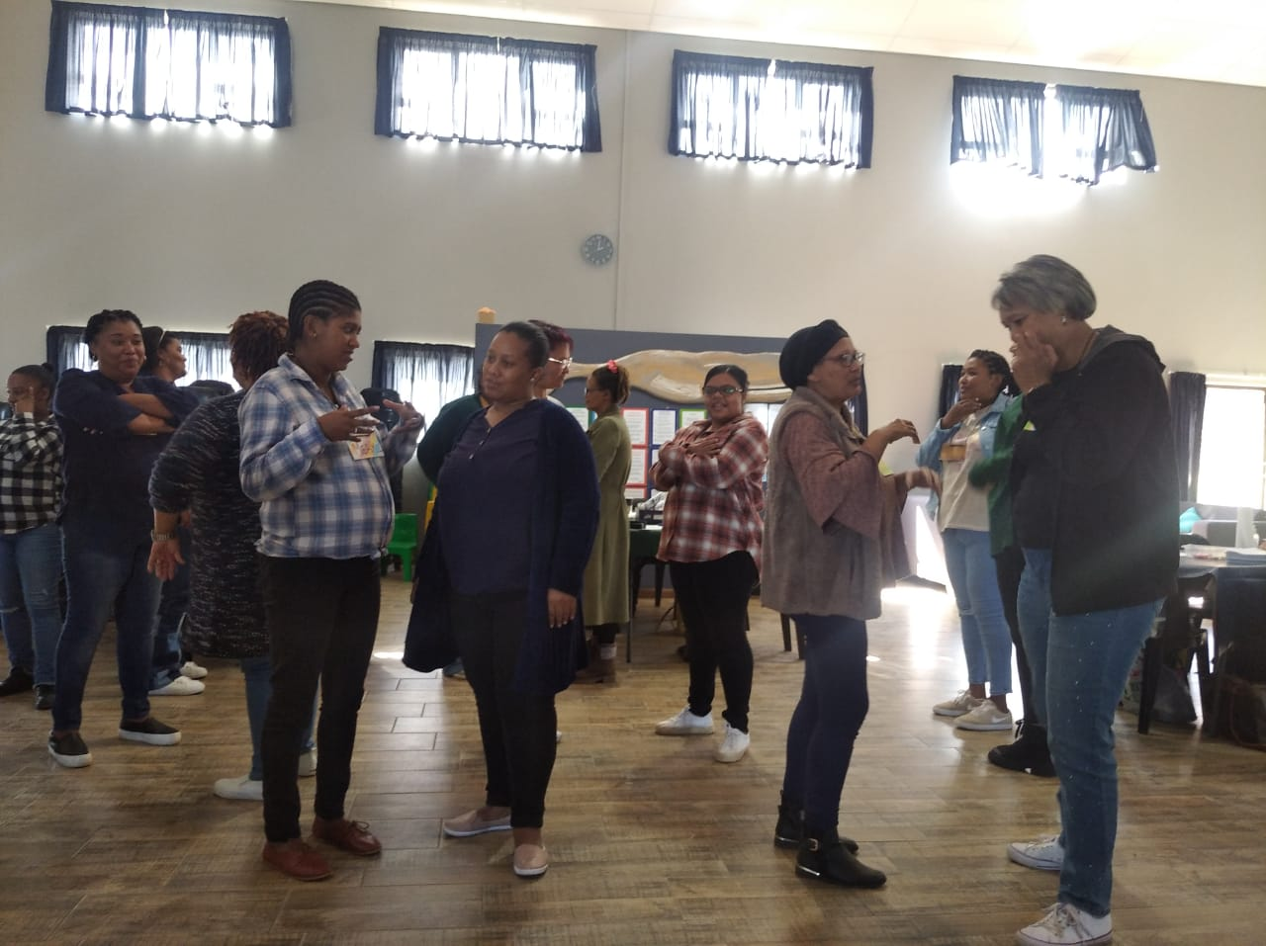

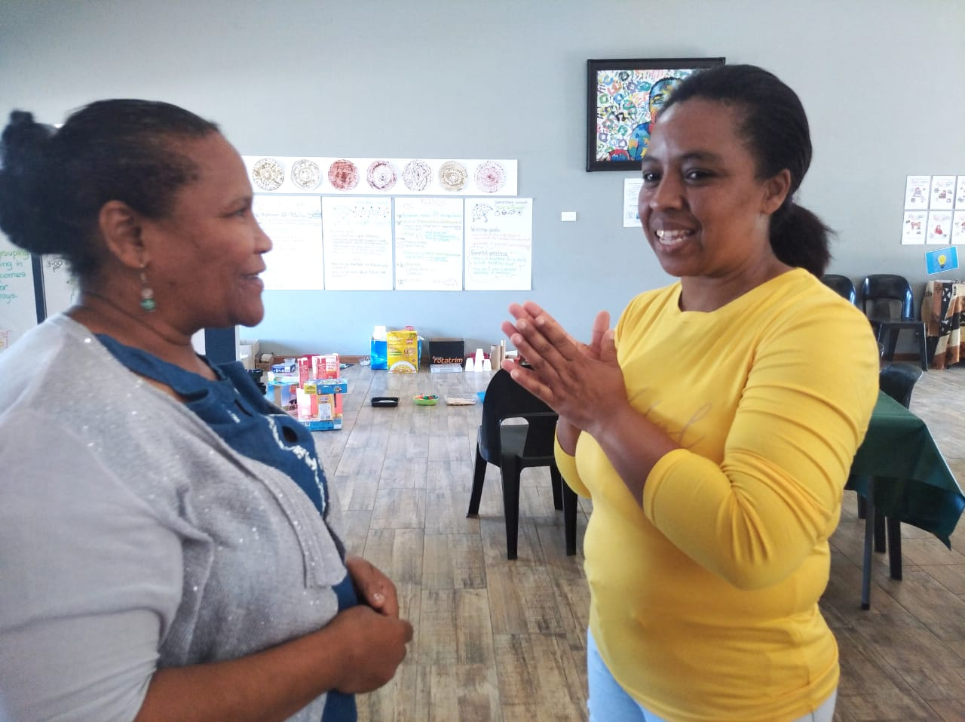

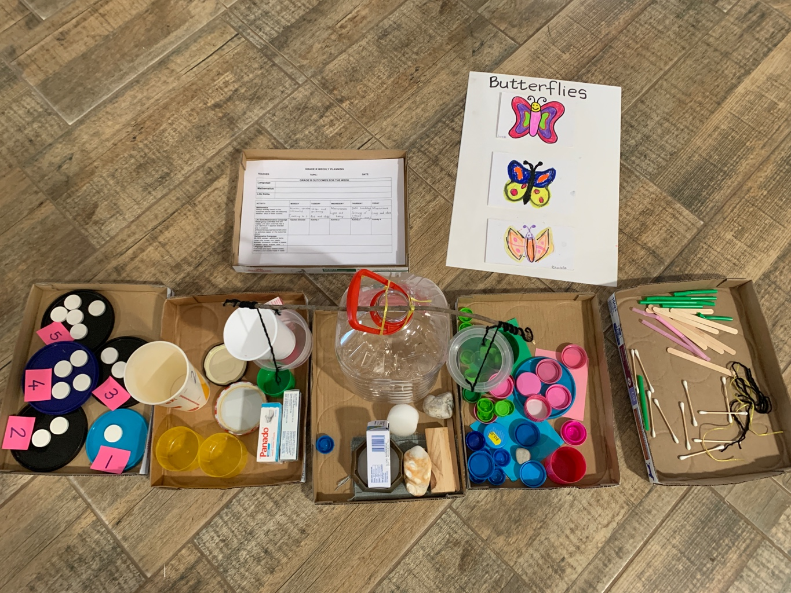

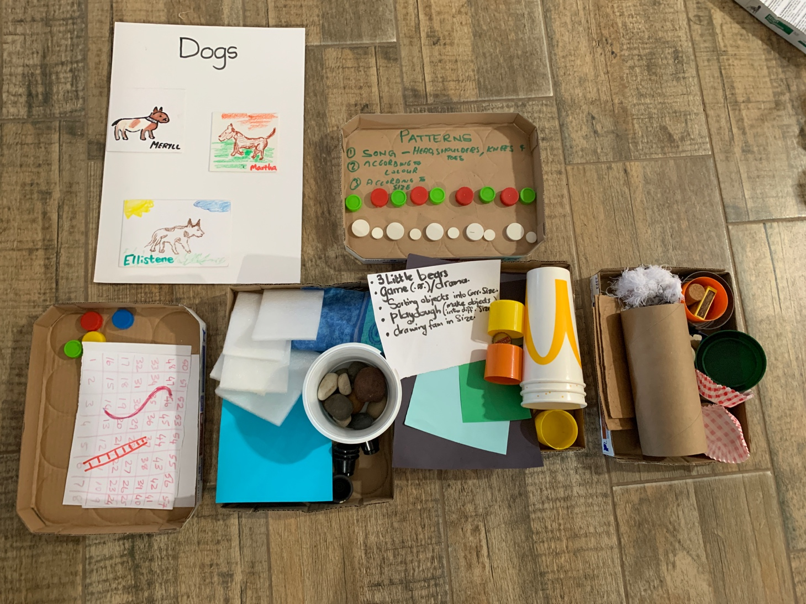

- Planning a two-day workshop (13th April 2024)
The Kouga facilitators in training spent their Saturday morning planning a two-day workshop for the new ECD centre staff who have not participated in the A+ introductory training. It was a productive morning; Natashia wrote: ‘I always learn something new. It‘s always good to work with my teammates.’

