When A+ facilitates an ECD project we develop a team of local early childhood facilitators. The reason is sustainability: when the project is complete and A+ is no longer there, there will be a team in place that will continue to support and grow the ECD centres’ knowledge and skills.

A+ has been working with the Kouga ECD facilitators for three years. They are making a difference by:
- Regularly visiting each ECD centre to demonstrate play-based teaching, to help set up a joyful learning environment, and to plan according to the 0-4 years National Curriculum Framework.
- Facilitating afternoon workshops that provide insights into diversity, play-based learning, creativity, and the arts.
- Facilitating the professional development of new principals and teachers.

We are very proud of Felicity Toll, Nomalungelo Mtsele, Elsie Vermaak, Petronella Ruiters, Nomonde Siqwengana, Natashia Visagie, Ntombpmzi Ndamse, and Marlyn Dyantyi.
Photo 1: Petronella Ruiters demonstrates play-based teaching at Twinkle ECD Centre
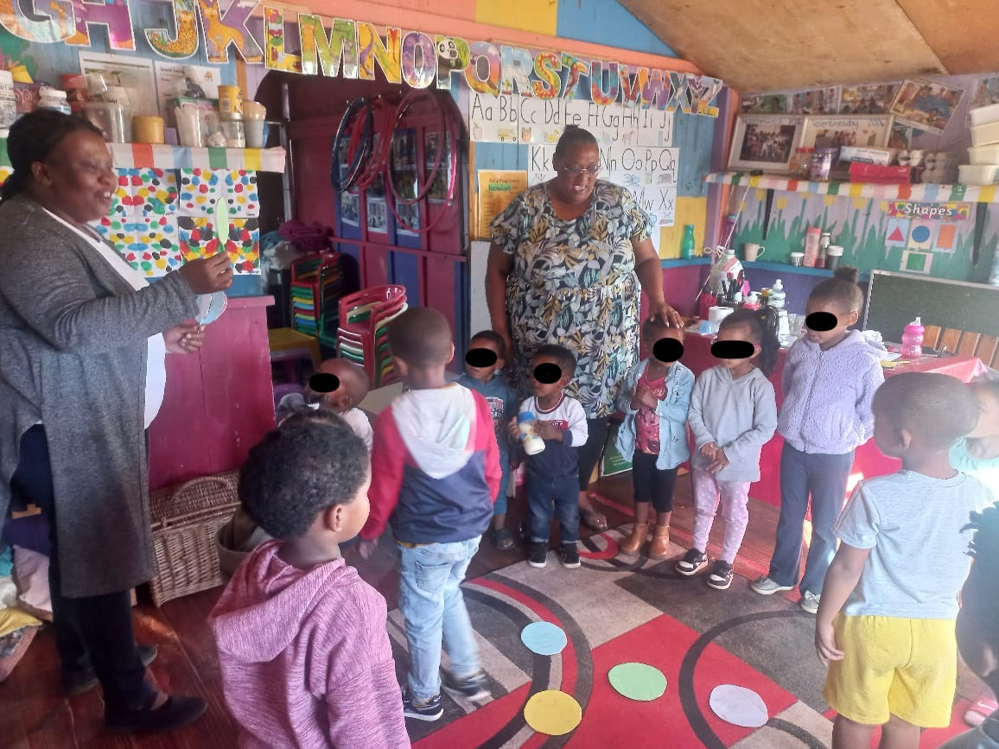

Photo 2: Petronella Ruiters demonstrates playful ways of teaching number to a small group of children.
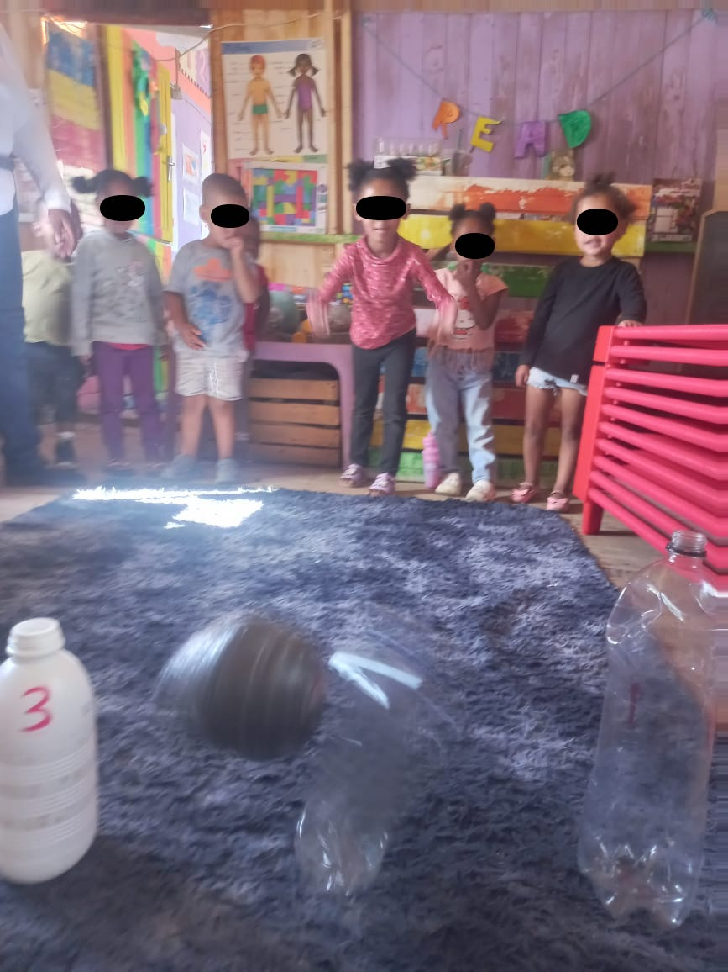

Photo 3: Petronella Ruiters demonstrates how to use the outdoors for joyful teaching and learning.
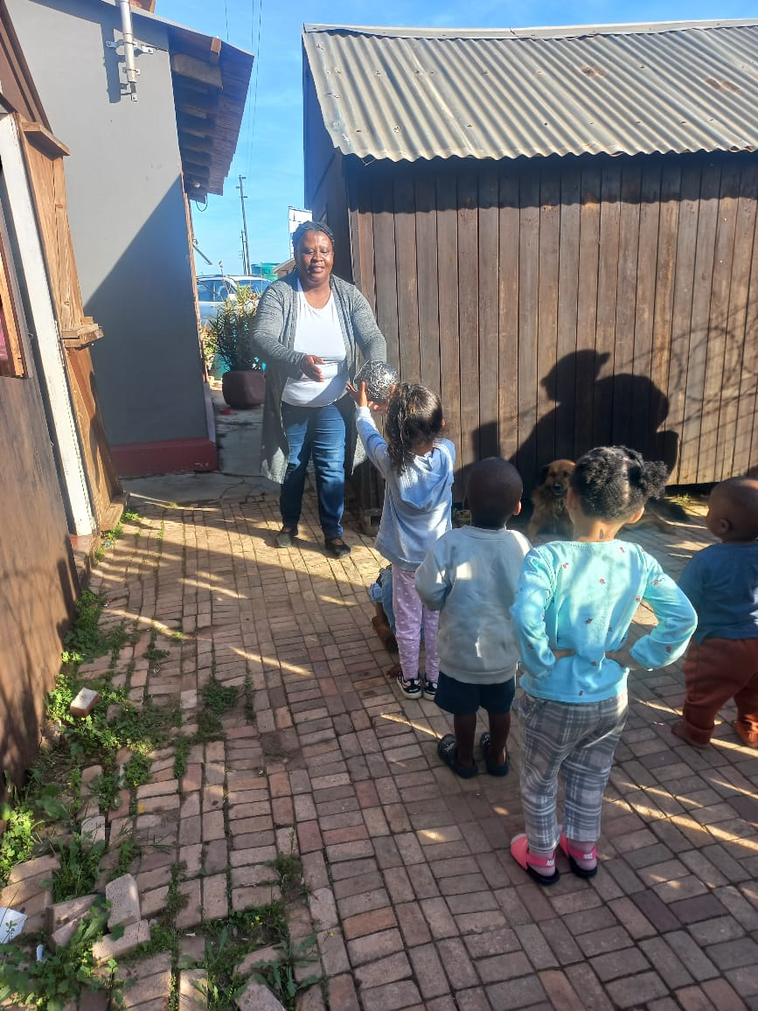

Photos 4 and 5: Nomonde Siqwengana demonstrates play-based teaching at Makhulu Educare.
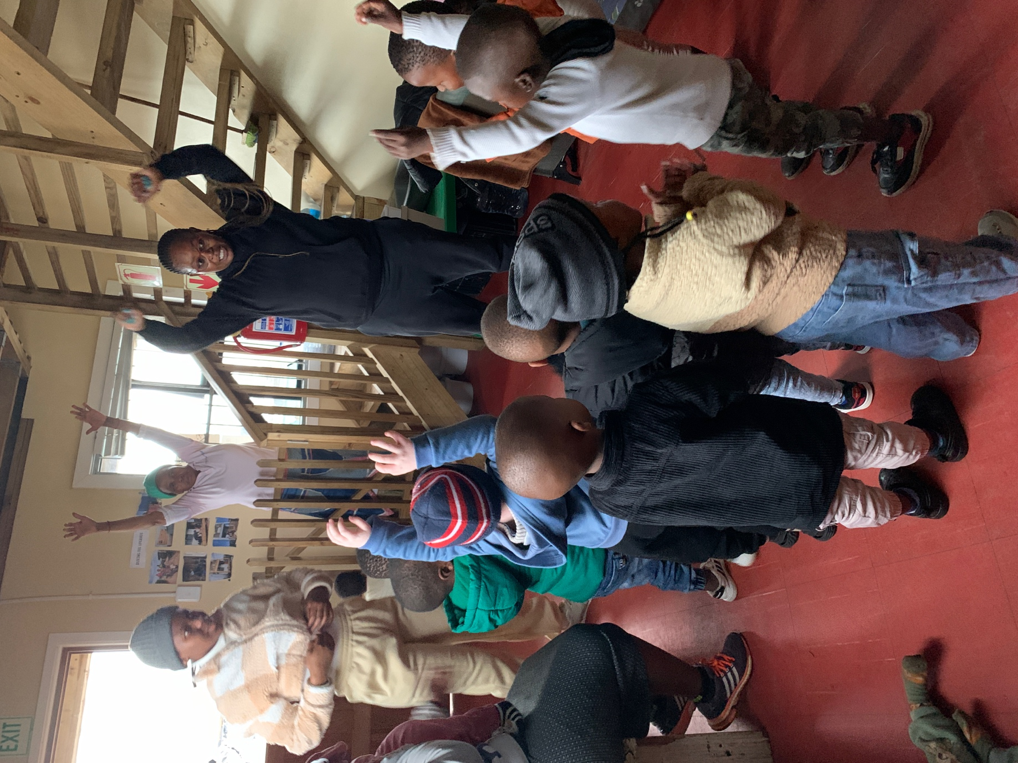
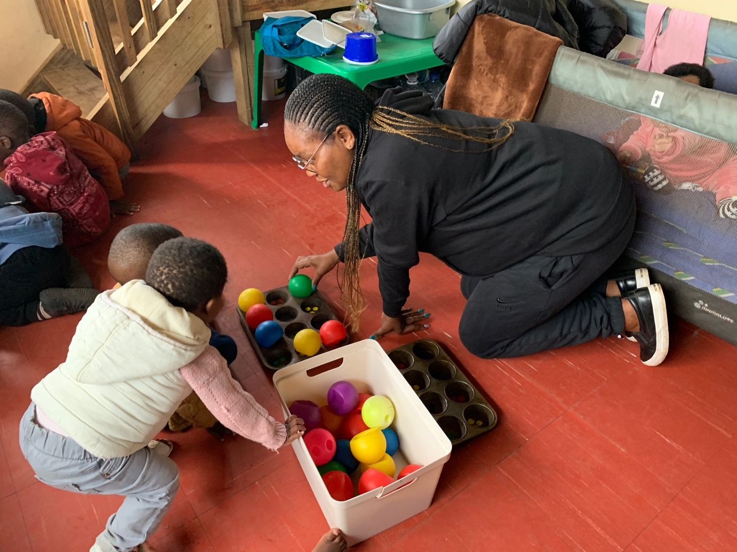

Photo 6: Felicity Toll and the children at Kleine Engele discuss road safety.
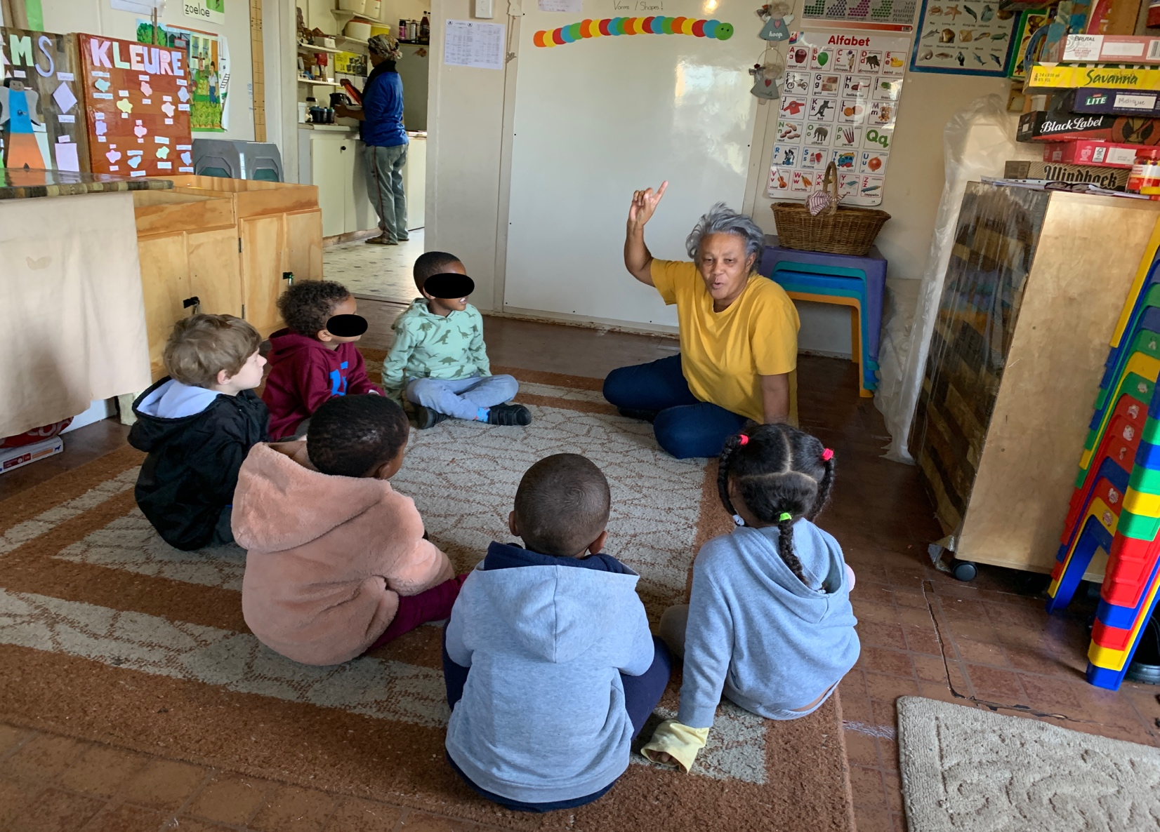

Photo 7: Ntombomzi Ndamse uses movement and song to teach the children at Masikhule in Kwanomzamo.
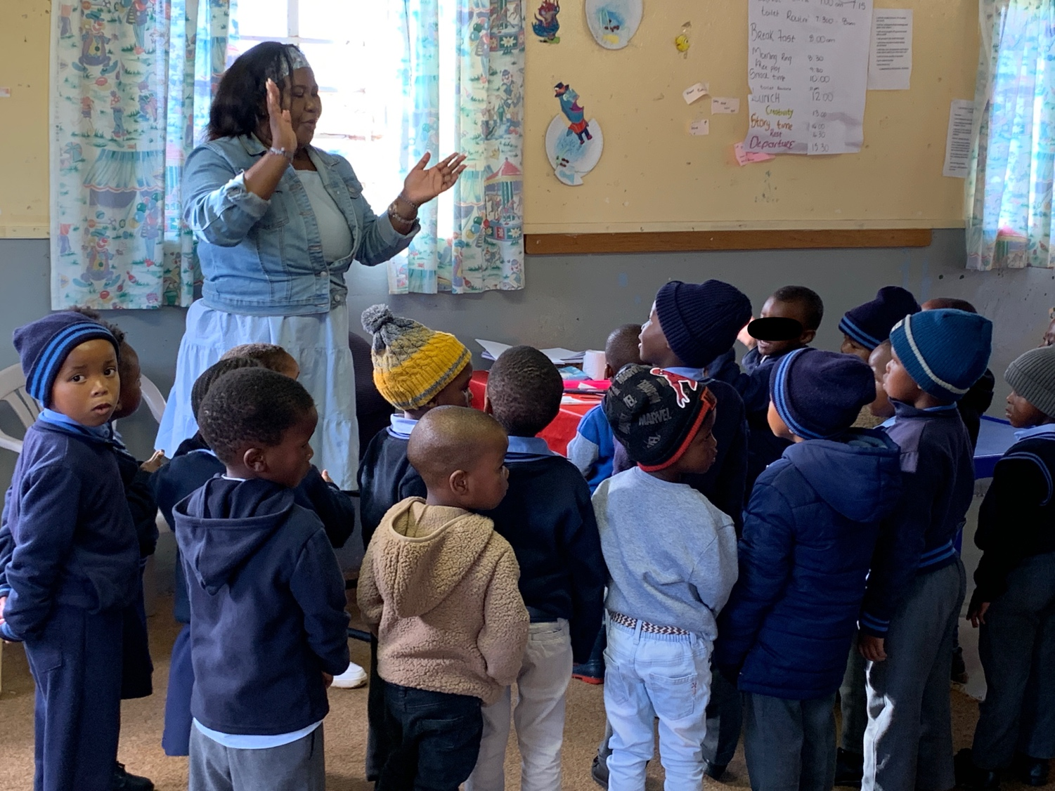

Photos 7: Nomalungelo Mtsele and the children at Nkqubela ECD centre in Kwanomzamo
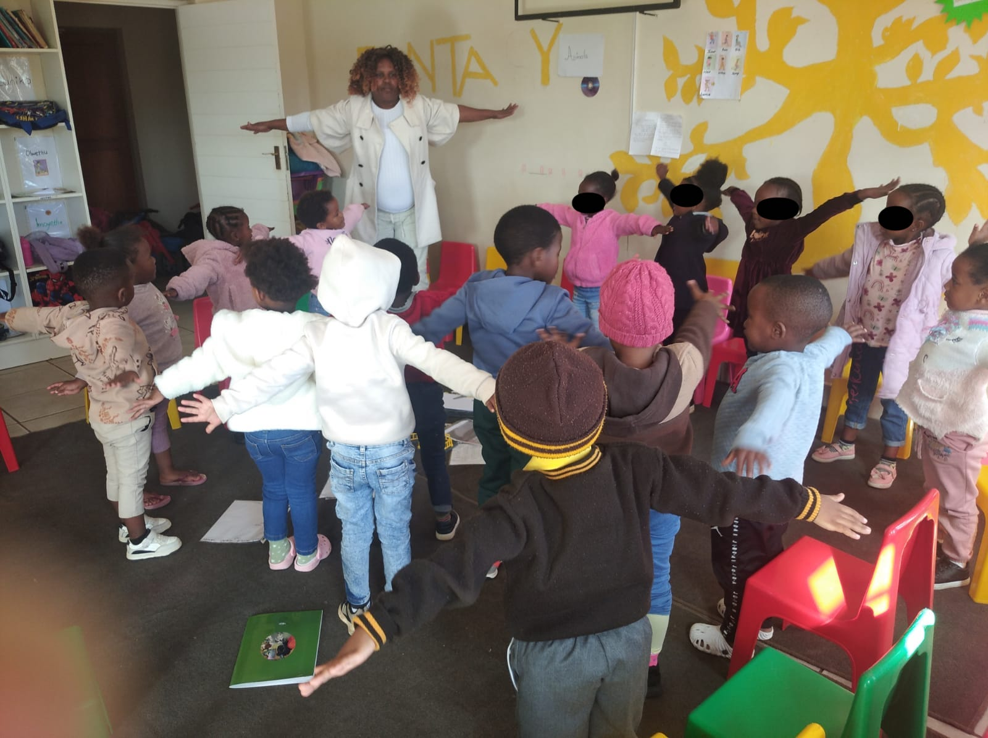

Photos 8: - 14 The Kouga facilitators planned and facilitated a one day workshop for new teachers and principals (September 2023).
